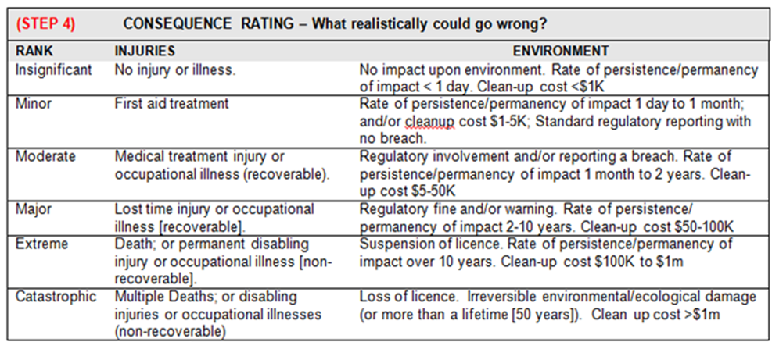
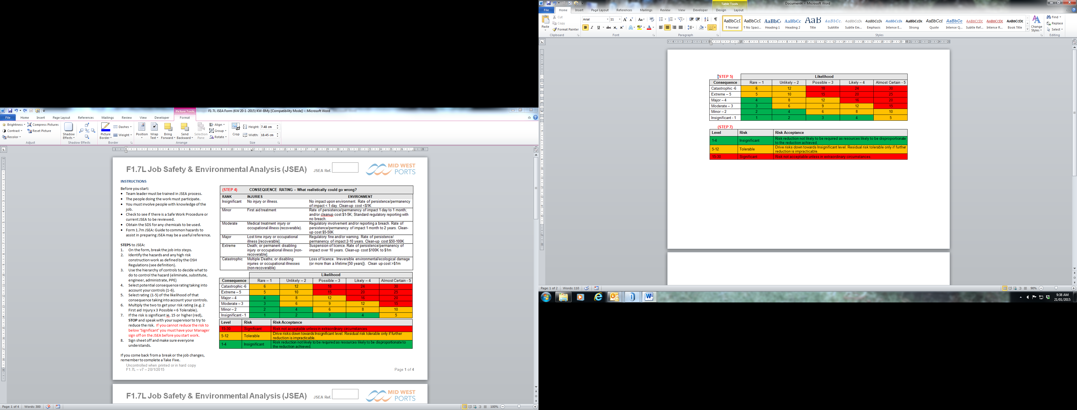
INSTRUCTIONS
Before you start:
Team leader must be trained in JSEA process.
The people doing the work must participate.
You must involve people with knowledge of the job.
Check to see if there is a Safe Work Procedure or current JSEA which can be reviewed and used.
Obtain the SDS for any chemicals to be used.
A copy of this JSEA must be on site at all times.

STEPS to JSEA:
On the form, break the job into steps.
Identify the hazards and any high risk construction work as defined by the OSH Regulations. Refer Form 1.7m JSEA: Guide to Common Hazards
Use the Hierarchy of Controls to decide what to do to control the hazard (elimination, substitution, engineer, administrative, PPE)
Select the potential consequence (1-6) as if there were no controls. Then reassess the consequence taking into account your chosen controls for the hazard.
Select rating (1-5) of the likelihood that the consequence could occur. The likelihood should be selected taking account of the control measures you have chosen.
Multiply the two to get your risk rating.
If the risk is significant (15 or higher - red), STOP and speak with your supervisor to reduce the risk. If you cannot reduce the risk below ‘Significant’ your Manager must sign off on the JSEA before you start work.
Each worker is to read and sign onto the JSEA.
If the work continues over numerous days, the employee must sign on each day. If anything changes in or around the job, the JSEA is updated and employees acknowledge this by signing the JSEA again.
On completion of Job, ensure signed and updated version is returned to office and filed.

Date: |  | JOB TITLE:

DESCRIPTION OF WORK:

PERMIT WORK REQUIRED: | Hot Work | Confined Space | Fumigation | Bunkering | Excavate /Penetrate
PERMIT WORK REQUIRED: | Working at Height | Abrasive Blasting | Crane Lift | Work Afloat/ Dive | Other

NOTE: Activities such as confined space entry, compressed air diving and high voltage electrical work will require an additional specific risk assessment
 | Activity  List the tasks required to perform the activity in the sequence they are carried out | Potential Hazard  Against each task list the hazards that could cause injury when the task is performed. | Consequence | Likelihood | Risk Rating | Control Measures  List the control measures required to eliminate or minimise  the risk of injury arising from the identified hazard | Consequence | Likelihood | Risk Rating | Who is responsible  Write the name of the person responsible to implement the control measure identified.

ADDITIONAL INFORMATION (to be discussed as part of the Risk Assessment)
EMERGENCY CONTACT INFORMATION | - Know where the nearest First Aid Box is kept (e.g. in the Work Vehicle)  - Nearest Life Ring and Ladder Locations  - Be aware of MWPA Emergency Response Procedure | - MWPA Emergency Number: 9964 0500  - MWPA OHS Officers: 0409 089 048/0400 527 470  - Ambulance, Fire Brigade, Police: 000  - Duty Wharf Supervisor: 9964 0510

SUPERVISOR APPROVAL
NOTE: If a risk is rated 15 or over (Significant Risk) you must arrange your Manager to sign off the JSEA BEFORE work commences.
Signature : |  |  | Signature:
Signature : | JSEA Team Leader |  | Signature: | Supervisor
Name: |  |  | Name:
Date: |  |  | Date:

MANAGER APPROVAL (required if there are Significant risks)

Signature :
Signature : | Manager
Name:
Date:

Custodian: OHS OFFICER
If the work continues over numerous days, the employee must sign on each day.
If anything changes, the JSEA is updated and employees acknowledge the changes by signing the JSEA.
DATE | NAME | SIGNATURE | INVOLVED IN CREATION OF JSEA (Y/N) | COMPANY

