

HSE-PLN-008 TRAFFIC MANAGEMENT PLAN – GILLAM ROAD

INTRODUCTION AND PURPOSE

The purpose of the Traffic Management Plan for Gillam Road is to ensure that:
- ANY vehicular activities do not impact adversely on operations in the area.
- Operator safety is maintained by use of a dedicated site traffic management plan.
- Public safety is not compromised by the activities of vehicles entering the Port.
- Disruption to vehicle flow and Port activities is kept to a minimum by designated routes and corridors of transport for vehicles entering and exiting the site.

All vehicular traffic and persons entering shall abide by the directions laid down in this document.

The majority of traffic accessing this area are trucks delivering product to storage sheds, maintenance vehicles, operational plant and personal vehicles. Due to the volume of heavy vehicles, front end loader operations, restricted area and local traffic conditions, Gillam Road is considered a high risk traffic area.

SITE RULES

The sites main access to Gillam Road is from Marine Terrace by entering the slip road from the west heading east. Site rules are:

- The area is a mine site; and comes under the Mine Safety and Inspection Act 1994.
- ALL personnel entering the site will be required to take part in the MWPA drug and alcohol testing program.
- ALL vehicles/trucks/machinery must have amber rotating beacons and headlights on as indicated by signage.
- The speed limit is 20 km/h.
- NO motor cycles or bicycles are permitted in the area.
- Minimum personal protective equipment (PPE) is as per signage at entrances.
- Public access is prohibited.

LEASE SITES

The following lease sites are located in this area (refer Attachment A for lease areas drawing):

Company | Activity | MWPA  Lease No.
QUBE Ports & Bulk | Operation of trucks and front end loaders for bulk cartage and loading of materials | 10
Imery’s | Stockpiling of talc (outdoors) | 19
GMA Garnet | GMA Garnet bulk storage | 20
Iluka Resources Ltd | Mineral sands bulk storage | 8-11
Sinosteel Midwest | Iron ore truck unloader and bulk storage | 13
MWPA | Iron ore truck unloader and bulk storage | 14
Mt Gibson Mining | Iron ore bulk storage | 17
EMR Golden Grove | Heavy precious metal (lead), copper and zinc metal concentrates bulk storage | 21
IGO | Metal Concentrates (copper and zinc) bulk storage | 27

VEHICLE ACCESS AND EGRESS PROCEDURE

Arrival at the slip road

Once entering the slip road from Marine Terrace, the driver will conform to the 20 km/h speed limit and site entry conditions.

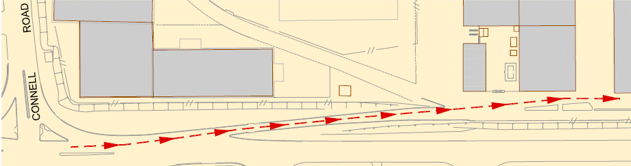
Figure 1 - Gillam Road
(Red arrow denotes travel path)

Proceed to required site

Vehicles entering the slip road have right of way to all other traffic. Vehicles are to keep left, as per normal road rules, unless wanting to enter the Sinosteel Midwest truck unloader.

Sinosteel Midwest truck unloader

If proceeding to the Sinosteel Midwest truck unloader, the vehicle shall stay to the right of the concrete barriers and line up with the hopper straight ahead.

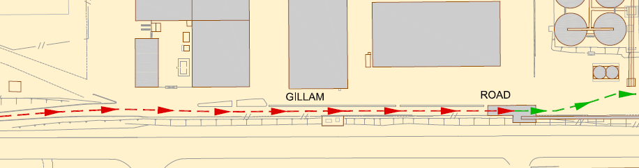
Figure 2 - Sinosteel Midwest truck unloader
(Red arrow denotes entry travel to truck unloader; green arrow denotes exit travel)

On completion of dumping, the truck will proceed out of the hopper and wait for the appropriate time to transfer to the left lane and proceed to the eastern end of the Minerals Lease. From there they will exit around the roundabout and then onto Marine Terrace, turning right. Note: Please turn off rotating lights once entering roundabout.

Ship Loading activities

During ship loading activities, vehicles moving to the MWPA truck unloader will exit the appropriate shed, following the flow of traffic towards the east until they reach the MWPA truck unloader ramp. Vehicles will head north up the ramp and into to truck unloader shed and dump as directed.

On completion of the dumping, the vehicle will move down the rise on the northern side, turn towards the west and then south and head towards the T junction or into Iluka’s sheds following normal road rules. Once at the T junction, vehicles have the option to head east or west depending on their destination.

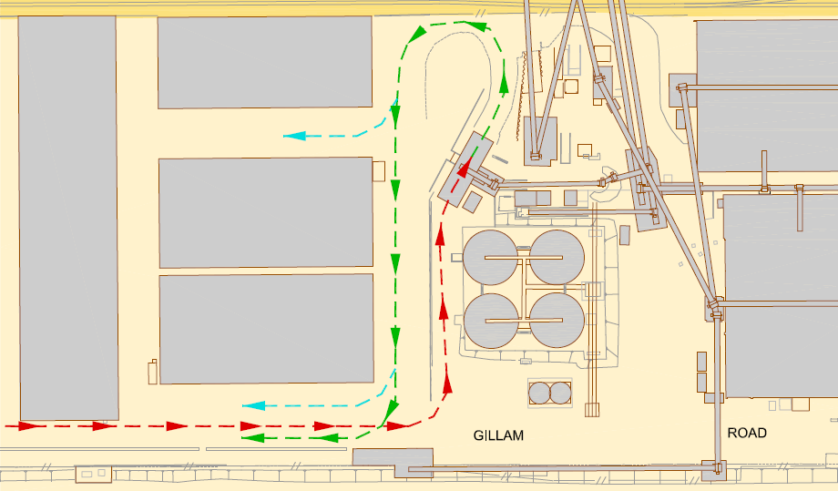
Figure 3 - Route for Shiploader - MWPA truck unloader
(Red arrow denotes entry travel to truck unloader; green arrow denotes exit travel; blue arrow denotes alternate path for authorised vehicles only)

MWPA (Formally Top Iron Pty Ltd) truck unloader

When maneuvering to enter the MWPA truck unloader, vehicles should be mindful to reduce speed and line the vehicle up for a straight entry into the shed taking into consideration any vehicles queuing.

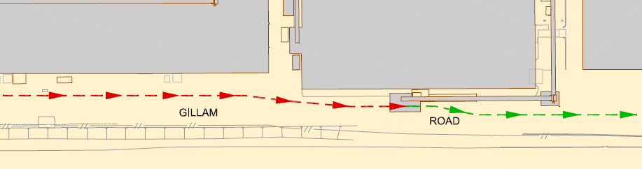
Figure 4 – MWPA truck unloader
(Red arrow denotes entry travel to truck unloader; green arrow denotes exit travel)

On completion of dumping, the vehicle will exit the truck unloader and move with care into the exit lane, heading towards the roundabout and then onto Marine Terrace, where they will turn right. Care needs to be taken for trucks exiting from the EMR Golden Grove shed and the one way lane around the Jabiru (IGO) Shed, as these will merge in with other traffic on Gillam Road. Note: Turn off rotating light once on roundabout.

EMR Golden Grove shed

Vehicles delivering product to EMR Golden Grove’s shed will move to the left and line the vehicle up with the shed opening. There upon acquiring the necessary acknowledgement, move slowly into the shed.

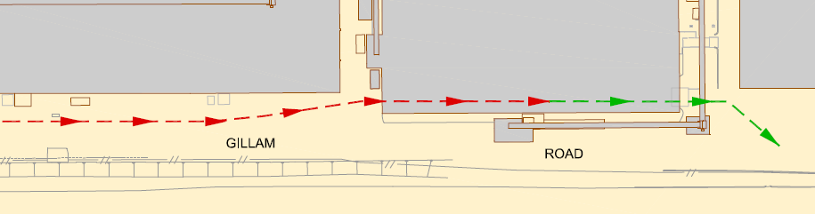
Figure 5 – EMR Golden Grove shed

(Red arrow denotes entry travel to EMR Golden Grove shed; green arrow denotes exit travel)

Trucks will then exit the EMR Golden Grove shed on the eastern end. Care needs to be taken for vehicles entering onto Gillam Road from the one way lane around the IGO shed and also for vehicles moving down Gillam Road. Trucks are to turn off the roundabout right onto Marine Terrace.

Vehicles returning to the west

With the redesign of Gillam Road in 2014 vehicles are now able to travel west along Gillam Road as far as Iluka Shed 4. From this point drivers are asked to proceed as directed via sign posting.

Vehicles entering via Connell Road onto Gillam Road

Vehicles normally expected to use this entry will be QUBE trucks delivering garnet to GMA Garnet sheds and light vehicles moving between the leases and sheds for maintenance requirements.

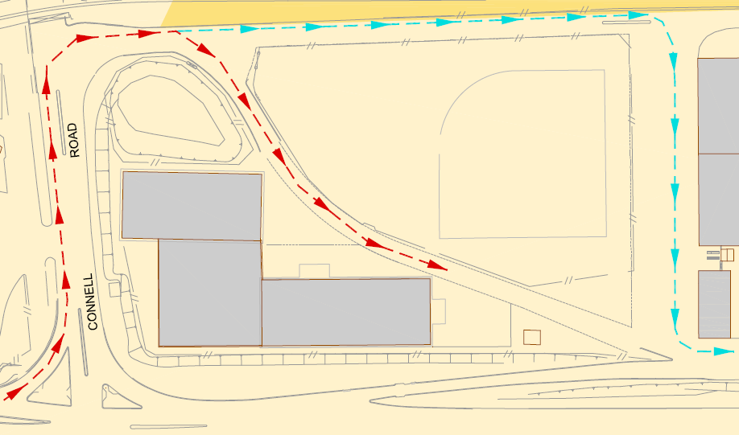
Figure 6 - Connell Road Entry
(Red arrow denotes travel path; blue arrow denotes alternate travel path)

Site preparation when ship loading via dumping into MWPA truck unloader

The following procedure (normally undertaken by QUBE personnel) must be undertaken before ship loading can commence:

- The orange flashing ‘Ship Loading in Progress’ lights are to be operating.

- Signage is to be erected to inform all vehicles entering the site that ship loading is in progress and trucking operations will be increased in the area.

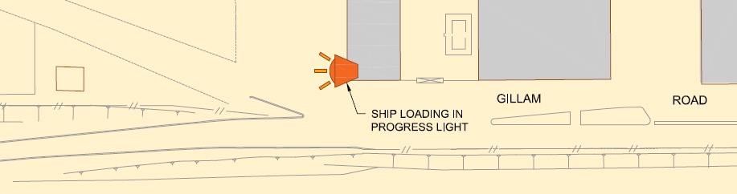
Figure 7 - Ship loading controls

Access to MWPA (formally Top Iron Pty Ltd) shed and IGO shed

Access to the MWPA shed is via a one way lane off Gillam Road, which runs anti-clockwise around Lease 27 shed.

For trucks unloading materials into Lease 27 shed, access is via Gillam Road on the southern side of the shed and exiting from the north onto the one way lane.

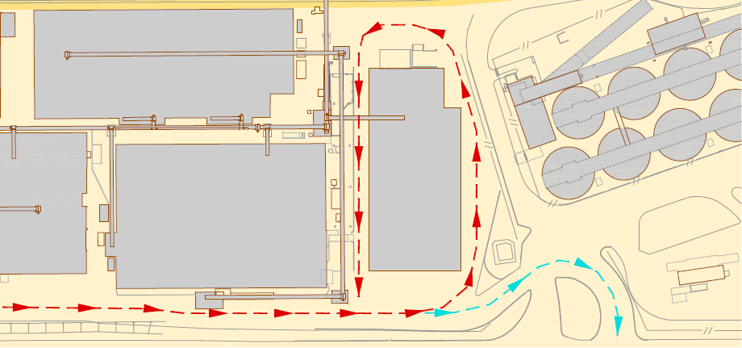
Figure 8 – Access to Lease 14 and Lease 27
(Red arrow denotes travel path; blue arrow denotes alternate travel path to exit BHF)

OTHER GENERAL

Emergency service vehicles will have right of way at all times.

Lessees may implement traffic control plans for their own sites as they see fit, provided there is no impact on common user areas or roads and MWPA is advised.

Convex traffic mirrors have been installed in a number of locations. These are to be cleaned by MWPA on a regular basis and should be replaced as the surface becomes such that it no longer effectively mirrors oncoming vehicles.

To minimise disruption to operational activities, where work is to be undertaken that is likely to affect other lessees or users of the facility, appropriate notification (and consultation as required) should be provided to other users within a timely manner.

Traffic management for all construction and maintenance work in work sites wholly or partly within on the road should be implemented in accordance with the Main Roads Western Australia Traffic Management for Works on Roads Code of Practice. Where normal road conditions are impacted a traffic management permit is required from MWPA refer to Form F2.20a Traffic Management Plan Permit available on MWPA’s website.

Signage and linemarking should comply as a minimum with AS1742.2-2009 Manual of uniform traffic control devices Part 2: Traffic control devices for general use.

Under the provisions of the Port Authorities Act 1999, MWPA has the legislative authority to deal with certain prescribed traffic or vehicle offences on Port land. There are two avenues provided: issue of an Infringement Notice and fine; or commencing a legal proceeding for breach of the Act.

ASSOCIATED DOCUMENTS

MWPA Procedure 2.20 Traffic Management – Geraldton Port
MWPA Form F2.20a Traffic Management Plan – Permit
MWPA Procedure 4.1 Permit to Work System
Attachment A – Lease areas drawing.

REFERANCES

AS1742.2-2009 Manual of uniform traffic control devices Part 2: Traffic control devices for general use
Main Roads Western Australia Traffic Management for Works on Roads Code of Practice
Mine Safety and Inspection Act 1994
Port Authorities Act 1999

ADMINISTRATION

Custodian: HSEQ Manager and Landside Operations Manager

Approved: Peter Klein
Chief Executive Officer

Date: 01 August 2017

ATTACHMENT A – LEASE AREAS MAP
