

**RAI-PRO-004 PORT RAILWAY LEVEL CROSSING PROCEDURE**

# Introduction

All roadways within the Mid West Ports Authority boundaries are ‘Private Roads’. Some of the private roads allow for public access and some are contained within the maritime landside security zone and do not afford public access.

There are four vehicular level crossings within the Geraldton Port boundary:

* + Connell Road (manual operation);
  + Ian Bogle Road western side of the common use Train Unloader (manual operation);
  + Ian Bogle Road opposite the CBH facility (manual operation); and
  + Ian Bogle Road at the eastern end of the port - Security Gate 4 (automatic operation).

There are two locations at which pedestrian traffic can cross the rail corridor (automatic operation): these are adjacent the Berths 4 and 5 ‘common use’ train unloader and the Overpass adjacent security gate 4. Access to both pedestrian crossings is controlled by MSIC swipe cards.

There are other locations with Personal Access Gates (PA Gates) at which pedestrian traffic, can access the rail corridor; these PA Gates are used by Rail Terminal workers only. Access to these PA Gates is controlled by the Rail Terminal Co-ordinator and is only for use in an emergency or for special needs.

# 

# LEVEL CROSSINGS

## Connell Road Special Use Level Crossing Overview and Access Procedure

Connell Road, although private and contained wholly within the MWPA boundary, is open to the general public and forms the main access to and from the Fishing Boat Harbour and the commercial facilities that are located in this area.

The level crossing is gated, locked and closed to all traffic except under special circumstances. An alternative route for vehicles and pedestrians is provided via Marine Terrace and the John Wilcock link rail overpass. In some circumstances, to allow for the road transport of large special loads into and out of the Fishing Boat Harbour and port area, this level crossing may be opened. Generally this is to provide for the movement of large fishing or workboats to and from the port by road.

All normal road traffic is via the overpass. This level crossing does not facilitate access to the maritime security zone.

The following procedures apply to access this level crossing:

1. All vehicular movements over the Connell Road special use level crossing must be controlled and conducted in the presence of the Rail Terminal Co-ordinator and/or Duty Operations Supervisor or their nominated delegate.
2. A Traffic Management Plan (TMP) – Permit is to be submitted and approved prior to commencing any operation that may require a TMP (e.g.: Tammi-lift operation / boat transfer).
3. Prior to opening the level crossing and conducting any vehicular movements, all rail traffic on all tracks must be advised and stopped short of the level crossing. If a train is notified as occupying the section between Narngulu and Geraldton, it should be confirmed as having being brought to a stand either by observation or by radio communication from the driver.
4. When all rail traffic approaching the level crossing has been confirmed as having stopped the road crossing gates may be unlocked and opened for the special vehicular traffic.
5. The special vehicular traffic must be monitored over the crossing and once clear of the crossing the gates are to be closed and locked against road traffic.
6. Only after the vehicular movement has cleared the level crossing and the gate closed and locked against road traffic may rail movement be authorised to recommence.

## Level Crossing West of the Common Use Train Unloader

Travelling north this level crossing intersects with Ian Bogle Road which is a private road contained wholly within the MWPA boundary. It is closed to the general public and forms a special case or emergency level crossing.

This level crossing is gated, locked and normally closed to all traffic and is only opened in special circumstances to allow for the road transport of large special loads or for emergency access into and out of the port area.

The following procedures apply to access this level crossing:

1. All vehicular movements over the level crossing located immediately west of the Common Use Train Unloader must be controlled and conducted in the presence of the Rail Terminal Co-ordinator and/or Duty Operations Supervisor or their nominated delegate.
2. Prior to opening the level crossing and conducting any vehicular movements all rail traffic on all tracks must be advised and stopped short of the level crossing.
3. When all rail traffic approaching the level crossing is confirmed by observation as having stopped, the road crossing gates may be unlocked and opened for the special vehicular traffic. Temporary stop signs and heavy mobile equipment boards are to be placed on Ian Bogle Road prior to any vehicle movement. These actions are to be carried out in conjunction with the traffic management plan for Ian Bogle Rd presented by the contractor moving special vehicular traffic.
4. The special vehicular traffic must be monitored over the crossing and once clear of the crossing the gates are to be closed and locked against road traffic. The temporary stop signs and heavy mobile equipment boards are also to be removed.
5. Only after the gate has been closed and locked against road traffic may rail movement be authorised to recommence.

## Level Crossing opposite the CBH Facility

Travelling north this level crossing intersects with Ian Bogle Road which is a private road and contained wholly within the Mid West Ports Authority Boundary. It is closed to the general public and forms a special case or emergency level crossing.

The crossing is contained within the CBH lease area and is not available to the general public. This level crossing is gated, locked and normally closed to all traffic and is only opened in special circumstances to allow for the road transport of large special loads or for emergency access into and out of the port area.

The following procedures apply to access this level crossing:

1. All vehicular movements over the level crossing opposite the CBH facility must be controlled and conducted in the presence of the Rail Terminal Co-ordinator and/or Duty Operations Supervisor or their nominated delegate.
2. Prior to opening the level crossing and conducting any vehicular movements all rail traffic on all tracks must be advised and stopped short of the level crossing.
3. When all rail traffic approaching the level crossing is confirmed by observation as having stopped, the road crossing gates may be unlocked and opened for the special vehicular traffic. Temporary stop signs and heavy mobile equipment boards are to be placed on Ian Bogle Road prior to any vehicle movement. These actions are to be carried out in conjunction with the traffic management plan for Ian Bogle Rd presented by the contractor moving special vehicular traffic.
4. The special vehicular traffic must be monitored over the crossing and once clear of the crossing the gates are to be closed and locked against road traffic. The temporary stop signs and heavy mobile equipment boards are also to be removed.
5. Only after the gate has been closed and locked against road traffic may rail movement be authorised to recommence.

## Ian Bogle Road (eastern Port entry) – Security Gate 4

Ian Bogle Road is a private road contained wholly within the MWPA boundary. The level crossing provides an eastern entry to the port maritime security zone for a limited number of MWPA personnel, or for special purpose or emergency entry to the port. The level crossing is contained within the Port boundary and is not available to the general public. This level crossing is gated and only accessible via electronic key on limited issue to specific Port personnel.

A pedestrian route is available by way of the adjacent over-line footbridge. No foot traffic is permitted through the level crossing whilst the over-line footbridge access is in service.

The following procedures apply to access this level crossing:

1. Vehicular movements over the Ian Bogle Road - Eastern Port Entry limited use level crossing are restricted to persons issued with the electronic key, instructed in its’ use, and conducted in accordance with these procedures.
2. Prior to opening the level crossing gates the location and movement of rail traffic approaching the level crossing must be visually ascertained.
3. Provided that rail born movements are not in or near the level crossing or stationary less than 15 metres from either side of the level crossing the gates may be operated to allow vehicular traffic to cross. Operating the gates is also restricted (during rail operations) by an automated train alarm / lock out system. If rail traffic has activated the lockout system a flashing amber light will be illuminated and the gates will not operate until the light stops flashing. The gates can then be activated when it is safe to cross. Care should be exercised to ensure that clear lines of sight are available to all tracks. The automated train alarm / lock out system will not activate whilst a vehicle is progressing over the level crossing. Note: Vehicles are NOT to stop within the level crossing between the gates.
4. Once the vehicular movement over the level crossing has been completed and the vehicle is clear of the level crossing the gate must be observed to ensure that no other vehicle or pedestrian enters the crossing and that the gates close fully.
5. A list of all personnel issued with electronic keys and instructed in their use must be maintained by the port security officer.

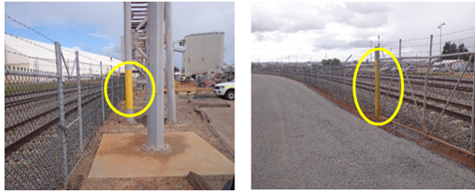

**Note:** The 15 metre distance has been delineated on both sides of the Security Gate 4 railway crossing by yellow painted markings on the fence line to the north and pedestrian overpass to the south.

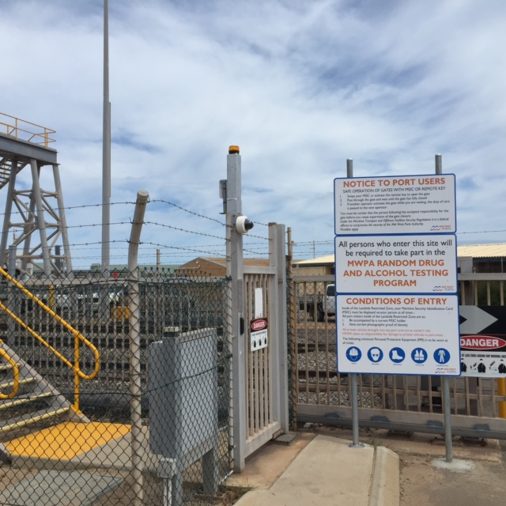

Amber Light will be flashing when Train has activated the automated train alarm / lock out system.

# OTHER RAIL CORRIDOR ACCESS

## Other rail corridor access may be granted subject to a specific need and requirement. In such circumstances this access must be controlled and managed by a person suitably qualified in rail safe working Protection Officer Level 2 or hold MWPA TLIW2001A (Protection Officer). In all circumstances such access may only take place with the prior knowledge and authorisation of the port Rail Terminal Co-ordinator.

## In most cases an F4.1k Application for Works in the MWPA Rail Corridor form will need to be completed 48 hours prior to the works being commenced. Details are available on the MWPA Website under Permit System.

In some instances a MWPA on-line induction may need to be completed. Details are available on the MWPA Website under HSE & MSIC Inductions.

# ASSOCIATED DOCUMENTS

F4.1k Application for Works in the MWPA Rail Corridor

# Administration

**Custodian:** General Manager Operations

**Approval:** Lindsay Morrison

General Manager Operations

**Date:** 21 November 2017