

EMERGENCY RESPONSE PLAN - OVERVIEW

EMR-PLN-001

UNCONTROLLED DOCUMENT
WHEN PRINTED

Approval and Implementation
Prepared by: | Ri´ziliens Pty Ltd
Version Number: | Version 1
Date of Approval: | 1/09/2017 |  | Date of Implementation: | 1/09/2017
Approved by: | Position: Mid West Ports Authority, Port of Geraldton –  Harbour Master
Approved by: | Name: | Harbour Master

Review and Amendments
Scheduled Review: |  | 1/9/2018 | Review Type: |  | Annual
Amendment History
# | Date | Amendments |  | Reviewed By
Version 2 | 1/9/2017 | - General update all sections.  - Update ERP 06 - Industrial/Transport Accident or Structural Instability  - Inclusion of ERP 19 Rail Terminal Incident.
Version 3 | 31/12/2018 | General update of all sections  Update now includes additional annexed Procedures |  | MWPA Emergency Response Committee
Version 4 | 22/2/2019 | Inclusion of biosecurity incident response  (ERP 20) |  | Harbour Master
Version 5 | 22/3/2019 | Remove reference to CEMP, change to Emergency Response Plan (ERP) |  | Harbour Master

Immediate Response to Emergencies for all Personnel

Quick Reference Plan Layout

TABLE OF CONTENTS
1 Introduction 7
1.1 Crisis & Emergency Management 7
1.2 Supporting and Related Documents 7
1.3 Purpose 8
1.4 Statutory Requirements 8
1.5 Definitions and Abbreviations 9
2 System Overview 11
2.1 Scope 11
2.2 Geographical Area of Responsibility 11
2.3 Participants in the Plan and their Responsibilities 11
2.4 Activities and Assets 12
2.5 Philosophy 12
2.6 Business Continuity Program Components 13
2.7 Objectives 13
2.8 Approach 13
2.9 Organisational Structures 14
2.10 First Responders 14
2.11 On Scene Commanders 15
2.12 Incident Management Team 15
2.13 Span of Control. 15
2.14 Crisis Management Team 17
2.15 Corporate Support Teams 18
2.16 Business Continuity Team 18
2.17 Relationship with Other Government Emergency Organisations 18
2.18 Defining an Emergency 19
2.19 Defining a Crisis 20
2.20 Vessel Place of Refuge 20
2.21 Emergency Command and Control 20
2.22 Relationship to WA Incident Levels 21
2.23 Communications during an Emergency or Crisis 22
2.24 Emergency Response Equipment 24
2.25 Training and Exercises 24
2.26 Audit and Review 25
3 Emergency Management Actions 26
3.1 Responding to an Incident, Emergency or Issue 26
3.2 Establishing the Incident Control Centre 27
3.3 Control Centre Locations 28
3.4 Confirm Structures and Roles 29
3.5 Incident Management Team Process 30
3.6 Crisis Management Process 33
3.7 Support Team Processes 34
3.8 Incident Action Plans 35
3.9 Incident Information Management 35
3.10 Guidelines for Dealing with Affected People. 35
3.11 Monitoring, Analysing and Responding to Traditional and Social Media. 36
3.12 Incident Reporting 38
3.13 IMT Shift Handover Procedures 40
3.14 Termination of an Emergency or Crisis 40
3.15 Clean-up and Recovery 40
3.16 Debrief 41
3.17 Incident Investigation 41
4 Attachment 1 – Duty Cards 42
5 Attachment 2 – Incident Display Boards and Forms 43
Main Events Log 44
Focus Board 45
Stakeholder Board 46
Affected Persons Tracking Board 47
Resource Tracking Board 48
Individual Log of Events 49
Message Taking Form 50
Media Release Template 51
AIIMS Briefing Form 51
6 Attachment 3 – Maps and Site Diagrams 53
Map 01 – Port of Geraldton Limits 54
Map 02 – Location and Layout of Geraldton Port 55
Map 03 – Emergency Evacuation and Equipment Locations 56
Map 04 – BHF Spill Kit Locations 57
Map 05 – Marine Fall Recovery Equipment Locations 58
Diagram 01 – Large Scale IMT Area Layout 59
7 Attachment 4 – Emergency Response Procedures 60
ERP 01 – Immediate Response to Emergencies for all Personnel 61
ERP 02 - Site Evacuation and Muster 62
ERP 03 - Medical Emergency 63
ERP 04 - Office/Structural Fire 64
ERP 05 - Dangerous Goods/Hazardous Material Release 65
ERP 06 - Industrial/Transport Accident or Structural Instability 66
ERP 07 - Confined Space Incident (Ashore) 67
ERP 08 - Working at Heights Incident 68
ERP 09 - Incident Involving a Ship 69
ERP 10 - Evacuation of Personnel from a Ship 71
ERP 11 – Aircraft Ditching in Port Waters 73
ERP 12 - Oil Spill/DG Release Into the Water 74
ERP 13 - Severe Weather 75
ERP 14 - Flood/Tidal Surge/Tsunami 77
ERP 15 - Earthquake 79
ERP 16 - Bomb Threat 80
ERP 17 - Armed Incursion/Security Breach 81
ERP 18 - Civil Disturbance 83
ERP 19 - Rail Terminal Incident 84
ERP 20 – Biosecurity Incident 85

LIST OF FIGURES

Figure 1 – BC Program Element Relationships 13
Figure 2 – MWPA CEM Organisational Structures 14
Figure 3 – Typical Port of Geraldton Incident Management Team 15
Figure 4 – Externally Augmented Incident Management Team 16
Figure 5 – Typical Port of MWPA Crisis Management Team 17
Figure 6 – Typical MWPA and Government Incident Management Interfaces 19
Figure 7 – Decision and Activation Process 26
Figure 8 – Establishing the Incident Control Centre 27
Figure 9 – Incident Management Process 30
Figure 10 – Crisis Management Process 33
Figure 11 – Telephone Responder Process. 34
Figure 12 – Corporate Communications Support Team Process. 34
Figure 13 – HR Support Team Process. 35

LIST OF TABLES

Table 1 – Supporting and Related Documents 11
Table 2 – Definitions and Abbreviations 14
Table 3 – WA Incident Levels and Indicative Port Responses 26
Table 4 – Key Command & Control Locations for Large Scale Emergencies 34
Table 5 – Default MWPA CMT and IMT Membership 35
Table 6 – Incident Management Process Responsibilities 38
Table 7 – Guidance on Incident Reporting Requirements 46

Introduction

Crisis & Emergency Management
The Mid West Ports Authority, Port of Geraldton (MWPA PoG) Emergency Response Plan (ERP) (this document) and the EMR-PLN-004 Crisis Management and Business Continuity Plan form part of the Business Continuity (BC) programme which is designed to ensure that:
- MWPA PoG is able to respond promptly and appropriately to a crisis or emergency event;
- Critical business functions can be maintained or restored in a timely fashion in the event of a material business disruption; and
- The financial, legal, reputational and other consequences arising from the disruption are minimised.
The document is structured into two distinct elements as follows:

- The ERP - detailing the general function of Emergency Response arrangements; and
- Attachments/Appendices - components of the ERP that are regularly reviewed i.e. Contact Lists, Equipment Lists, etc.
Where detailed information is not provided in the ERP, direction to the related documentation is provided in the table below or in the text of the plan.

Supporting and Related Documents
The following table outlines relevant documents associated with the MWPA Preparedness, Prevention, Response and Recovery program.
Table 1 – Supporting and Related Documents
Document Reference | Title | Custodian
HSE-PLN-002 | Occupational Health and Safety Management Plan | Safety Manager
HSE-PLN-001 | Environmental Management Plan | Sustainability Manager
EMR-PLN-002 | Emergency Contact Directory | Harbour Master/ Marine Manager/Security Officer
EMR-PLN-003 | Oil Spill Contingency Plan | Harbour Master/Marine Manager/Security Officer
EMR-PLN-004 | Crisis Emergency and Business Continuity Plan | GM – Trade & Corporate Services
EMR-PLN-005 | Information Systems Disaster Recovery Plan | Corporate Information Manager
EMR-PLN-006 | Disaster Management Plan for Hard Copy Records | Corporate Information Manager
EMR-PLN-007 | Building Evacuation and First Aid | Safety Manager
HSE-WI-005 | Contractor and Worker Requirements Handbook | Safety Manager
QMS-PRO-006 | Risk Management Procedure | Safety Manager
QMS-WI-004 | Media Liaison | GM – Sustainability, Culture & People
HSE-PRO-005 | Incident Reporting and Investigation | Safety Manager
HSE-PRO-013 | Waste Management Procedure | Sustainability Manager
HSE-PRO-009 | Wildlife Procedure | Sustainability Manager
MAR-SWP-003 | Vessel Quarantine Rubbish Disposal | Superintendent Landside Operations
EMR-PLN-004 | Crisis Management and Business Continuity Plan | GM – Trade & Corporate Services
MAR-SWP-007 | Bunkering by Road Tanker or Pipeline | Harbour Master/Marine Manager
RAI-PRO-003 | Rail Safety Management System Overview | GM –Operations
LSO-PLN-001 | Rail Terminal Security Plan | GM –Operations
No Ref. Confidential Document | Maritime Security Plan – Port of Geraldton | Harbour Master/Port Security Officer

Purpose
The purpose of this ERP is to describe the emergency response arrangements at the Port and to enable MWPA PoG, port users and emergency service personnel to manage an effective and safe response to emergencies within the Port’s limits. It provides guidelines for actions to be taken during an emergency to minimise the potential for loss of life, injury to people, and damage to the environment and property by covering foreseeable incidents and outlining response action.

Statutory Requirements
This Plan is administered by the MWPA PoG in accordance with its responsibilities as a Port Authority under the WA Port Authorities Act 1999 and Regulations and the WA Emergency Management Act 2005. Depending on the type of emergency, other legislation and standards may also be applicable, including:
- Pollution of Waters by Oil and Noxious Substances Act 1987.
- WA Occupational Safety and Health Act 1984.
- Navigation Act 2012.
- Biosecurity Act 2015.
- WA Mines Safety and Inspection Act 1994.
- WA Mines Safety and Inspection Regulations 1995 (specifically Regulation 4.30 – Preparation of Emergency Plan).
- WA Dangerous Goods Safety Act 2004.
- WA Environmental Protection Act 1986.
- Rail Safety National Law (WA) Act 2015.
The Plan also aligns to the principles set out in the following;
- AS3745-2010 Planning for Emergencies in Buildings.
- WA State Emergency Management Policy
- WA State Emergency Management Procedure
- State Emergency Management Committee – Suite of WestPlan Documents
https://semc.wa.gov.au/resources/legislation-and-policy-framework/plan/westplans
- International Ship and Port Facility Security Code.
- Marine Transport and Offshore Facilities Act 2003
- AMSA National Maritime Place of Refuge Risk Assessment Guidelines.
- Australasian Inter-service Incident Management System (AIIMS 4th Edition 2013).

Definitions and Abbreviations
The following definitions and abbreviations are used throughout this Management Plan.
Table 2 – Definitions and Abbreviations
Term / Abbreviation | Definition
AIIMS | Australasian Inter-service Incident Management System.  A system which integrates effective practices in emergency preparedness and response into a comprehensive framework for incident management. Such a system enables responders at all levels to work together more effectively to manage incidents no matter what the cause, size or complexity.
AMSA | Australian Maritime Safety Authority.
BC | Business Continuity.
BCP | Business Continuity Plan.
BCT | The Business Continuity Team (BCT) manages the return to business as usual. It may take over from or be formed by members of the IMT.
BCT Leader | Leads the Business Continuity Team in the recovery of the critical business function. They liaise with the IMT and CMT.
BIA | Business Impact Assessment (BIA) is a component of business continuity planning that helps to identify business critical and non-critical processes or functions.
CA | Controlling Agency: The agency nominated (through legislation or by agreement with the HMA) to control the response activities to an incident. A Controlling Agency may not be the prescribed HMA but a HMA will always be a Controlling Agency. For oil spills in Port Waters, PoG is the CA.
CEO | Chief Executive Officer (MWPA)
CMT | The Crisis Management Team (CMT) manages the corporate, reputational and communications impacts for the organisation. It provides strategic direction and assistance to both the IMT and BCT.
CMT Leader | The CMT Leader will usually be the Chief Executive Officer or delegate.
CMT Room | The location where the CMT convenes to provide strategic guidance to an incident or issue.  Primary Location = CEOs Office, Admin Building 298 Marine Terrace, Geraldton.  Alternate Location = 5 Chapman Road, Geraldton.  Virtual Meetings = The CMT may convene via telephone or video conference with the Perth office or when members are travelling away from Geraldton  Specific details of area layouts and room content are contained in this plan.
Crisis | A crisis or potential crisis is an incident or issue that may significantly affect either the legal and financial liability, future operability, profitability or reputation of MWPA.
DAWR | Department of Agriculture and Water Resources
DFES | Department of Fire and Emergency Services
DWER | Department of Water and Environment Regulation
DMIRS | Department of Mines, Industry, Regulation and Safety
DPIRD | Department of Primary Industries and Regional Development
DoT | Department for Transport.
DoBCA | Department of Biodiversity Conservation and Attractions
EAP | Employee Assistance Program. Contracted service provider which assists with supporting affected people through counselling and post incident psychological support services.
Emergency | The occurrence or imminent occurrence of a hazard which is of such a nature or magnitude that it requires a significant and coordinated response.
EM | Emergency Management
ER | Emergency Response
ERP | Emergency Response Procedure. Detailed and pre-planned immediate actions taken in response to an emergency (Attachment 4 of this plan).
First Responders | First Responders, usually MWPA PoG personnel (or other on scene personnel) will carry out local response activities, such as basic first aid/medical assistance, basic fire-fighting, casualty assistance, oil spill response, and assistance with search and rescue.
HMA | Hazard Management Agency (HMA). An organisation which, because of its legislative responsibility or specialised knowledge, expertise and resources, is responsible for ensuring that all emergency management activities pertaining to the prevention of, preparedness for, response to and recovery from a specific hazard are undertaken.
IAP | Incident Action Plan: The plan used to describe the incident objectives, strategies, resources and other information relevant to the control of an incident.
IC | Incident Controller: Leads the Incident Management Team and is responsible for the management of all incident control activities in an emergency.
ICC | Incident Control Centre (ICC). The location where the Incident Controller and members of the Incident Management Team provide overall direction of response activities in an incident.  Primary Location = Board Room, 1st floor Admin Building 298 Marine Terrace, Geraldton and adjoining offices.  Alternate Location = 5 Chapman Road Board Room.
IMT | The Incident Management Team (IMT) manages the overall emergency response, operational and technical issues arising from an emergency event.
NEC | Nominated Emergency Contacts (NEC). A person nominated to be informed in the event of an emergency. This may be but is not necessarily the Next of Kin (see below).
NOK | Next of Kin (NOK). A person's closest living blood relative or relatives.
OSC | The On Scene Commander (OSC) commands all emergency response operations at or close by the event location. The OSC is normally the senior MWPA PoG person at any affected location, or a person mobilised by the Incident Management Team to take control of the affected area.
MERCOM | Maritime Emergency Response Commander (MERCOM) is responsible for the management of emergency intervention issues in response to a maritime casualty. The MERCOM is appointed by AMSA and is supported by statutory powers under the Protection of the Sea (Powers of Intervention) Act 1981.
MWPA | Mid West Ports Authority.
MWPA PoG | Port of Geraldton.
SDS | Safety Data Sheet (Formerly Materiel Safety Data Sheet - MSDS).
SEMC | WA State Emergency Management Committee

System Overview

Scope
This Plan applies to all emergencies associated with operations under the control of MWPA PoG under the Port Authorities Act 1999 and the geographical area outlined in section 2.2 below, with the exception of:

- Marine oil spills which are covered by the Oil Spill Contingency Plan (OSCP): and
- Security events covered under the Maritime Security Plan (MSP).

Geographical Area of Responsibility
The geographical area covered by the Plan encompasses both onshore and offshore areas.
The offshore area is defined under the Port Authorities Act 1999. Geraldton Port waters encompass moorings, breakwaters, navigational channel, harbour basin and port boundary (see Attachment 3, Map 01). This area covers coastal and offshore waters designated as Port Limits for PoG in Western Australia.
This Plan also covers onshore areas designated as Port Limits for PoG in Western Australia, including port buildings and facilities (see Attachment 3, Diagram 1) as follows:
- Port operation services for users of the commercial shipping precinct - marine services, road and rail unloading facilities; bulk handling facilities including conveyors, ship loaders and fuel pipelines; general supply of services including power, water, sewer and roads; Port developments and upgrades.

- Fishing Boat Harbour infrastructure - boat pens, wharves, refuelling facilities, power, water, communications and sewage services, and navigational aids.

Participants in the Plan and their Responsibilities
All Port Users, local Emergency Services and relevant local and state government bodies will be considered participants in the MWPA PoG EMP. All parties will be responsible for their own domestic arrangements necessary to give effect to the action required under the plan.
All lease holders, port facility operators, rail companies and main contractors (including stevedoring companies) which operate within the Port are responsible for ensuring that their own Emergency Response Procedure (ERP) and its components are kept up to date. In particular, all ERPs must:
- be capable of responding to any incident which may affect their operation within the Port;
- include an evacuation Plan
- be tested during its currency
- be held in the appropriate incident centre.
- be detailed in the composition of personnel at the location and the interfaces with other Incident Response organisations including Police, Fire and Medical support authorities;
- contain procedures for the reporting of incidents to HMA, MWPA PoG and to any other relevant authorities required by legislation;
- contain procedures and identify resources that provide an effective response to identified emergencies,
- comply with all safety standards and requirements of law.

Activities and Assets
The range of activities and assets that may be impacted by an emergency event include:
- all marine vessels associated with MWPA PoG’s operations;
- all landside assets owned and operated by the MWPA PoG;
- all operations/services under contract to the MWPA PoG i.e. Berth 6 fire services, stevedoring and towage operations;
- construction projects; and
- Offices, warehouses, storage sheds and lease sites.

Philosophy
The MWPA PoG recognises the ‘Comprehensive Approach’ adopted by the State and Federal Governments for incident response and disaster management, namely preparedness, prevention, response and recovery and applies typical measures under this program that include:
1. Preparedness:  - Staff training/awareness/education  - Crisis and Emergency Managements and Response Procedures  - Training/Exercises  - Incident Communications  - Evacuation Plans  - Mutual Aid Agreements  - Warning Systems  - Resource Inventories  - Provision of special resources/equipment. | 2. Prevention:  - Facility management  - Safety Management Systems  - System, OHS Regulations  - Safety improvement programs  - Legislation  - Information staff awareness and education  - Incident equipment  - Detection systems  - Failsafe systems.
3. Response:  - Implementing Plans  - Implementing Incident Procedures  - Issuing Control Notices  - Activating Incident Control Centres  - Mobilising resources  - Notifying Public Authorities  - Providing medical assistance  - Providing immediate relief  - Political and Commercial Interests  - Search and Rescue. | 4. Recovery:  - Restoring essential services  - Staff and Environmental rehabilitation  - Counselling Programs  - Support and Assistance plans  - Health and Safety information  - Long term medical care  - Physical restoration and reconstruction  - Public information  - Conducting economic and environmental studies.

Not all of these measures are likely to be relevant in every incident. The hazard, the incident and the nature of their interaction will determine which are appropriate. However, due to the nature of the risks within the area of the MWPA PoG’s responsibility, the need for preparedness, prevention, response and recovery planning will remain constant.

Business Continuity Program Components
The components of the BC program are not independent processes or phases and they may need to be managed concurrently to minimise impact, ensure continuity and expedite business recovery. The following diagram illustrates this relationship noting that the timings in the example are indicative only.
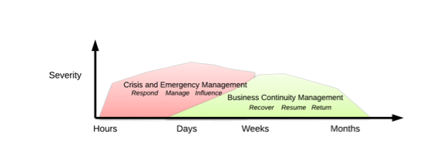
Figure 1 – BC Program Element Relationships

Objectives
In the event of an emergency or business interruption, the key objectives of the BC program are to protect and preserve:
- life and the safety of MWPA PoG personnel, contractors and the public associated with or affected by our operations;
- the environment, heritage and cultural resources;
- minimise the effect on Port assets including berths and channel;
- continuity of Port services and operations;
- the reputation of MWPA PoG; and
- contractual and commercial arrangements.
AIIMS doctrine encourages Management by Objectives during an emergency. In essence this means, determining what your objectives (desired outcomes of the event) are. Once you have your objectives, identify the threats to these objectives and formulate an action plan with tactics to overcome the threats.

Approach
The key elements of MWPA PoG’s CEM program are:
- understanding the overall context within which MWPA PoG operates and its critical objectives;
- identifying the threats or interruptions that may be faced in achieving these objectives;
- quantifying the disruptive impact of these events on critical business functions and processes;
- identifying the infrastructure and resources required to enable MWPA PoG to continue to operate at a minimum acceptable level;
- developing practical recovery plans which describe how MWPA PoG will continue to achieve its objectives should potential interruptions occur;
- testing and measuring controls and other mitigation strategies;
- ensuring that all staff understand their roles and responsibilities in the event a major disruption occurs;
- ensuring adequate resourcing in the event of an emergency.

Organisational Structures
MWPA PoGs CEM program comprises four key elements:
- Emergency Response – first responders and On Scene Commander;
- Emergency Management – Incident Management Team;
- Crisis Management – Crisis Management Team; and
- Business Continuity Management – Business Continuity Team(s).

Generally, the structure and relationship of each element will follow the process outlined in Figure 2. However, the composition of each element and the respective teams will depend on the nature and severity of the event and should be customised to accommodate the exact situation, and availability of relevant team personnel. In some instances, the response structure will comprise of, or coordinate closely with, affected port users and external emergency service providers as outlined in Figure 6.
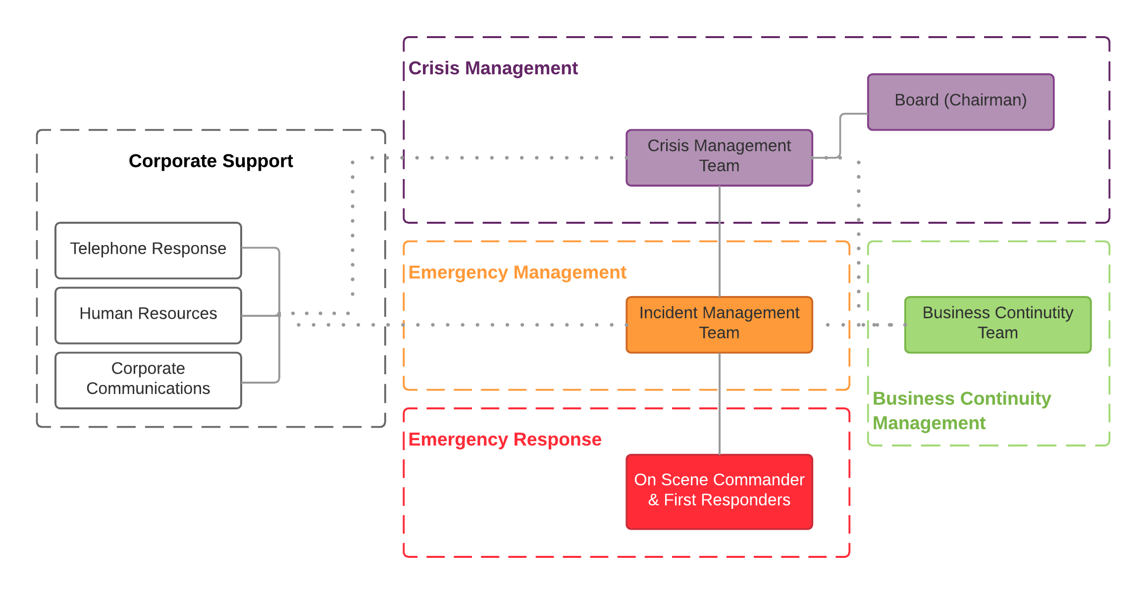
Figure 2 – MWPA CEM Organisational Structures

First Responders
The initial response will comprise First Responders, usually MWPA PoG personnel (or other on scene personnel) who will carry out local response activities, such as basic first aid/medical assistance, basic fire-fighting, casualty assistance, oil spill response, and assistance with search and rescue.
First Responders also have a role to play in assessing the potential consequence of the disruption event and determining whether the IMT is required.
In many cases, Port users, landside and marine side will contribute to, or may have primary responsibility for, response and recovery activities depending on the location of the incident.
Land based emergency response is heavily reliant upon assistance from external emergency services such as police, ambulance and fire, i.e. the Department of Fire and Emergency Service (DFES).
Vessel masters are responsible for emergency management and emergency response on board vessels, and may seek Port or external assistance as required.

On Scene Commanders
The First Responders are led by the On Scene Commander (OSC). The OSC commands all emergency response operations at or close by the event location. The OSC is normally the senior MWPA PoG person at any affected location (initially an appointed Assembly Area Marshall or Supervisor), or a person subsequently mobilised by the Incident Management Team to take control of the affected area.
The OSC is the ‘eyes and ears’ of the Incident Controller and directs the First Responders and the workforce and provides reports back to the IMT/Incident Controller. Figure 3 shows the initial response structure.

Incident Management Team
The IMT is led by the Incident Controller and is structured in accordance with the Australasian Inter-service Incident Management System (AIIMS). Figure 3 sets out an indicative IMT structure. It is important to note that the AIIMS structure is designed to be adaptable and scalable to suit the specific nature of the incident. A tailored approach to structuring the IMT at MWPA PoG is set out below and further described at the Levels of Response section and in Table 3.
The core IMT is based on the principle of Functional Management - the utilisation of specific functions to manage an emergency. The IMT utilises the following four functions:
- Control - The management of all activities necessary for the resolution of an emergency;
- Planning - Development of plans for the recovery from an emergency;
- Operations - The tasking and application of resources to achieve resolution of an emergency; and
- Logistics - The acquisition and provision of human and physical resources, facilities, services and materials to support the achievement of the objectives.

Span of Control.
During emergencies, the environment in which supervision is required can rapidly change and become dangerous if not managed effectively. Under the principle of span of control, up to five reporting groups or individuals is considered to be desirable. Where span of control is exceeded, the supervising officer should consider delegating responsibility to others. Conversely, where the span of control is lower, or the tasks are fewer (for example in a de-escalating emergency), the Supervisor may reassume responsibility or reorganise delegation to contract the structure to fit the tasks required. Depending on the scale of the event, the IC may hold all of these functional roles or delegate the functions as required.
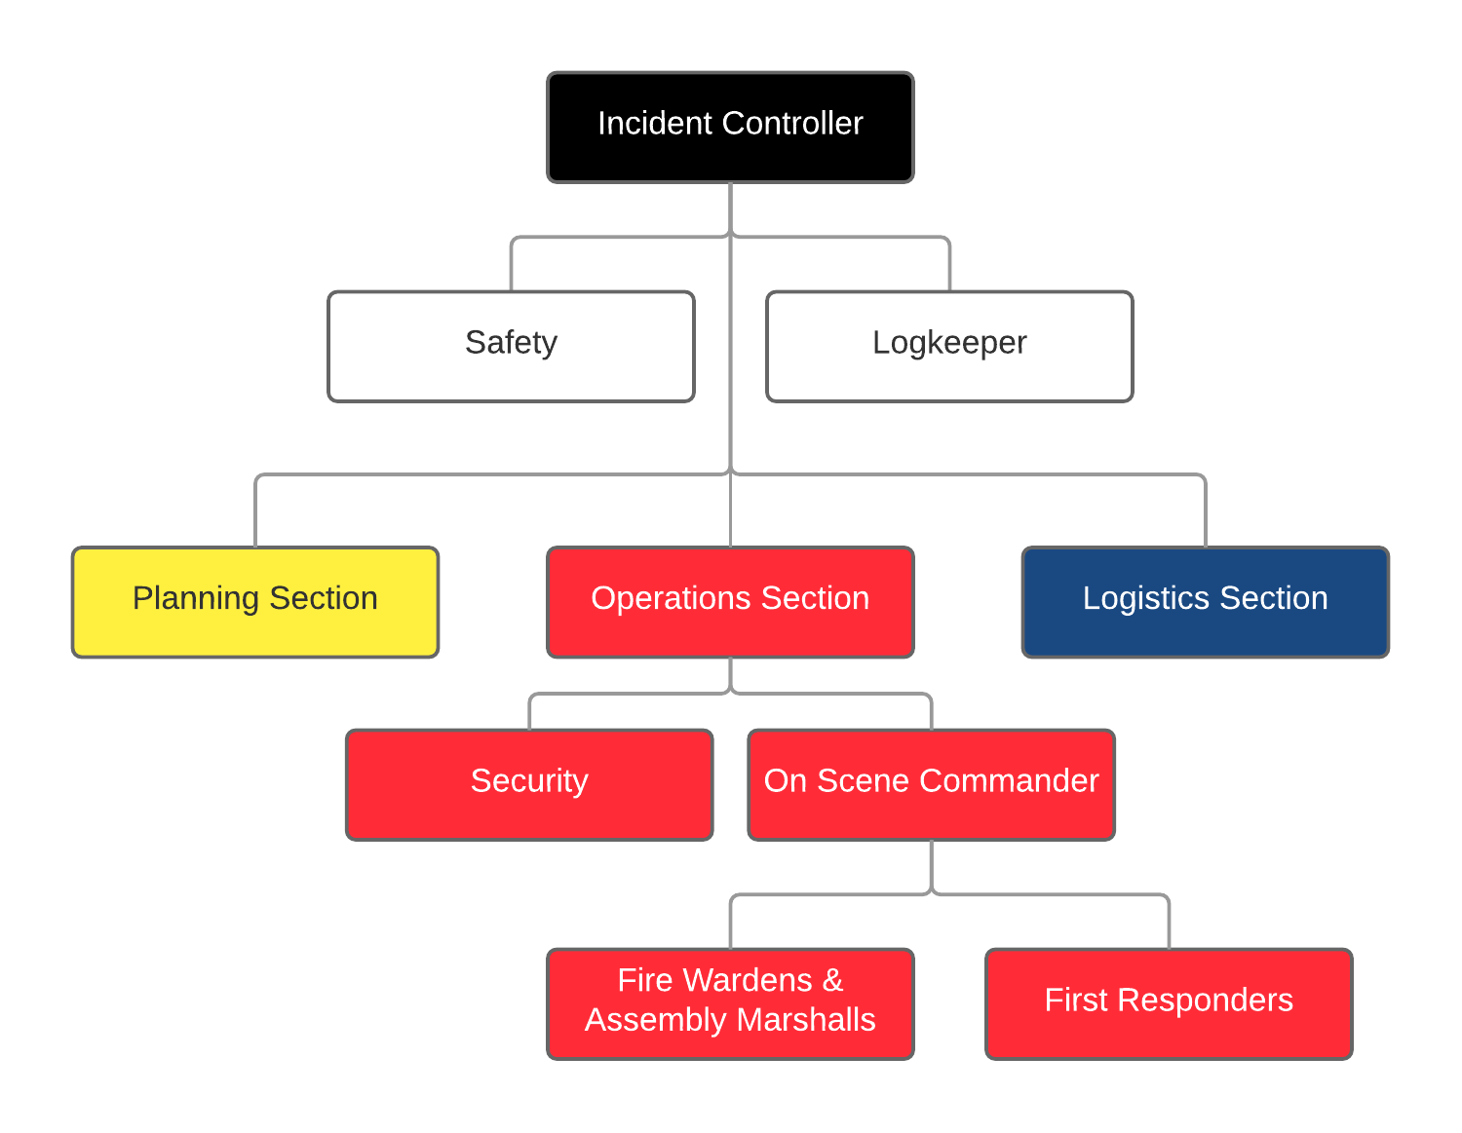
Figure 3 – Typical Port of Geraldton Incident Management Team
For large scale incidents, the Expanded IMT may act on behalf of the State or the appointed Hazard Management Agency, as a Controlling Agency, for example, oil spills or transport emergencies, or the IMT may be lead or assisted by State (i.e. WA Police, DFES, Department of Transport) and Federal (Australian Maritime Safety Authority or [AMSA]) response teams in the event of protracted incidents. The structure below depicts an IMT as set out in WestPlan Marine Oil Pollution and is considered the most likely to be used for a protracted oil spill event at the MWPA PoG supported by external personnel.
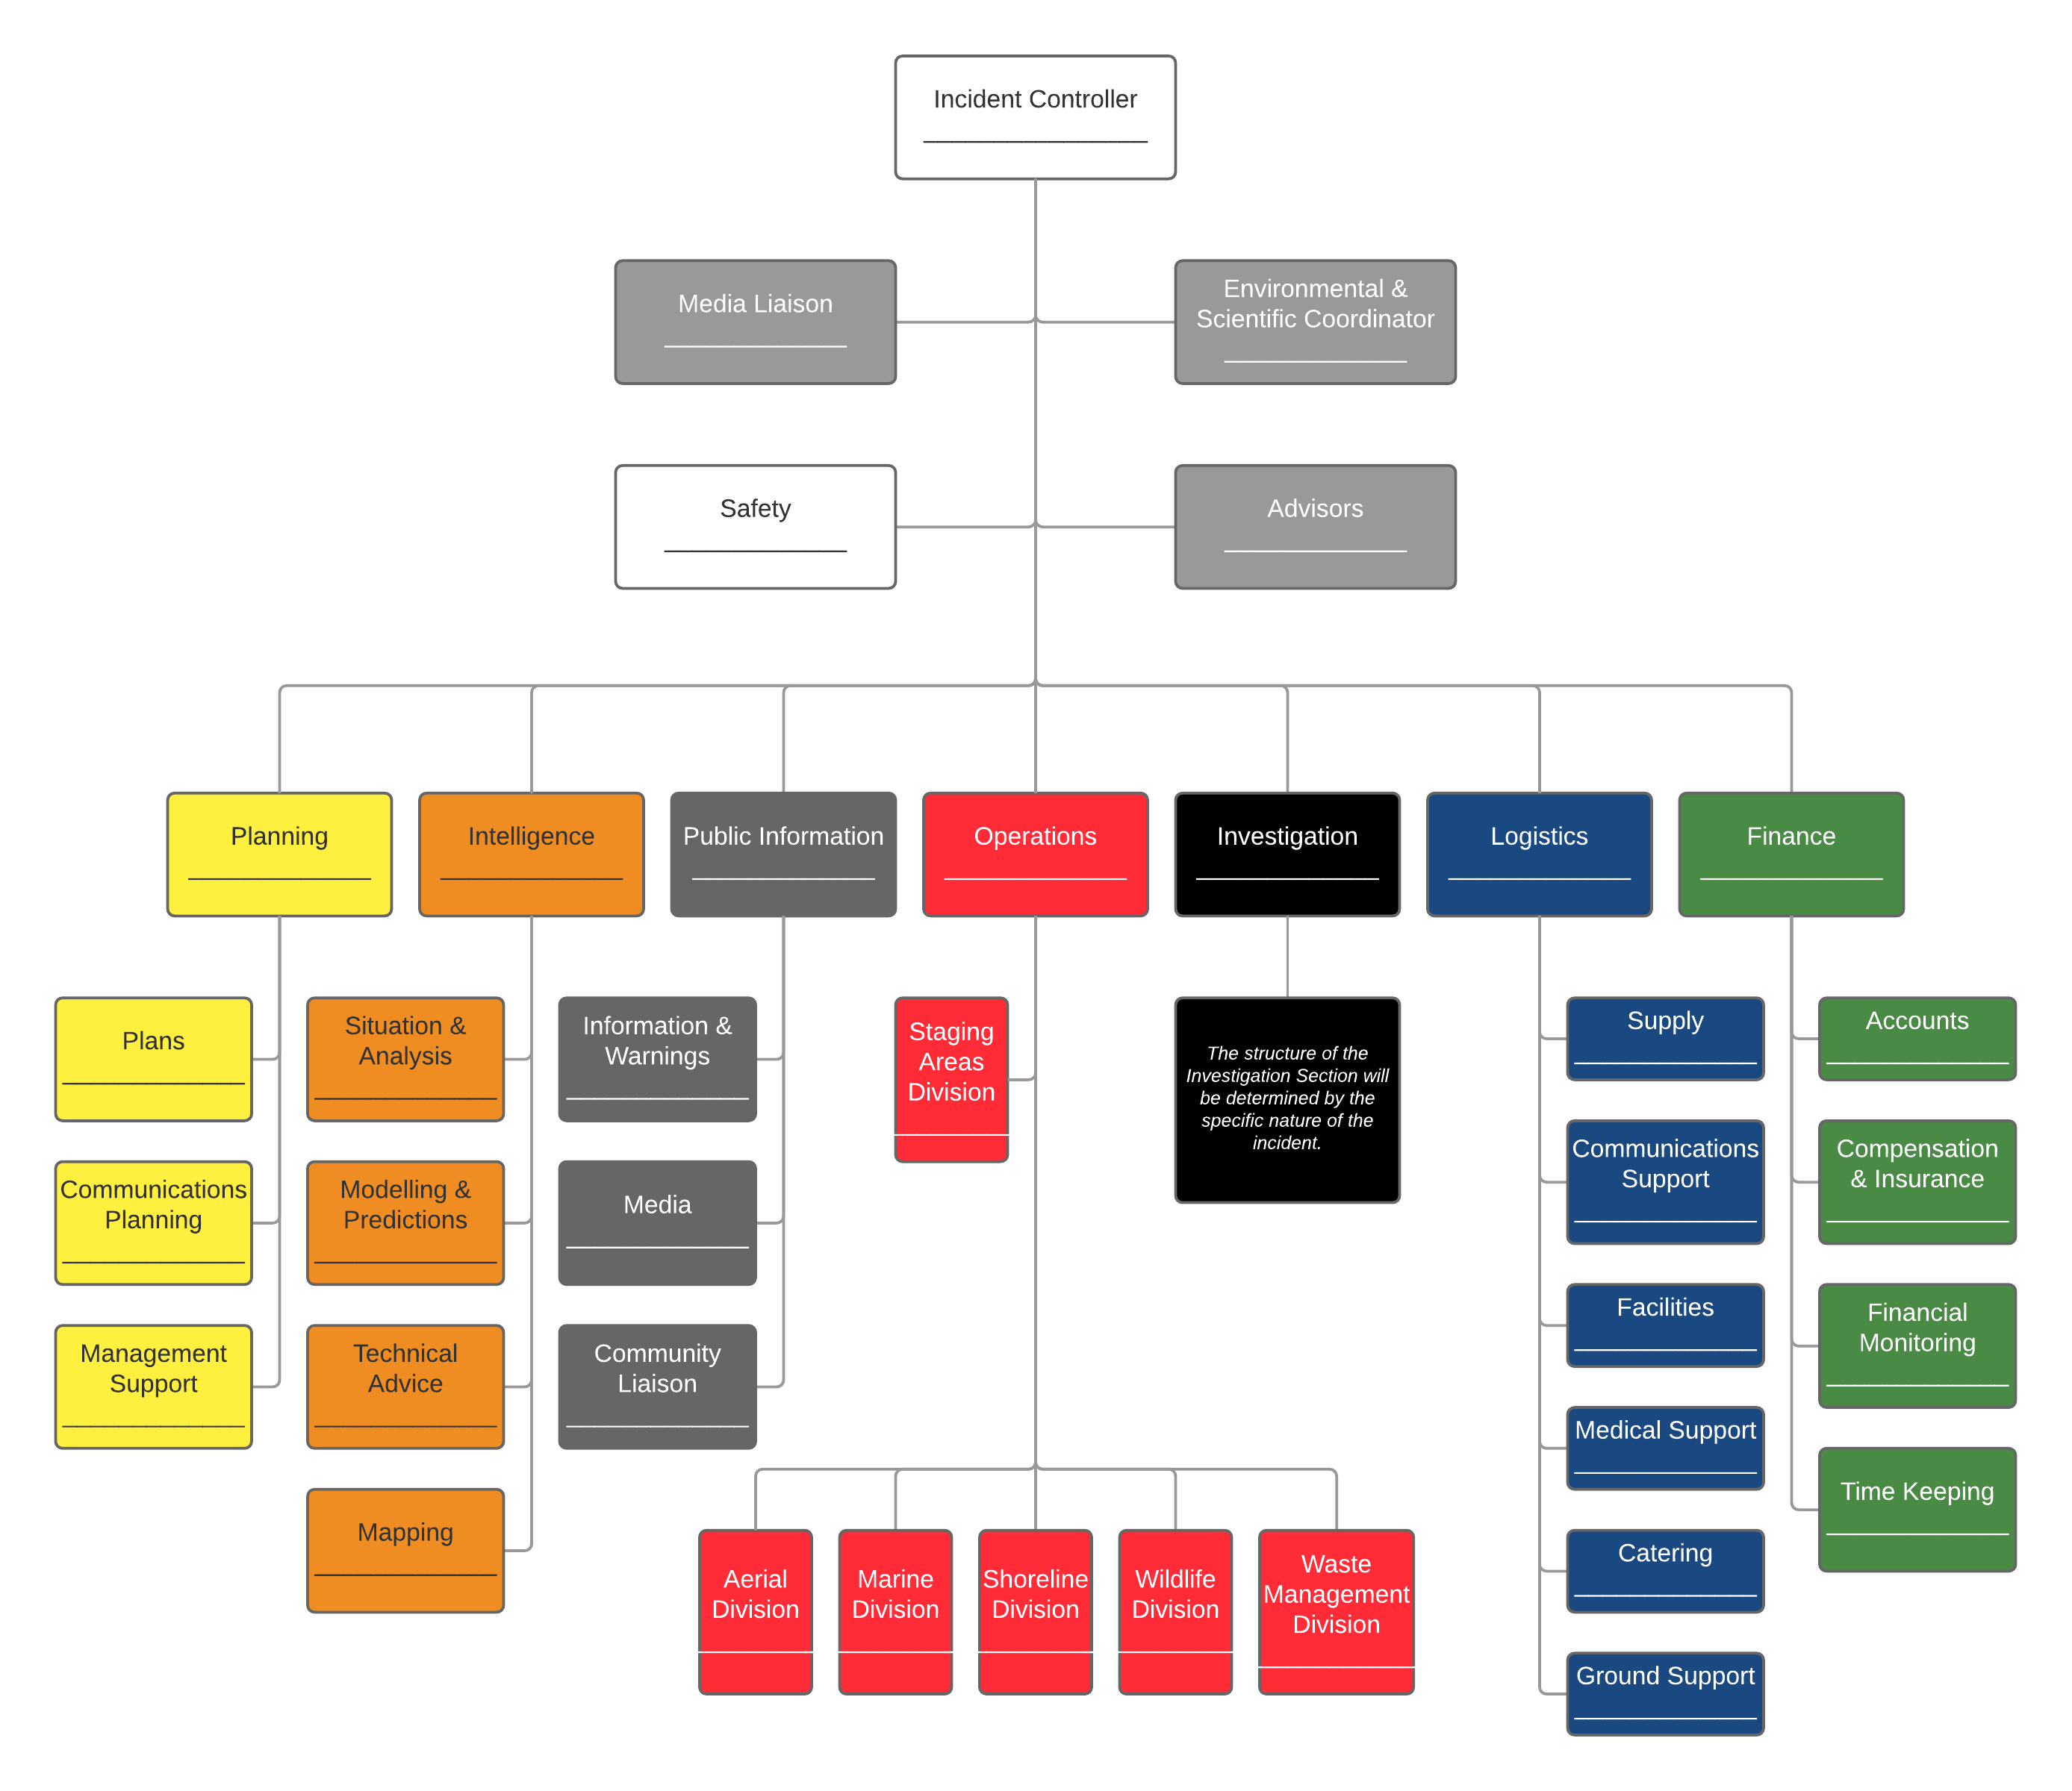
Figure 4 – Externally Augmented Incident Management Team

The role of the IMT includes:
- Managing operational and technical tasks arising as a result of an emergency;
- Third party coordination;
- Providing technical and logistical support to the On Scene Commander;
- Monitoring the situation to determine if it requires the activation of the Crisis Management Team (CMT); impacts a business critical function(s) and requires the activation of the Business Continuity Team (BCT) and relevant Business Continuity Procedure (BCP); and
- Provides regular information updates to the executive, or CMT if invoked.
The MWPA PoG Harbour Master is the nominated Incident Controller for on/water incidents with the General Manager - Operations being responsible for landside incidents, dependant on availability and the nature of the incident.

Crisis Management Team
The Crisis Management Team (CMT) will be led by the MWPA Chief Executive Officer (CEO) or appointed delegate and will comprise a number of functional disciplines, having regard to the nature of the issue. A typical CMT is depicted in Figure 5.
The CMT may be partially or fully activated in response to a crisis which comes from an emergency and is escalated directly by the IMT, or a crisis which has no underlying emergency event (e.g. a reputation or governance issue).
The CMT focuses incidents or issue that may significantly affect legal and financial liability, future operability, profitability and reputation of MWPA. The CMT is not responsible for managing operational and technical issues as this is the focus of the IMT and/or BCT. The primary objectives of crisis management are to:
- Maintain corporate control and minimise impacts on the organisation and stakeholders;
- Provide executive leadership to the IMT and Business Continuity Team (BCT);
- Define strategies on both internal and external stakeholder management and the flow of information; and
- Protect the reputation of the MWPA PoG.
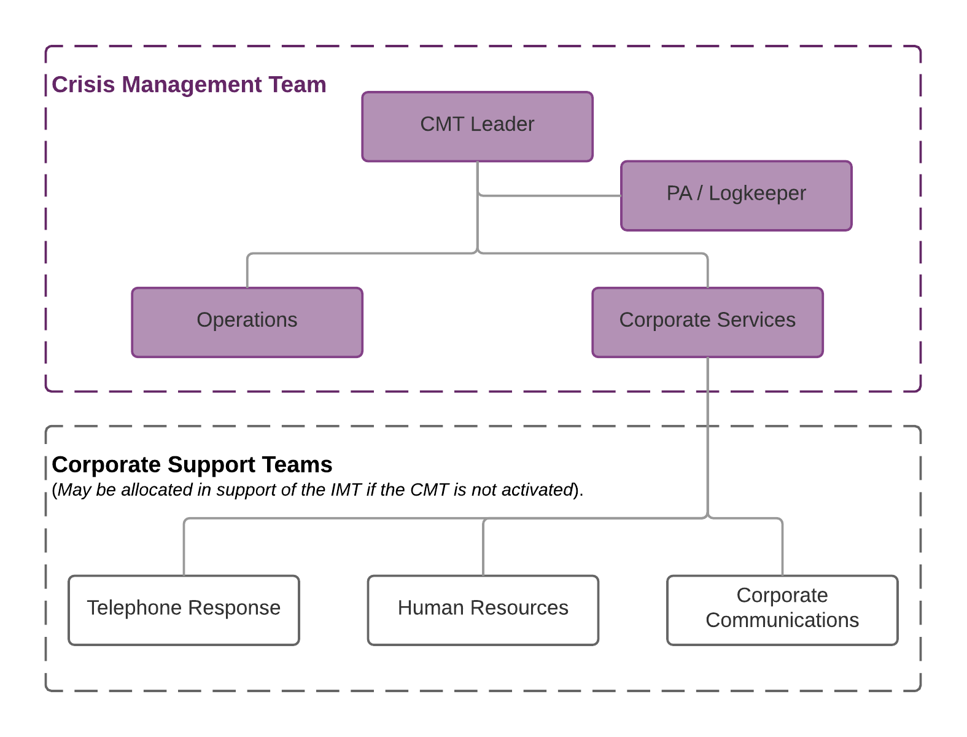
Figure 5 – Typical Port of MWPA Crisis Management Team

Corporate Support Teams
The IC may request additional MWPA PoG staff support in the form of support teams to provide:
- Corporate communications to engage media, government, port users, employees and other relevant stakeholders;
- HR support and resources; and
- Telephone response to receive enquiries from the media, customers, advisors, and the wider public in addition to arrangements established by the IMT.
These teams may transfer support to the CMT if convened or become part of the Augmented IMT in areas such as Public Information and Planning.

Business Continuity Team
Business continuity management is concerned with ensuring that critical business functions that are subject to a disruptive event or ‘outage’ are managed and recovered in line with EMR-PRO-004 Crisis Management and Business Continuity Plan.
A BCT (inclusive of the IT Disaster Recovery Team [IT DRT] if required) will lead the management and recovery of impacted critical business functions.
In most circumstances, the appointed BCT Leader will be the respective functional area manager with support provided by the respective areas personnel.
As soon as an outage or potential outage is identified, the BCT should be activated, usually at the request of the IMT, however may also be activated by the CMT. The BCT will invoke the required BCP and then work closely with the IMT and or CMT. The BCT will lead the recovery and eventual restoration of the effected critical function in accordance with the relevant BCP(s).

Relationship with Other Government Emergency Organisations
Any significant event will be managed by standing government Emergency Management structures. The response will be predominantly coordinated through the WA Police, DFES or the Department of Transport (Marine Safety) in accordance with State Emergency Management Plans. MWPA PoG may be required to lead, interface or augment these organisations to ensure appropriate arrangements are implemented within the defined disaster recovery strategy.
AMSA is the Statutory and Combat Agency responsible for responding to oil and/or chemical spills in Commonwealth waters, except in those incidents close to shore when oil or chemicals are likely to impact the shoreline. In these circumstances, the State via the Department of Transport will be the Jurisdictional Authority for protecting the coastline while AMSA assumes responsibility for ship operational matters (for example, containing the spill within the ship, organising salvage and the like). The interface is depicted below.
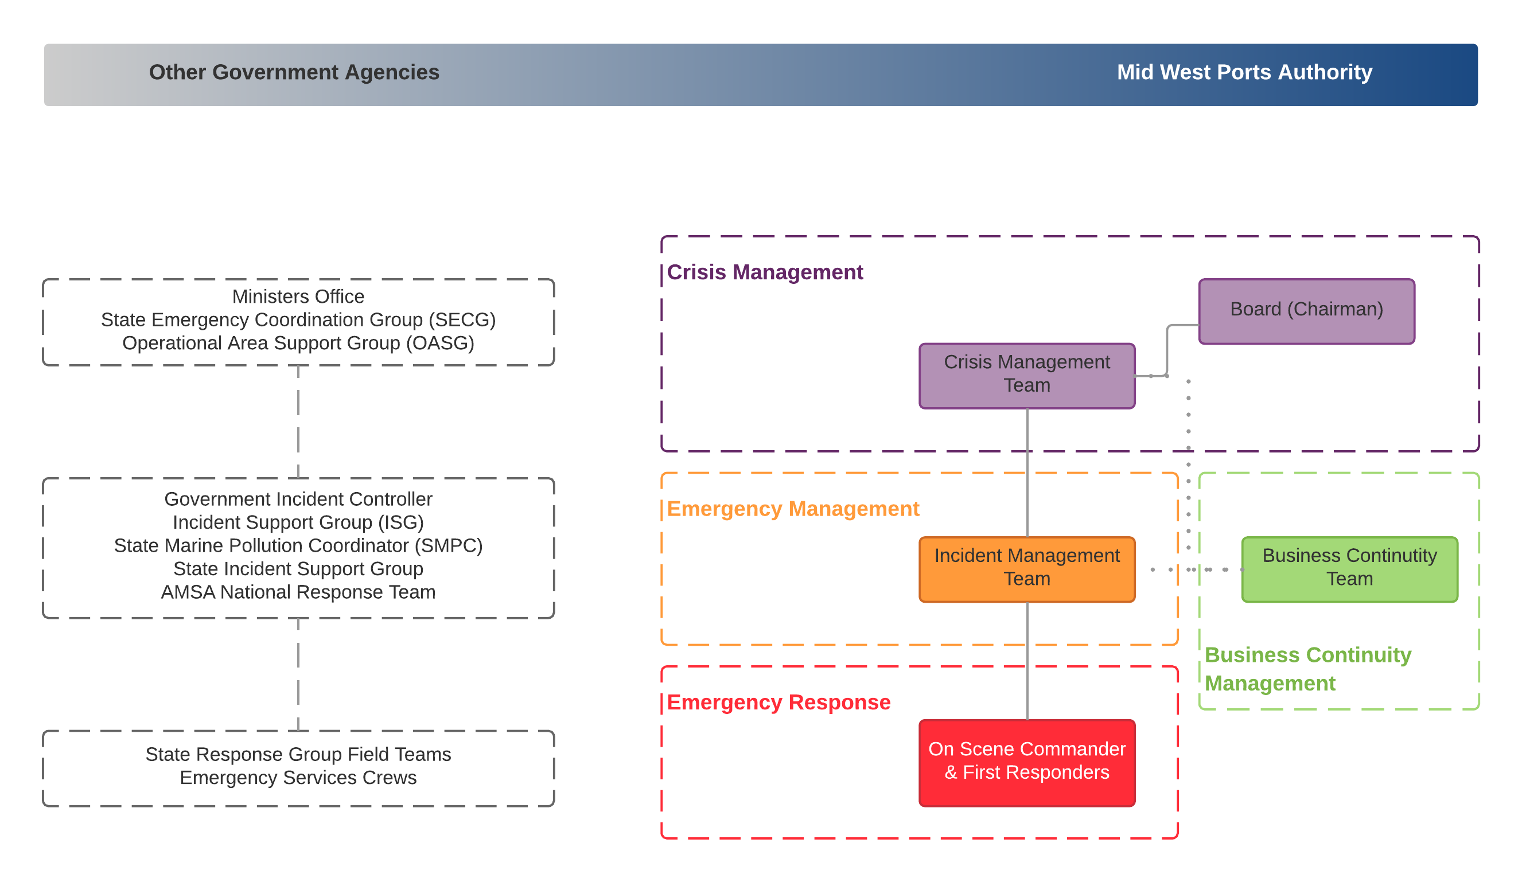
Figure 6 – Typical MWPA and Government Incident Management Interfaces

Defining an Emergency
An emergency is defined as an event, actual or imminent, which endangers or threatens to endanger life, property or the environment, and which is beyond the resources of a single organisation to manage or which requires coordination of a number of significant emergency management activities.
For emergencies within the MWPA PoG geographic area of responsibility, the IC will be responsible for defining the level of the emergency and response required.
This plan has been produced to provide guidance in the event of the following potential emergencies:
- Security threats:  - Bomb threat;  - Armed intrusion;  - Civil disturbance.  - Natural disasters:  - Bushfire;  - Earthquake;  - Flood/tidal surge/tsunami;  - Severe storm.  - Shipping emergencies or threats. | - Accidents:  - Medical emergency;  - Personal injury;  - Casualty in a confined space.  - Industrial:  - Rail/transport accident;  - Structural instability.  - Fires.  - Dangerous Goods or chemical spillage or gas leak.

Separate response procedures have been developed at Attachment 4 of this plan to assist in responding to these emergencies.

Defining a Crisis
A crisis or potential crisis is an incident or issue that may significantly affect either the legal and financial liability, future operability, profitability or reputation of MWPA. Crisis management is MWPAs strategic response to a crisis situation.

Vessel Place of Refuge
The National Maritime Place of Refuge Risk Assessment Guidelines is an arrangement, agreed by the Commonwealth, State and Northern Territory governments, for the management of requests for, or circumstances that require a place of refuge.

All place of refuge requests should, as far as practically possible, be made through AMSAs Rescue Coordination Centre (RRC Australia). Within Australia, only a State or Northern Territory government agency or AMSA has the authority to assess and grant a place of refuge request from a vessel.

The Marine Safety, General Manager, DoT will represent the WA government in matters pertaining to the assessment or granting of a place of refuge request during an MTE, particularly in relation to dealings with the AMSA through the Maritime Emergency Response Commander (MERCOM).

Further details on Place of Refuge arrangements are outlined in AMSA National Maritime Place of Refuge Risk Assessment Guidelines.

Should the Port of Geraldton receive a request from a vessel for a Place of Refuge, the request shall immediately be referred to the relevant Authority.
- For vessels within 3 nautical miles (coastal waters), the request shall be directed to the Department of Transport (Marine Safety) as per the details at Attachment 5 – Emergency Contact Directory.
- For vessels beyond 3 nautical miles (coastal waters), the request shall be directed to AMSA Rescue Coordination Centre (RCC) as per the details at Attachment 5 – Emergency Contact Directory.
- The Harbour Master to liaise with MERCOM

Emergency Command and Control
MWPA PoG Incident Controller
The MWPA PoG Incident Controller may assign duties as described in the Duty Cards.
- The MWPA PoG Incident Controller may, depending on the nature of the potential threat, request the assistance of the emergency services via a direct telephone call on ‘000’.
- Regardless of the Emergency, the ‘000’ operator may also be requested to notify the Police. Control of Level 2 or Level 3 incidents, will usually be assumed by the Emergency Services when they arrive unless it is an oil spill and MWPA PoG is the designated Control Agency.
- The MWPA PoG Incident Controller will continue in a supportive role as required in any incident.
Landside Evacuation
In the event of an evacuation, the MWPA PoG Incident Controller will coordinate the evacuation.
Shipping Incidents
For incidents on board a ship the Harbour Master (MWPA PoG Incident Controller) will co-ordinate the response between the ships Master and the emergency services.
- The Harbour Master/Marine Manager, for the purpose of performing his or her principal functions, may direct the owner, master, or person in charge of a vessel to comply with the requirements as detailed in Part 7, Division 3, Section 104 to 109 of the WA Port Authorities Act.
- The Master of each vessel is at all times responsible for the safety of that vessel. Actions within this plan that require action by the Master or crew shall only be carried out with full agreement of the vessel’s Master as applicable.
- Nothing in this plan shall override any decisions or actions taken by the Master, Harbour Master/Marine Manager, or Duty Pilot in order to preserve the safety of life, safety of equipment, or protection of the environment.

Relationship to WA Incident Levels
The WA State Emergency Management Committee (SEMC) Policy and State Emergency Response Procedure 2 – Incident Level Declaration -classifies incidents into three levels of response. The Policy recognises that there will be some overlap between levels and therefore the Incident Controller will determine the incident level based on the actual and/or potential impact of the incident.
The Emergency Management capability at MWPA PoG is capable of controlling or contributing to incidents across all three levels. Table 3 provides guidance on aligning capability and response options between MWPA PoG and State arrangements. The ‘typical conditions’ listed in Table 3 are provided for consideration only, and the escalation of an incident is at the discretion of the Incident Controller in consultation with appropriate internal or external stakeholders.
Table 3 – WA Incident Levels and Indicative Port Responses
WA SEMC Policy Level | Indicative MWPA Response
Level 1 Incident:  There are no significant issues;  There is a single or limited multi agency response (day to day business);  The incident area is limited in extent (i.e. to one jurisdiction/district);  Response duration is within a single shift of the Controlling Agency;  Resources can be sourced from one local government district;  There is minimal impact on the community and critical infrastructure;  The incident can be managed by a Controlling Agency IMT only;  There is little potential for incident escalation; and  There is a low level of complexity. | First Responders and OSC activated, IC with possible scaled IMT activated. MWPA CMT notified and briefed.
Level 2 Incident:  Requires a multi-agency response;  Has a duration covering multiple shifts;  Requires coordination of multi-agency resources;  There is medium-term impact on critical infrastructure;  Resources can be sourced from district or State level;  There is a medium level of complexity;  One or two incident areas are involved;  There is a medium impact on the community (health, safety, economic, technological or other);  There is potential for the incident to be declared an ‘Emergency Situation’; and/or  The incident involves multiple hazards. | First Responders and OSC activated, full MWPA IMT activated. MWPA CMT activated. Potential external augmentation /control of the IMT by Emergency Services or HMA. IC must notify other agencies involved or potentially involved. The Office of Emergency Management must be notified. Email the Incident Level Declaration Form to policy@oem.wa.gov.au.  Consider potential for emergency to escalate to Level 3 and make notifications in advance as per below.
Level 3 Incident:  Requires significant multi agency response;  There is a protracted response duration;  There is significant impact on critical infrastructure;  Resources need to be sourced from State, National and even International level;  There is a high level of complexity;  There is significant impact on the routine functioning of the community (health, safety, economic, technological or other);  There are multiple incident areas;  Evacuation and/or relocation of community is required;  There is actual or potential loss of life or multiple, serious injuries; and/or  A declaration of an ‘Emergency Situation’ or ‘State of Emergency’ is required. | First Responders and OSC, full MWPA IMT activated. MWPA CMT activated. External control of the IMT by Emergency Services or HMA with support by MWPA.

Communications during an Emergency or Crisis
Emergency Contact Directory. A comprehensive list of emergency contacts is contained in EMR-PLN-002.
Notification of Emergency Services. Emergency Services can be contacted by telephone on 000.
Raising the Alarm. There is no general emergency siren for the Geraldton Port area; therefore all emergency incidents must be reported to the Port emergency number. The established procedure for raising the alarm will be:
- Notify MWPA 24/7 Emergency Number (this is the Duty Wharf Supervisor) +61 8 9964 0500 or Marine Emergency VHF CH 11.
- Duty Wharf Supervisor will then make appropriate notifications to Port or external agencies.
Radio Communications. Radio Communications will utilise the following set frequencies:
- VHF Radio - TAIT 20077 and ICOM IC F110S
  - Ch 1 = Port 1 (159.25 MHz)
  - Ch 2 = Marine 06 (156.30 MHz)
  - Ch 3 = Marine 11 Port Emergency (156.55 MHz)
  - Ch 4 = Port 4 Repeater (162.3875 MHz)
- VHF Radio TAIT TM8110
  - Ch 1 = Port 1 (159.25 MHz)
  - Ch 2 = Marine 06 (156.30 MHz)
  - Ch 3 = Marine 11 Port Emergency (156.55 MHz)
  - Ch 4 = Port 4 Repeater (162.3875 MHz)
  - Ch 5 = Port 2 (159.46 MHz)
  - Ch 6 = Port 3 (158.89 MHz)
  - Ch 9 = Marine Emergency CH 16 (156.80 MHz)
Radio Communication Equipment. Radio equipment at the port is as follows;
- 2-way Radios (UHF) Vehicles
Department / Driver | Registration | Make | Model | Port Location | Overnight Storage
Maintenance Supervisor | 1GFR966 | Ford | Ranger  PX MKII 3.2 TDCi XLT Crew Cab 4x4 Auto | Berth 2 Maintenance Shed | Operating Used by Staff Privately
Plumber | 1GAV076 | Nissan | Navara  2.3 T/Diesel RX Dual Cab | Berth 2 Maintenance Shed | Operating for Home Garaging
Security Bus Marine | 1GDH267 | Toyota | Hiace  3.0 Turbo Diesel Commuter KDH223R Bus | Gate 1 | Operating by Staff at The Port Only
Maintenance Operations | 1GFR971 | Ford | Ranger  PX MKII 2.2 TDCi XL Crew Cab Hi-Rider 4x2 | Berth 2 Maintenance Shed | Operating by Staff at The Port Only
Maintenance Operations | 1EDJ302 | Toyota | Hilux  2.7 Workmate Double TGN16R Pick-Up | Berth 2 Maintenance Shed | Operating by Staff at The Port Only
- 2-way radios (UHF) Vehicles
Department / Driver | Registration | Make | Model | Port Location | Overnight Storage
Engineering Pool | 1GMF368 | Holden | Colorado  RG 2.8 LS Crew Cab Chassis | Berth 1 (Behind Lease 28 – Tug Pen) | Operating by Staff at The Port Only
Security Bus Marine | 1GDH267 | Toyota | Hiace  3.0 Turbo Diesel Commuter KDH223R Bus | Gate 1 | Operating by Staff at The Port Only
- 2 way radios (UHF) Offices
  - Maintenance Supervisor’s Office
  - Duty Wharf Supervisor’s Office – Berth 5
  - Operations Manager’s Office
  - Operations Supervisor - Berth 5 Office
- 2 way radios (UHF) Vessels
  - MV ‘Jorgensen’ and PV ‘Glengarry’
  - Dinghy (portable set)
  - (NOTE: UHF Radios above are unique MWPA frequency)
- Motorola HT 1000 Hand Held (VHF) units Pilots (2 sets)
- ICOM ICM33 Hand Held (VHF) units HM & Pilots (6 sets)
- Standard Horizon HX370S Hand Held (VHF) units Duty Operations Supervisor Office (5 sets)
- Standard Horizon HX370S Hand Held (VHF) units Port Security Office (6 sets)
- Uniden UH -055 Hand Held (UHF) CB Radios CBH (2 sets)
- 2 way radios Marine (VHF)
  - Harbour Master’s Office
  - PV ‘Jorgensen’ (2 sets)
  - PV ‘Glengarry’ (2 sets)
  - Duty Wharf Supervisor’s Office
  - SES/Bushfires Communications Bus
  - Security Gatehouse
  - Pilot Boat Office
  - Berth 5
- 2 way radio (HF) PV ‘Jorgensen’ and PV ‘Glengarry’
- HF (27 meg) CB Radio PV ‘Jorgensen’ and PV ‘Glengarry’
Notification of Other Port Users - Other Port users will be notified and updated as required. Contact details are listed EMR-PLN-002.
Notification of Neighbours – Many emergencies will have the potential for an off-site impact. In this case, affected businesses and residences must be notified. The WA Police will control the evacuation of affected persons on neighbouring premises. The IMT Operations Officer is responsible for coordinating communication with neighbours.
Communication with the Media - The Chief Executive Officer or appointed delegate is the MWPA PoG traditional and social media spokesperson, responsible for all external communications, traditional and social media releases unless otherwise directed.
The Corporate Communications Team (under the large scale IMT AIIMS structure this becomes Public Information Section) manages and controls all external and internal information releases.
When responding to the media, government and any third party, reassure concern, control and commitment. These words may be used as the basis for any release. A draft media release is at Attachment 2.

Emergency Response Equipment
MWPA PoG maintains a range of medical and fire-fighting equipment commensurate to the site emergency risks required from first responders with basic training. A summary of the equipment is provided in the respective sections of Attachment 3 (Maps and Site Diagrams) and in the Fire and Medical sections of Attachment 4 (Emergency Response Procedures).
Specialist emergency response equipment will be provided by responding emergency services.
A detailed list of oil spill response equipment located at the Port and Geraldton surrounds is contained in the MWPA First Strike Response Plan.

Training and Exercises
The Harbour Master shall prepare an Incident Response exercise and training schedule for the forthcoming year, in consultation the Emergency Response Committee.
The exercises and training shall test the relevant incident response checklists for the Port and offshore situations and provide sufficient training and experience for all MWPA PoG personnel, Port Users and Emergency Agencies as appropriate. An incident that activates this ERP may be regarded as a test exercise of the plan.
2.25.1 Training

- First Aid – A pool of MWPA PoG staff are trained in Applied First Aid and a small number have received Advanced Resuscitation Training. If someone is seriously injured and there is any concern for their health, then an ambulance should be called and the person should be taken immediately to hospital for a full medical assessment.
- Fire Wardens and Assembly Area Marshalls – Personnel identified for appointments Fire Wardens and Assembly Area Marshalls are to be trained as per the guidelines in AS 4375 Planning for Emergencies in Facilities.
- Fire-fighting – MWPA PoG staff members receive limited fire-fighting training using hand-held fire extinguishers and hose reels. Resources and expertise are available from local Department of Fire and Emergency Services (DFES).
- Hazardous Materials – MWPA PoG staff members receive limited training in handling Hazardous Material spills. Resources and expertise is available from local DFES.
- Working at Heights – Personnel required to work at heights shall be trained in accordance with AS/NZS 1891.4Industrial Fall Arrest Devices. Additional support in a rescue situation may be available from DFES.
- Confined Space – Personnel required to work in confined spaces shall be trained in accordance with AS2865 Safe Working in a Confined Space. Additional support in a rescue situation may be available from DFES.
- On Scene Commanders (OSC) – Shall receive training in command and control as well as assessing emergency situations as outlined in the OSC duty card of this plan. This training is to be conducted on appointment and as ongoing refreshers in the lead up to scheduled drills and exercise.
- Inductions –All employees are to be briefed on the Emergency Management arrangements when joining MWPA PoG. Training is to include responsibility for safety and emergency response procedures. All visitors and contractors are to receive appropriate levels of induction as required by their roles at the Port.
- Incident and Crisis Management Teams and Supporting Staff – The Harbour Master is responsible for the development and maintenance of emergency capabilities through ongoing development and rehearsal of emergency response procedures and plans. Specific inductions are to be provided for all team members and support staff to ensure they are conversant with the roles and responsibilities outlined in this plan prior to their appointment in any capacity.
2.25.2 Exercises and Drills

- MWPA personnel regularly participate in scheduled drills and mock exercises so that they will be well practiced in handling their emergency response roles in the face of a real crisis. Exercises will be conducted in consultation with emergency agencies.
- The MWPA CEM organisation, (CMT, IMT and supporting teams) is to conduct a major emergency level exercise every 12 months to measure and assure capability. This outcome may be achieved by coordinating with an annual MWPA activity which practices all parts of the CEM program with selected third parties including local Emergency Services.
- Annual drills are to be conducted to ensure evacuation and mustering within the prescribed guidelines set out in the respective emergency response procedures. Participation in biannual muster and evacuation drills is mandatory for all employees.

Audit and Review
2.26.1 Review of Plans and Procedures
The Harbour Master or delegate shall ensure that legislative requirements and the MWPA ERP are complied with by reviewing all emergency response checklists, practices and procedures, ensuring that regular drills and exercises and training are arranged and recommended changes are actioned where necessary.
The ERP is to be fully reviewed annually or as required and will be modified and updated to ensure that port safety is maintained at the highest level. EMR-PLN-002 Emergency Contact Directory is to be updated quarterly and as changes are brought to the attention of staff.
All leaseholders, rail companies and main contractors within the Port are responsible for ensuring their Emergency Response capability is maintained through up-to-date procedures, regular drills and training and review. Updated ERPs shall be tested as arranged by the Harbour Master.
2.26.2 Management Review
The CEO is responsible for managing the overall MWPA Crisis, Emergency and Business Continuity Management framework. The Board shall maintain an overview of the overall capability through annual reporting by executive management.

Emergency Management Actions

Responding to an Incident, Emergency or Issue
The activation process will vary depending on the incident or issue. The process is based on assessment of the situation and escalating the response as required by the relevant procedures. This is summarised below:
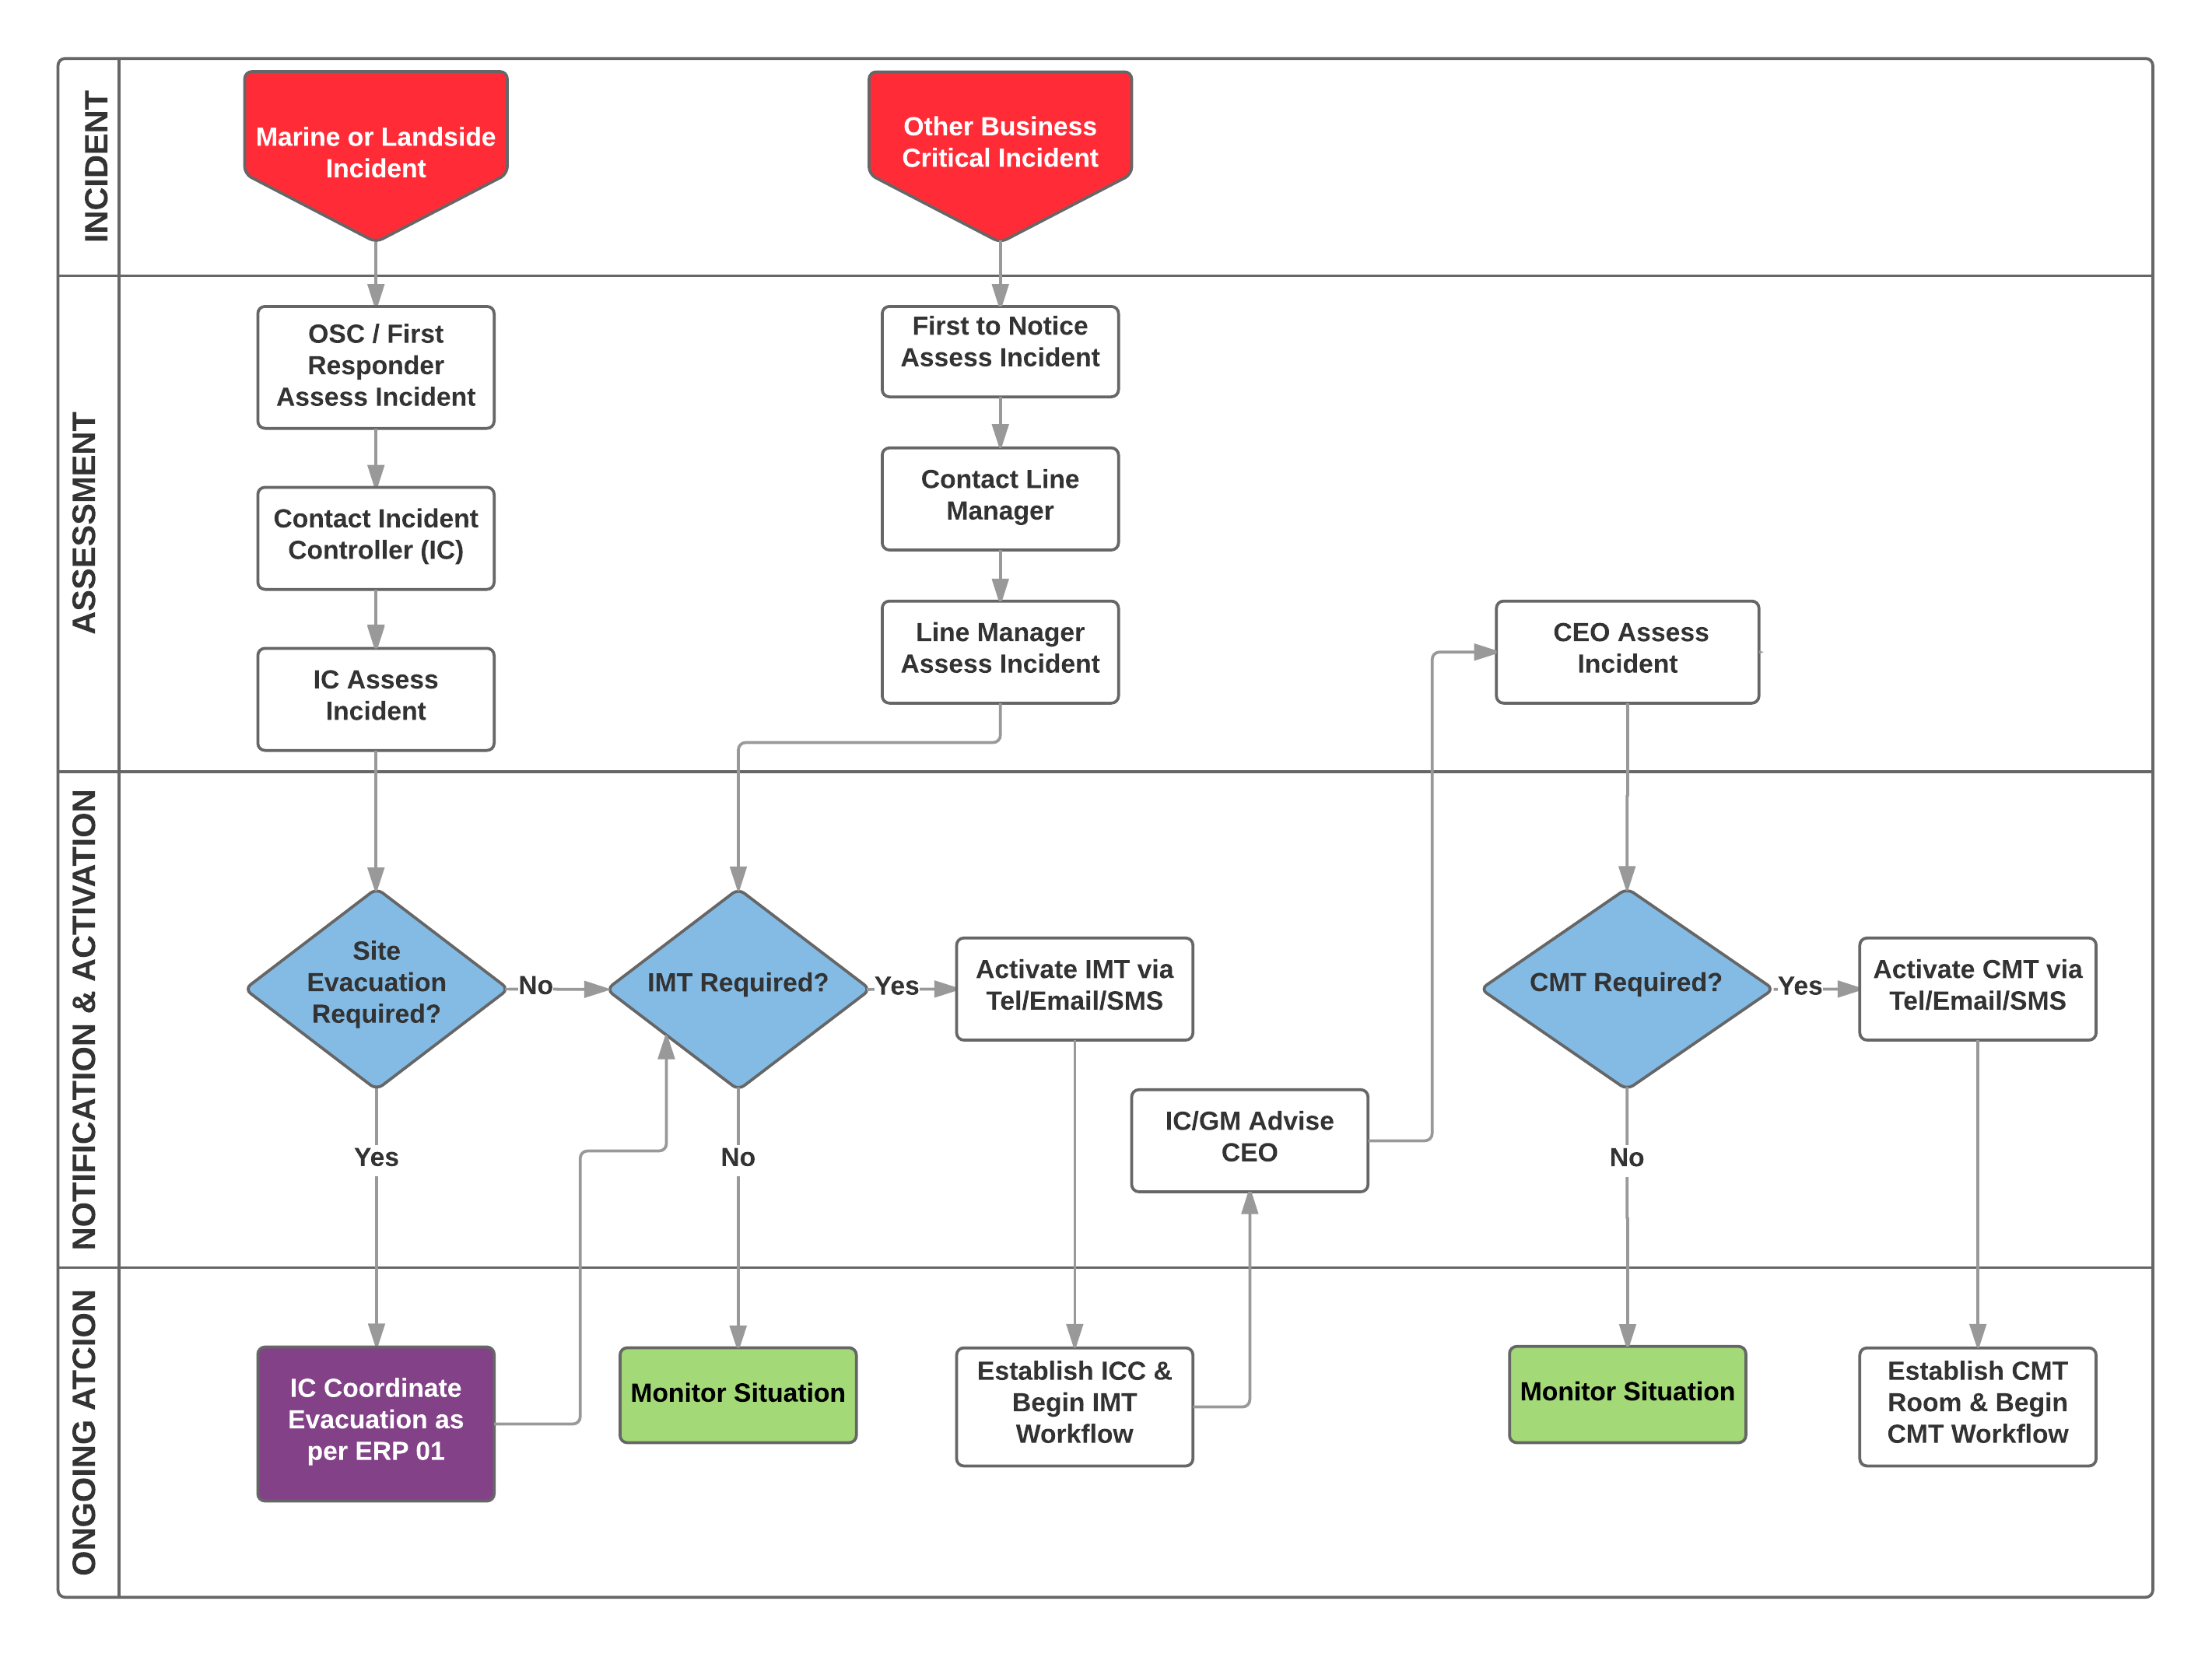
Figure 7 – Decision and Activation Process

Establishing the Incident Control Centre
The first person to arrive at the ICC will follow the flowchart below.
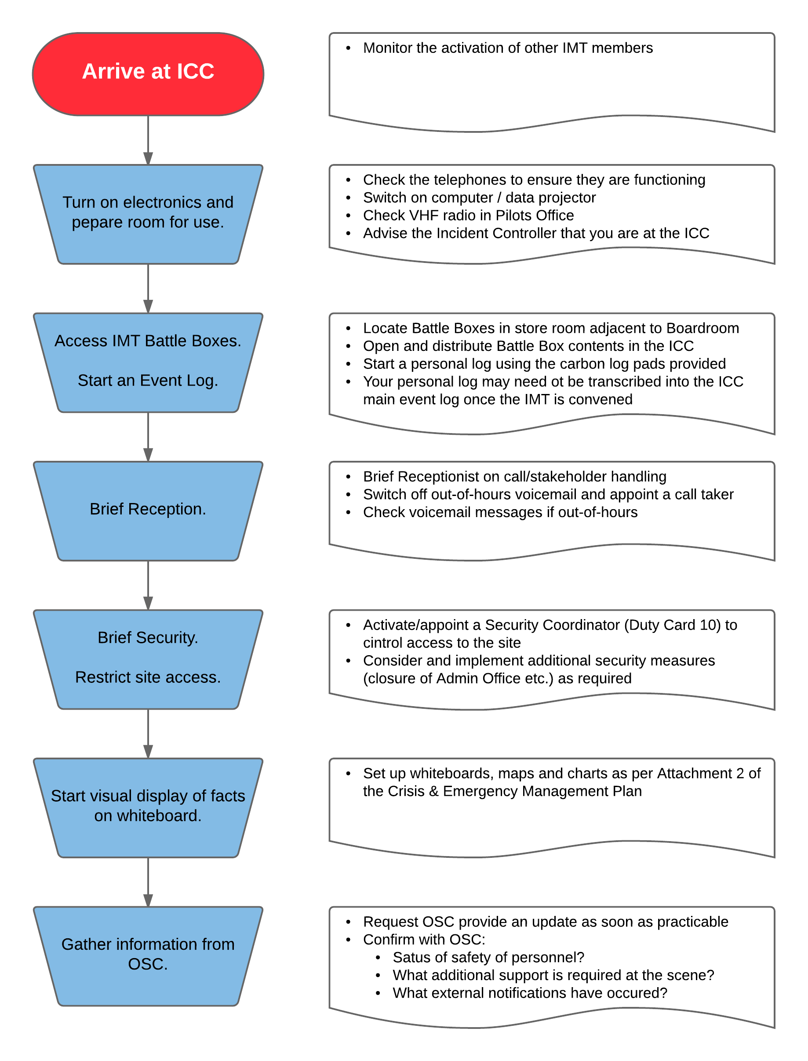
Figure 8 – Establishing the Incident Control Centre

Control Centre Locations

Incident Control Centres. The meeting room on the first floor of the MWPA PoG admin building and adjacent offices will be utilised as the Primary Incident Control Centre (ICC) once the IMT is activated. Note that initial direction by the Incident Controller may be made prior to mobilisation of the IMT to the alternate ICC or to evacuate the site.

The IMT convenes at the ICC in the following locations:
- Primary Location = Board Room, 1st floor Admin Building 298 Marine Terrace, Geraldton and adjoining offices.
- Alternate Location = 5 Chapman Road, Geraldton.

The IMT tools are stored in the Battle Boxes located in the Port Main Office box room (adjacent to the Board Room). Other details for the ICC are:
- Establishing the ICC – see Figure 8.
- The ICC equipment list is attached to the individual Battle Boxes.

All IMT personnel will have out of hour’s access to the ICC via Security.
If the Primary and Alternate ICC is not useable for any reason, the Incident Controller will make alternative arrangements at the time, commensurate with the nature and scale of the emergency. Possibilities include a range of function centres and meeting rooms are available for lease/hire locally. Details can be obtained from the City of Greater Geraldton website at https://www.cgg.wa.gov.au/play/planning-an-event/venues-for-hire.aspx.

Large Scale Incidents and Off-site Incident Control Centres. For Level 2 or 3 emergencies where MWPA PoG hosts an augmented IMT and potentially State and National Oil Spill Response Teams, a combination of facilities including the Primary ICC, Administration Building and off-site facilities may be required. The following arrangement is recommended but subject to the determination of the IC and commensurate to the incident;

Table 4 – Key Command & Control Locations for Large Scale Emergencies
Location | Purpose/Functional Groups
CEO’s Office | CMT Room
MWPA PoG Harbour Masters Office and Pilot area | Incident Controller  Operations Section
Admin ground floor MSIC and HSEQ Building 298 Marine Tce | Investigation Section  Safety and Security
GM Corporate Services area | Public Information Section
MWPA PoG Boardroom | ICC Briefing Room (Incident Main Event Log)
MWPA PoG First Floor IM Room | Planning  Intelligence Section
Operations Manager’s Office  GM Landside Operations | Logistics Section  Finance Section
Meeting Room Department of Primary Industries and regional Development Leased Offices | Induction and Security Briefing Room
Training Room (Berth 5 Office) | Field Team briefing area
MWPA Workshop Area | Field Team dressing area  Field Team kitchen/dining
Queens Park Theatre (75 Cathedral Avenue, Geraldton) | Community Briefings  Media Centre  Press Conferences

CMT Room. The CEO’s Office on the first floor of the MWPA PoG admin building and adjacent offices will be utilised as the Primary Crisis Management Team Room once the CMT is activated. Note that initial direction by the CEO may be made prior to mobilisation of the CMT to convene virtually of at the alternate location.
The CMT may convene as follows:
- Primary Location = CEO’s Office, Admin Building 298 Marine Terrace, Geraldton.
- Alternate Location = 5 Chapman Road
- Virtual Meetings = The CMT may convene via telephone or video conference with the Perth office or when members are travelling away from Geraldton

Confirm Structures and Roles
The default structure for the MWPA CMT and IMT are shown at Figures 3 and 5 of this document.

The Incident Controller will decide whether a full or partial mobilisation of the IMT is required depending on the nature of the incident and the level of support required by the OSC/First Responders. Duty Cards for all IMT roles are at Attachment 1.

The CEO will decide whether a full or partial mobilisation of the CMT is required depending on the nature of the issue/incident and the level of support required.

Teams will be drawn from the Primary and Alternate team members identified in Table 5:

Table 5 – Default MWPA CMT and IMT Membership
Crisis Management Team
Role | Primary | Alternate 1
CMT Leader | Chief Executive Officer | GM Corporate Services
Operations (subject to marine or landside event where primary holds the role of IC) | General Manager - Landside Operations Harbour Master | Operations Manager
Corporate Services | GM Corporate Services | Finance Manager  Commercial Manager
Log keeper | CEO‘s PA | GM Ops Admin Assistant
Incident Management Team
Incident Controller Marine Event | Harbour Master | Senior Pilot
Incident Controller Landside Event | General Manager - Operations | Operations Manager
Operations Section Chief (subject to marine or landside event) | Senior Pilot  Operations Manager | Senior Pilot  Operations Manager
Logistics Section Chief | Commercial Manager | Finance Manager
Planning Section Chief | Infrastructure Manager | Environmental Officer/Assistant
Safety | Safety Manager | OHS Officer
Log keeper | Ship Scheduler
Support Teams
Role | Primary | Alternate 1
HR Support | HR Manager | HR Advisor
Corporate Communications | Corporate Information Manager | Records Management Officer
Telephone Response | Commercial Assistant / Receptionist  MSIC Officer  IT Support Officer | Accounts Payable Officer

Corporate Support Teams. The Incident Controller will activate support teams as required in consultation with the CEO and line managers.
- Telephone Response Team - will be established to assist Reception with the increased level of telephone traffic that can be anticipated in any major incident. The team will be sourced from available staff and will operate from the Administration Area adjacent to the main reception desk. The primary functions of the Team are to:
  - Relieve call-handling pressure on the Reception Desk
  - Process enquiries and pass critical messages to the IMT

- Corporate Communications Team - will initially consist of the CEO supported by the PA and will be augmented by Communications Officer as required to assist with monitoring media and collating requests and responses. The team will initially operate from CEOs office and may re-locate to an alternate area as indicated in Table 4 for larger incidents. The members of this team may also reconfigure to form the nucleus of the Public Information Section for larger incidents. Primary functions of the Corporate Communications Team are to:
- Monitor and analyse media
- Develop communication releases
- Manage and engage with key stakeholders

- HR Support Team - will be provided by the HR Manager and HR staff augmented with support from a designated Employee Assistance Provider (EAP). This team will operate from the Chapman Road leased offices. Primary functions of the Team are to:
- Manage enquiries from Emergency Contacts and Relatives of Port staff
- Coordinate HR responses with contractor companies
- Coordinate welfare support to Emergency Contacts and staff.

Incident Management Team Process
The process of problem-solving and decision-making in the IMT is shown in Figure 9 below and further described in Table 6.
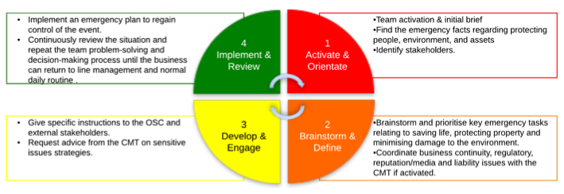
Figure 9 – Incident Management Process

Table 6 – Incident Management Process Responsibilities
Incident Management Process Responsibilities
 | What |  |  |  | Who | When | How
Step 1 – Activate & Orientate
Step 1 – Activate & Orientate | Notification and Activation using the flowchart at Figure 7. |  |  |  | IC | On notification of incident | Phone/SMS/Email
Step 1 – Activate & Orientate | Initial Brief. Share information relating to;  - Incident history and responses already taken  - Current response actions  - Response organisations that are activated |  |  |  | IC to IMT | Initial Briefing | Verbal Brief
Step 1 – Activate & Orientate | Identify Stakeholders and Confirm facts. Who is involved and what is the current situation with;  - People,  - Environment,  - Assets. |  |  |  | IMT | Initial Meeting | General discussion.  Input from OSC as required/available.  Capture info on Stakeholder & Situation Board.
Step 2 – Brainstorm & Define
Step 2 – Brainstorm & Define | Brainstorm Problems/Issues relating to;  - People  - Environment  - Assets  - Business Continuity  - Liability  - Reputation. |  |  |  | IMT | Planning Session | Brainstorming.  Capture info on Situation Board.
Step 2 – Brainstorm & Define | Develop Tasks & Strategies to deal with the issues identified;  - Strategies are the general plan or direction selected to accomplish Objectives for individual Sections.  - Tactics are the short-term specific actions taken to complete or satisfy the Objectives |  |  |  | IMT | Planning Session | Brainstorming.  Capture info on Situation Board.
Step 2 – Brainstorm & Define | Discuss what resources will be needed to accomplish the Objectives |  |  |  | Operations  Logistics | Planning Session | Brainstorming.  Capture info on Resources Board.
Step 2 – Brainstorm & Define | Coordinate obtaining resources and appropriate financial tracking |  |  |  | Operations  Logistics | Planning Session | Brainstorming.
Step 2 – Brainstorm & Define | Confirm strategy and ensure all Objectives have been assigned to someone for action. |  |  |  | IC | Summation | Summary brief.
Step 2 – Brainstorm & Define | Record assignments against Objectives |  |  |  | Planning | Summation | Situation Board

Step 3 – Develop & Engage
Step 3 – Develop & Engage | Develop Objectives and tactics into action plans |  |  |  | Operations SC Planning SC | Section Planning Meeting | Discussion.  Capture info on Situation Board
Step 3 – Develop & Engage | Discuss strategic issues and stakeholder position with CEO |  |  |  | IC | Initial/update briefing | Verbal brief
Step 3 – Develop & Engage | Brief the OSC/Responders on plans/tasks |  |  |  | Operations SC | Initial/update briefing | Formal orders
Step 4 - Implement
& Review
Step 4 - Implement  & Review | Implement Plans and monitor for effectiveness. Make corrective actions as needed through consultation with the Incident Controller, Section Chiefs and OSC. |  |  |  | All | Operations Briefings | General discussion.  Input from OSC as required/available.  Capture info on Stakeholder & Situation Board.
Step 4 - Implement  & Review | Implement stakeholder and communications strategies and monitor for effectiveness. |  |  |  | IC | Briefings | General discussions.  Input from CEO as required.  Capture info on Stakeholder Board
Step 4 - Implement  & Review | If the situation continues, return to Step 2 of the process and continue the IMT workflow.  Once the situation is under control, follow the incident stand-down procedures. |  |  |  | All | New Planning Cycle

Crisis Management Process
The process of problem-solving and decision-making in the CMT is shown in Figure 10 below.
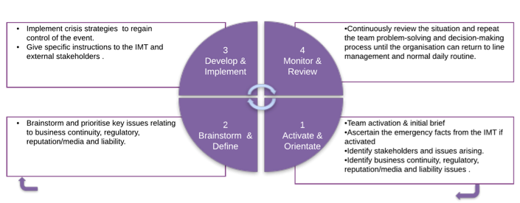

2 – Brainstorm & Define | 1 – Activate & Orientate
Implementation of existing Business Continuity Plans?  Insurance?  Process workarounds?  Alternate sales/marketing strategies?  Leveraging other Ports sites/capacity?  Using competitor supplies/facilities? | Financial impact?  Business threat or direct interruption of business?  How is the incident or issue developing?  Associated constraints on other assets or projects?  Resumption of operations?  Impact on customers/clients?  Impact on suppliers? | Business Continuity
Holding statements and media releases?  Monitoring strategies?  Influencing strategies?  Regulator relationship reinforcement/building? | Positive or negative perceptions?  Media led rumour or speculation?  Current level of enquiry, or interest by local, national and international media?  Current and likely perception of the incident?  Government involvement?  Likely effects on reputation?  Likely impacts on or response from pressure groups and agencies? | Reputation
Regulatory interface?  Insurance review/underwriter support?  Clarify legal relationships?  Review the composition of investigations and use of an independent third party? | Extent of liabilities, claims or penalties?  Criminal liability?  Major third party liability?  Financial impact and compensation?  Insurance?  Loss of revenue?  Legal issues? | Liability

Figure 10 – Crisis Management Process

Support Team Processes
- Telephone Response Team work process is outlined below:
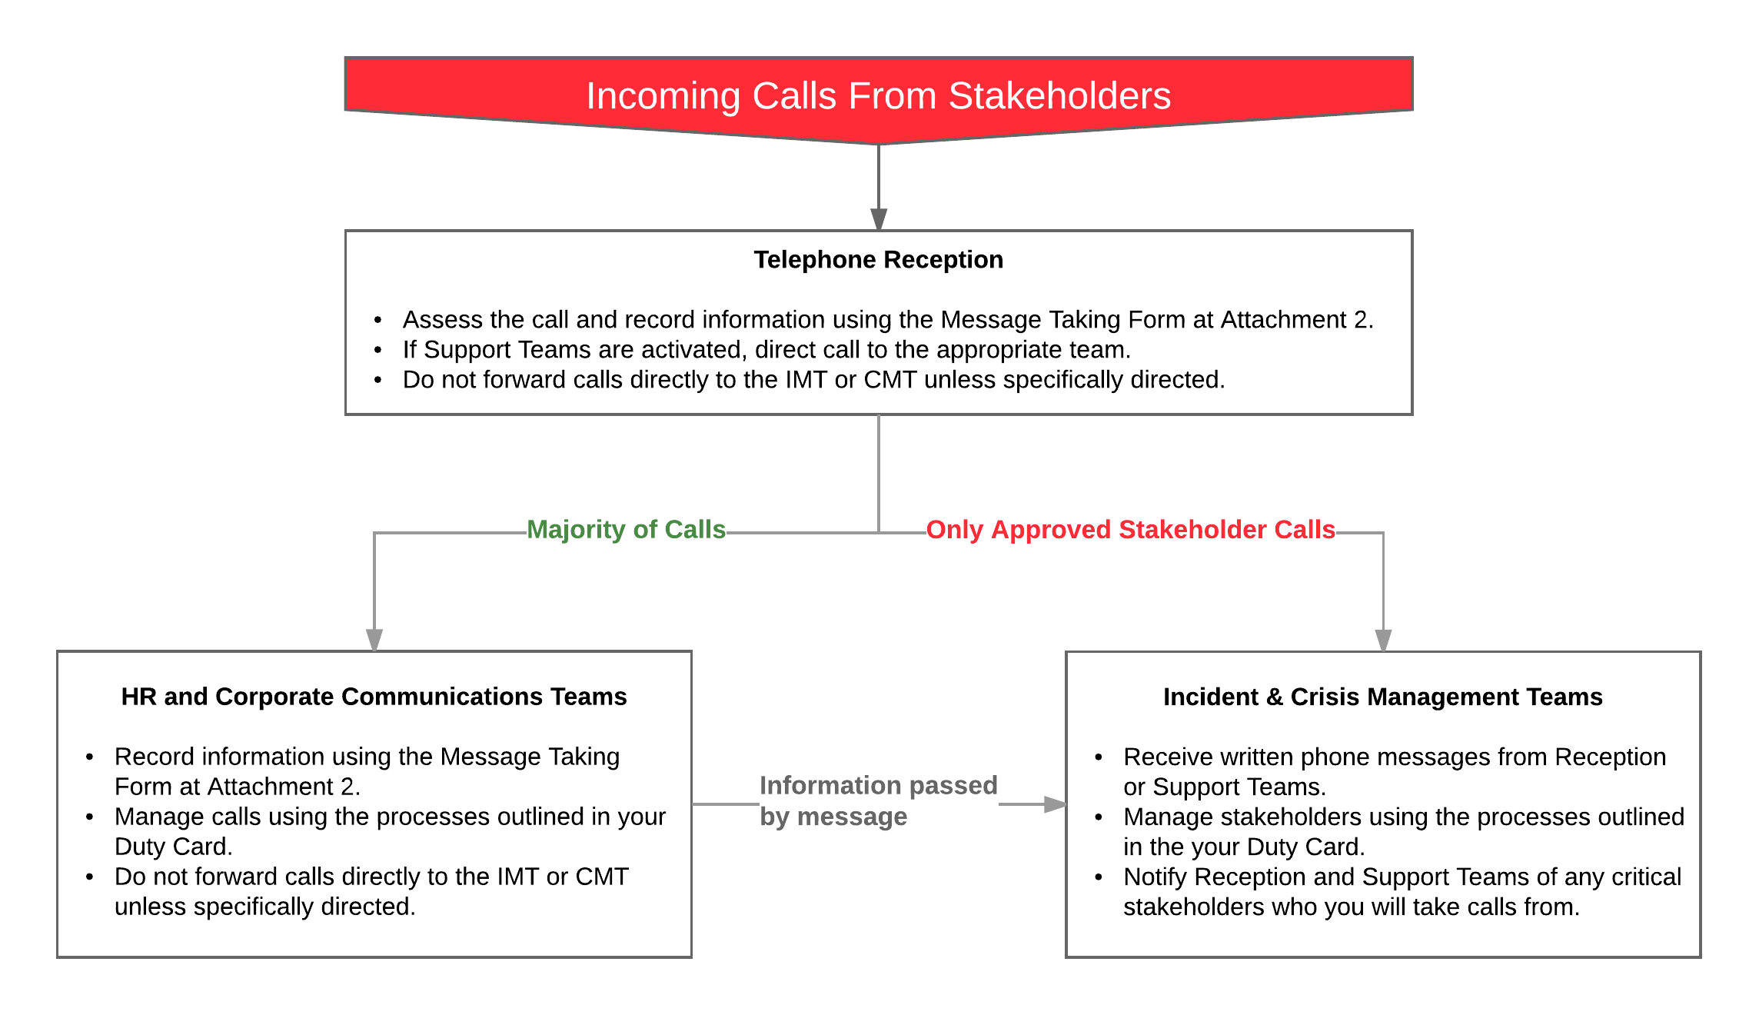
Figure 11 – Telephone Responder Process.

- Corporate Communications Team work process is outlined below and further defined in the Monitoring, Analysing and Responding to Traditional and Social Media section and individual duty cards:
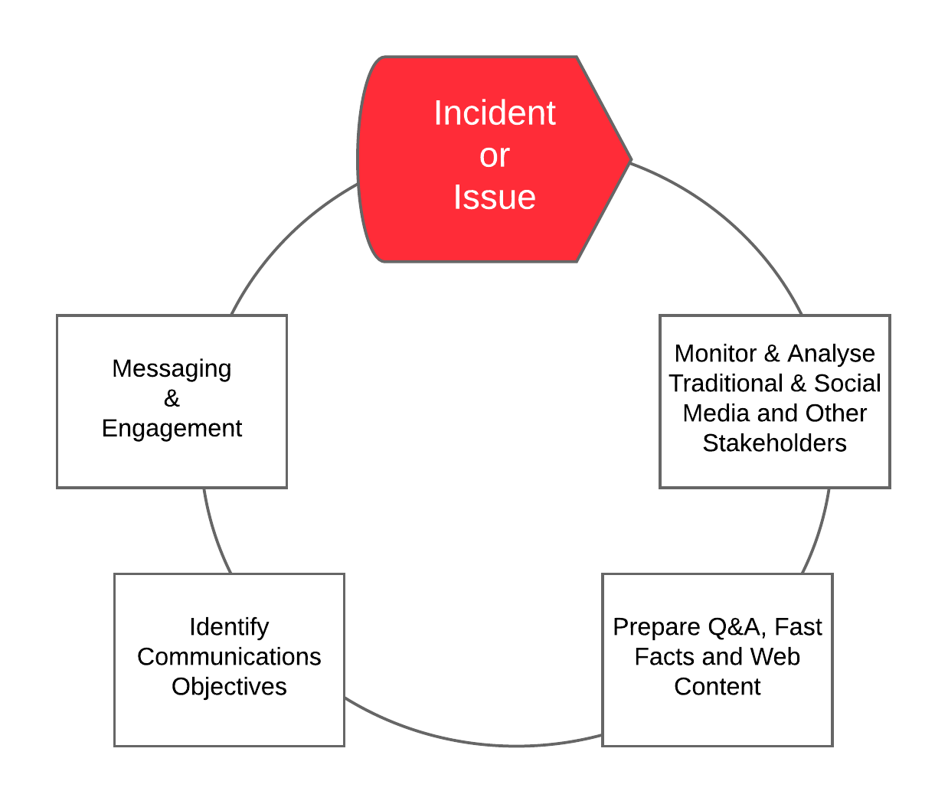
Figure 12 – Corporate Communications Support Team Process.

- HR Support Team work process is outlined below and further defined in the Guidelines for Dealing with Affected People section and individual duty cards:
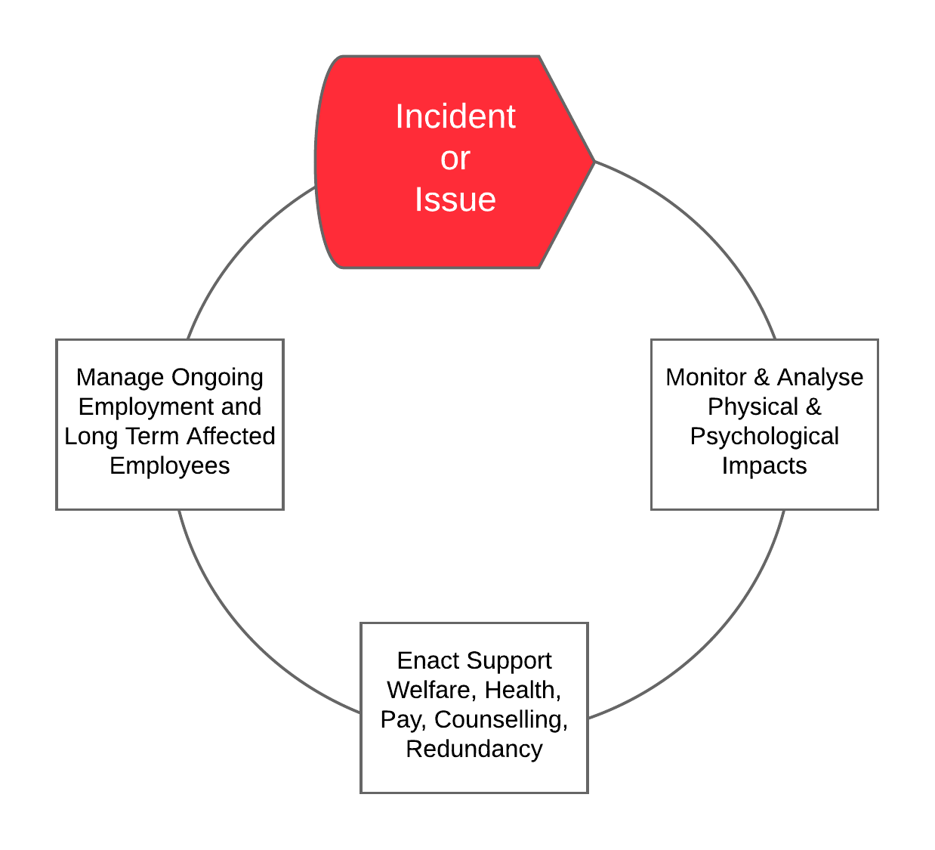
Figure 13 – HR Support Team Process.

Incident Action Plans
In the early stages of an incident and for non-complex incidents, the Incident Controller may develop an informal Incident Action Plan (IAP). This informal IAP would be based on an initial assessment upon activation and knowledge of pre-existing plans and standard operating procedures. The informal IAP is communicated to the IMT using the Situation Board in the ICC using the example at Attachment 2 to assist with information display.
For incidents that have a potential for extended involvement (oil spill in particular), the formal IAP should be documented. The formal IAP process is outlined in the Oil Spill Contingency Plan.

Incident Information Management
Log Keeping. The Planning Section Chief will supervise the Log Keeper in the maintenance of a central team log of main events. The Log will be displayed on the ICC wall via the data-projector. All IMT members will assist the Log Keeper by maintaining a personal log using the carbon log pads provided.
Managing Stakeholders. It is critical that key stakeholders that are affected by the incident are identified early in the planning process and clear responsibilities for contact are established. A stakeholder-tracking matrix should be established by the Liaison appointment based on the example format shown at Attachment 2.
Information Display Boards. A sample of useful display board layouts is contained at Attachment 2. These should be used in the ICC to ensure that critical information is clearly displayed and shared between all members and sections of the IMT.

Guidelines for Dealing with Affected People.
HR Records and Information Management. Information on employees and their Nominated Emergency Contact (NEC) or Next of Kin (NOK) is accessed through the HR Manager. As soon as affected persons are identified, the HR Manager will search for the NEC/NOK information and advice the IMT of a notification plan to be implemented ‘First and Fast’.
Internal and External Communications. Communicating with the NEC/NOK of affected people is a critical part of the HR Support Team process. The priority is to ensure that NEC/NOK are informed first and fast. This action is to be done in coordination with the activated IMT or the CEO/CMT. The release of all information relating to affected people must be coordinated to ensure that information is not made public until the NEC/NOK of affected personnel are notified first. Notification of NEC/NOK for a workplace fatality is the responsibility of WA Police however it is essential that the HR Support Team work closely and expeditiously with WA Police to ensure appropriate support is provided to the NEC/NOK during and after the notification process. In some serious injury cases notification may also require close coordination with WA Police.
Consideration must be given to internal as well as external communications. It is important that unaffected employees are informed that the HR Support Team has been activated to deal with the NEC/NOK of affected people, that they are briefed on colleagues where appropriate, and guided on how to handle any queries or questions they may receive from external sources.
There may be occasions where there are affected people from both MWPA and contractor/external organisations. It is the responsibility of the HR Support Team to ensure the notification of all affected parties is coordinated with the HR Support Teams from all affected organisations.
A senior MWPA Manager and desirably a Peer Supporter should normally advise the NEC/NOK of any serious work related injury. In some cases, the local police may also be present when notifying of a serious injury.

Monitoring, Analysing and Responding to Traditional and Social Media.
The best way to respond to the potential deluge of media demands for information during a crisis is to consider the media as a resource to be utilised and not a threat and to understand that the implementation of strategy is most effective by direct contact with stakeholders rather than by using the media as the medium. The following section provides a guide to preparing for and managing media during an incident.

Preparation

- Keep file footage, Fast Facts and simple Q&A on current operations and issues up-to-date and ready to use.
- Train to respond to media calls and web log under pressure situations.
- Have spokespeople identified and well trained.
- Know where and how to organise a press conference or briefing to traditional and social media.
- Be able to update the website within one hour, 24/7.
- Build relationships with industry journalists and key news reporters.
- Have soft copy templates for media releases (Attachment 2) ready for immediate broadcast nationally
- With Social Media, adapt traditional policy to speed, volume and Generation Y involvement, determine audiences to engage, identify decision makers and know their social medium, be authentic and accept accountability for what you write, use social media etiquette and understand the concept of community, exercise good judgment, protect confidential and proprietary information, respect copyright and fair use.
Execution

- Produce a simple releasable Information statement immediately for all Telephone Responders and staff.
- Develop key messages and modify as the situation changes.
- Develop Q&A to support strategy and key messages.
- Rehearse the MWPA spokesperson.
- Consult relevant parties e.g. partners/contractors to ensure consistency of message.
- Inform the media or issue a statement as soon as possible and continue to update the media as the situation develops.
- Update the website in line with Releasable Information and media releases.
- Monitor media coverage for information on the incident and constantly assess the effectiveness of the media strategy.
- With Social Media, formally assess communication risk, optimize your web log (blog), staff the ability to monitor, analyse and respond 24/7, minimize the number of commentators to ensure responsiveness, courtesy and transparency, remain level-headed, do not get angry or make threats and accept that not every question can be answered on a one-to-one basis.
Questions and Answers (Q&A). The questions the media and other stakeholders may ask in the immediate aftermath of a crisis or major emergency typically follow a pattern. Make sure you have the answers prepared. These messages must be simple, memorable and answer the media's initial and critical 5W+H questions:

- What happened?
- Who is involved?
- When did it happen?
- Where did it occur?
- Why did happen?
- How will it be prevented from happening again?

Do:
- Express sympathy for any loss of life and regret for any damage to the environment, and stress priority for avoiding any further loss or damage.
- Explain briefly and clearly what has happened, where and when, and the roles of the parties involved. Confine yourself to verified facts.

Do not:
- Speculate on possible causes of the incident or apportion blame; these will be the subject of an Inquiry.
- Estimate or discuss costs; these sensitive issues could involve insurance considerations.
- Release names of dead or injured until the Nominated Emergency Contacts (NEC) have been informed and, if necessary, police permission obtained. Fire, ambulance services and hospital authorities should be reminded accordingly.

Messaging. Use the traditional media release template and express concern, control and commitment in any messaging. The media release template is located at Attachment 2.

Incident Reporting
HSE-PRO-005 Incident Reporting and Investigation provides detailed information on reporting of accidents, incidents or hazards including recording follow-up actions. The following table provides a condensed summary on statutory reporting requirements during emergencies;

Table 7 – Guidance on Incident Reporting Requirements
Incident Type | Notification | Link/Contact
Electrical Accident | General: Relevant network operator (or Energy Safety) | Western Power: 13 13 51  Energy Safety: 1800 678 198
Electrical Accident | Designated Mine Site: As soon as practicable to DMIRS. Accident reports, incident reports must be submitted to Resources Safety via the online Safety Regulation System (SRS).  A company administrator must register for SRS access before reports can be submitted. | Email:  SRSNotificationsManager@dmp.wa.gov.au  Phone:  08 9358 8101
Work Injury | Designated Mine Site: As soon as practicable to DMP. | As above.
Work Injury | General: Serious injuries and work-related deaths need to be reported to Worksafe forthwith according to section 23I of the Occupational Safety and Health Act 1984. | 24 hour incident/accident reporting line 1800 678 198
Transport or Storage of DG | Designated Mine Site: As soon as practicable to DMIRS Resources Safety DG Officer. DG incident report form must be lodged within 21 days of a reportable situation: www.dmirs.wa.gov.au/documents/Forms/DGS_F_IncidentReport.pdf | Phone: 08) 9358 8002 (08.30-16.30 Mon-Fri)  Fax: (08) 9358 8000  Email: dgsb@dmirs.wa.gov.au
Transport or Storage of DG | General: Hazardous materials emissions and major pollution incidents. Department of Environment Regulation (DER). | 24 hr Pollution Watch hotline – 1300 784 782  Online report - www.der.wa.gov.au/your-environment/reporting-pollution/report-pollution-form
Environmental Incident | Department of Water and Environment Regulation (DER). | As above
Oil Spill | Department of Water and Environment Regulation (DER). | As above
Oil Spill | Department of Transport for state waters.  Initially by phone to the Oil Spill Response Coordination. Then by Pollution Report (POLREP);  http://www.transport.wa.gov.au/mediaFiles/marine/MAC-F-PollutionReport.pdf | Email: marine.pollution@transport.wa.gov.au and rccaus@amsa.gov.au  Phone (08) 9480 9924  Fax: 1300 905 866
Oil Spill | AMSA for Commonwealth Waters. Australian Search and Rescue (AusSAR): Rescue Coordination Centre | Phone: (02) 6230 6811  Free call: 1800 641 792  Fax: (02) 6230 6868
Shipping Incident | For Commercial Vessels. The operator must notify the AMSA by any means available within 4 hours of becoming aware of the accident or dangerous occurrence. An Incident Alert form is to be completed (AMSA Form 18 & 19)  An incident report (AMSA Form 19) is a more detailed follow up report and must be forwarded from the operator to the Inspectorate within 72 hours.  The Harbour Master or Assistant Harbour Master must notify AMSA in the form of the AMSA SV-HH document. | Forms: www.amsa.gov.au/vessels/ship-safety/incident-reporting/comm-vessels-gen-report/index.asp  Email: reports@amsa.gov.au or  Fax: +61 2 6230 6868 or 1800 622 153  Forms: http://www.amsa.gov.au/InternetForms/SVHH/Default.aspx
Shipping Incident | For Domestic Commercial Vessels (under 24m). Notification to DoT WA using Incident Report (Marine Incident Report Form) within 7 days of incident. http://www.transport.wa.gov.au/mediaFiles/marine/MAC_F_MarineIncidentReport.pdf | Email: Marine.Investigations@transport.wa.gov.au  Phone: 1300 863 308  Fax: 08 9435 7807
Rail Incident | Both MWPA, its Maintenance Providers and Train Operating Companies will notify each other of incidents that may impact on, or have the ability to, affect the safety of employees and/or this service.  MWPA shall each be responsible for informing the Regulator of any notifiable occurrences as defined in the relevant Act and Regulations that occur within the MWPA Rail Terminal inclusive of any incident involving the terminal infrastructure except as noted in sections 14.1, 14.2 and 14.3 of the Rail Interface Agreement.  Train Operating Companies and the MWPA shall be individually responsible for informing the Regulator of any notifiable occurrences as defined in the relevant Act and Regulations for any incident involving the rolling stock or train crew that occur within the MWPA Rail Terminal.  Where other regulatory agencies must be notified following an incident, both MWPA and Train Operating Companies will individually ensure their reporting obligations are fulfilled. | The incident coordination single point of contact of MWPA is (08) 9964 0500.  Notifiable occurrences are categorised as follows:  - Category A, the most serious, which must be immediately orally reported by phoning the Australian Transport Safety Bureau (ATSB) on 1800 011 034 and following up with a written report to the ONRSR within 72 hours  - Category B, which must be reported to the Office of the National Rail Safety Regulator (ONRSR) within 72 hours.  All written reports must be provided to the ONRSR using the prescribed form unless the ONRSR has agreed in writing that a rail transport operator may provide submissions as a digital batch submission.
Pipeline Incident | Immediate notification to DMIRS. Pipeline operation under the State petroleum legislation. | 24 hour Phone: 0437 973 672, 0437 970 014 and 0437 972 947  Email written notification to petreps@dmirs.wa.gov.au.
Security Incident | As per the guidelines in the MWPA PoG Maritime Security Plan
Registered Plant (mine-site) | DMIRS - Notifiable Incident Report form must be submitted to Resources Safety via the online Safety Regulation System (SRS).  A company administrator must register for SRS access before reports can be submitted. | Email:  SRSNotificationsManager@ dmirs.wa.gov.au  Phone:  08 9358 8101

IMT Shift Handover Procedures
If relief is required in a prolonged emergency, follow this process.

Incident Controller

- Provide a brief on actions to date and current priorities.
- If the changeover of all IMT members is to be simultaneous, arrange an extended update when the majority of reliefs have arrived.

IMT Members

- Individually brief your relief without disrupting the rest of the team.
- Advise the Log Keeper and the Incident Controller.

Termination of an Emergency or Crisis
Emergency Response. Actions will cease when the Incident Controller, after consultation with all relevant personnel involved, is satisfied that it is safe to do so.
The ‘All Clear’ should be communicated to all MWPA PoG personnel by any or all of the following methods:
  - VHF radio across all channels used during the emergency
  - Direct telephone (using contacts at Attachment 5)
  - In-person briefings to all teams
Affected neighbouring industries and residents should also be notified using contacts at Attachment 5.
Crisis Management. The CEO/CMT Leader will decide when to revert from Crisis Management to business as usual or transition to Business Continuity and recovery procedures. The following considerations shall apply when standing down a crisis response.
- Notify all relevant stakeholders as appropriate.
- Ensure appropriate on-going measures are in place for support to affected people, business recovery and liability/reputation management.
- Convene a corporate debrief after stand down to capture key lessons and follow up actions with respect to business continuity, financial and legal liability and reputation

Clean-up and Recovery
The Incident Controller will coordinate all clean-up and repair activities with the assistance of the Manager of the affected area.
Any long term clean-up activities will be carried out in consultation with the relevant authorities.

Debrief
A debriefing shall be arranged to review the situation with all participants to determine the strong points as well as any areas requiring improvement. The IcC will arrange a debriefing as soon as is practicable, and in any case, not more than two weeks after an emergency. All agencies involved with the incident should participate. Recommendations for improvement, based on lessons learned, may be made. A debriefing session should cover the following aspects:
- description of the incident situation;
- summary of the response strategies and actions undertaken;
- identification of the circumstances or causes which lead to the incident or situation;
- the nature and severity of the damage to personnel, equipment, environment, resources, reputation, liability and business continuity;
- identification of residual risks or ongoing issues;
- review of the efficiency and effectiveness of the alert procedure, emergency organisation, use of resources and communication;
- summary of key lessons learnt;
- items for improvement in any of the plans used.
The Log Keeper will be required to take minutes of the debriefing session. If necessary, a corrective action plan will be set up to ensure the improvement of the organization ability to respond to an incident.

Incident Investigation
Follow-up investigation of emergencies will be undertaken in accordance with HSE-PRO-005 Incident Reporting and Investigation. Should a statutory or external investigation also be required, MWPA shall ensure measures are implemented to preserve any evidence associated with the incident.

Attachment 1 – Duty Cards

Attachment 1 is issued separately and contains the duty Cards set out below. The cards are produced in hard copy (laminated) and contained in the IMT and CMT Battle Boxes.

Emergency Management
- Duty Card 01 - Incident Controller
- Duty Card 02 - Operations Section Chief
- Duty Card 03 - Planning Section Chief
- Duty Card 04 - Logistics Section Chief
- Duty Card 05 - Safety Officer
- Duty Card 06 - Log Keeper
- Duty Card 07 - Telephone Responders
- Duty Card 08 - HR Support Team
- Duty Card 09 - Corporate Communications Support Team
- Duty Card 10 - Security Coordinator
- Duty Card 11 - On Scene Commander
- Duty Card 12 - Assembly Area 1 Marshall - Outside main security gate
- Duty Card 13 - Assembly Area 2 Marshall - MWPA Workshop Amenities Verandah
- Duty Card 14 - Assembly Area 3 Marshall - MWPA Operations Building at railway line fence
- Duty Card 15 - Assembly Area 4 Marshall - MWPA Admin Building
- Duty Card 16 - Assembly Area 5 Marshall - Shepherd Park (Ian Bogle Rd side)
- Duty Card 17 - Assembly Area 6 Marshall - Gillam Rd (South Fence Opposite MGI Shed)
- Duty Card 18 - Assembly Area 7 Marshall - Gillam Rd (Left-hand side exit to roundabout)
- Duty Card 19 – Fire Warden (General)
Crisis Management
- Duty Card 20 – CMT Leader
- Duty Card 21 – CMT Operations
- Duty Card 22 – CMT Corporate Services
- Duty Card 23 – CMT PA/ Log Keeper

Attachment 2 – Incident Display Boards and Forms

The following section contains templates for ICC display boards, forms and templates for use during incidents.

Main Events Log
Focus Board
Stakeholder Board
Affected Persons Tracking Board
Resource Tracking Board
Individual Log of Events
Message Taking Form
Media Release Template
AIIMS Briefing Form

Main Events Log

TIME | EVENT
27 May 2014
13:44 | IMT Convened
13:47 | IC briefs IMT  - Fire at shed  - Injured people  - 000 responding
13:52 | Logistics calls hospital to confirm arrangements
13:54 | IMT planning session. Discussion on;  - Reception of DFES  - Evacuation of injured  - Notification to neighbours  - Information to those at Assembly Areas
13:57 | IC calls CEO and provides initial summary.
14:02 | CEO directs preparation of initial media release.

Notes:
- The log is maintained on an electronic whiteboard or computer linked to data-projector by the IMT and CMT Log Keepers.
- An example of information to be recorded is shown in the table.
- Individual IMT and CMT members maintain personal log of events on the carbon notepads and provide a copy of pertinent information for the team log to the Log Keeper.

Focus Board
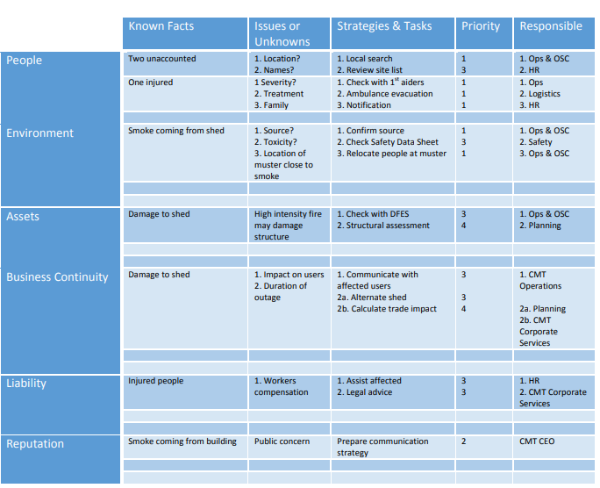

Notes:
- The board is drawn up on an electronic whiteboard and aids the IMT and CMT to list tasks, issues and identify priorities.
- All team members contribute to populating information on the board.
- Team Leaders use the board as the basis for update briefings and maintaining a ‘plan-on-a-page’ approach to the current situation and guide the team updates/planning sessions.
- The information displayed is succinct with tasks and strategies developed in detail by the person allocated responsibility.
- An example of information to be recorded is shown in the table.

Stakeholder Board

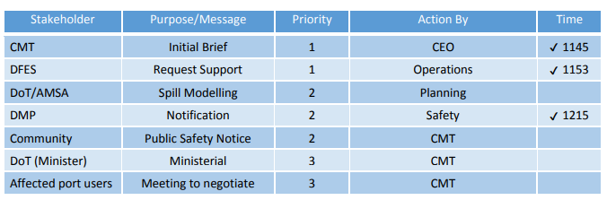

Notes:
- The board is drawn up on a whiteboard and aids the IMT and CMT to manage stakeholders that are affected by the incident.
- The board is maintained by the IMT with contributions from all team members and the CMT.
- An example of information to be recorded is shown in the table.

Affected Persons Tracking Board

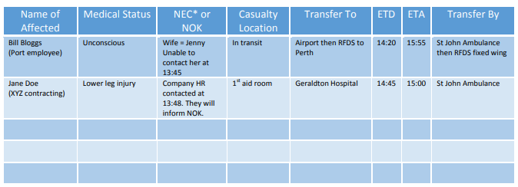

* NEC is nominated emergency contact. This is not necessarily the next of kin (NOK).

Notes:
- The Affected Persons Tracking Board is maintained by the HR Manager.
- It is intended to keep track of all affected personnel so their current status, whereabouts and overall management can be appropriately attended to.
- An example of information to be recorded is shown in the table.

Resource Tracking Board

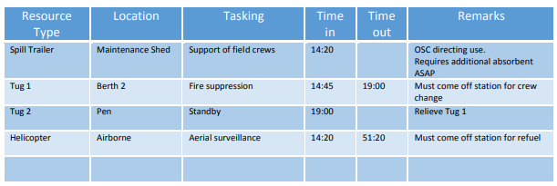

Notes:
- The Resource Tracking Board is maintained by Logistics.
- It is intended to keep track of all emergency response resources so their current status, whereabouts and overall management can be appropriately attended to.
- An example of information to be recorded is shown in the table.

Individual Log of Events

Message Taking Form
MID WEST PORTS AUTHORITY MESSAGE TAKING FORM
DATE: | TIME:
TELPHONE RESPONDER’S NAME:
THIS IS MID WEST PORTS AUTHORITY.
WHOM DO YOU WISH TO SPEAK TO?
If normal business and lines are free, connect the caller. If crisis or emergency business, do not connect the caller unless cleared to do so.
WHAT IS YOUR NAME?
WHAT IS YOUR ORGANIZATION?
HOW CAN WE CONTACT YOU?
WHAT IS YOUR MESSAGE?

Copy To (tick as required):
- CMT
- IMT
- Corporate Communications Support Team
- HR Support Team
- Reception/Switchboard

Media Release Template

MEDIA RELEASE

Day, Date Month Year

Mid West Ports Authority regrets to advise/reports that an (description of event e.g. fire, explosion) occurred at (location) at approximately (time) today.
Emergency Response procedures have been activated and the Port Authority is currently directing all its efforts to ensure the safety of personnel in the area. Few details relating to the extent of the incident are available at this time.
Further information will be made available as it comes to hand.
Please direct all inquiries to the Mid West Ports Authority information number (08) ######## or email ########

Note: It is optional to include when the next media release maybe anticipated if this helps in demonstrating Concern, Control and Commitment.

Distribution Checklist
- Minister Office
- Media Outlets
- Internal
- Contractors
- NOK/NEC
- Other key stakeholders

AIIMS Briefing Form
To be used by Operations Section and Field Crews when briefing on incident tasking.
Component | Areas to Consider | Notes
Situation | The current and predicted situation including:  - An overview of Incident;  - Current and expected weather;  - Life, environment and property risks/threats;  - A summary of resources deployed so far (area work crews etc.)
Mission | Statement of intent (what you need to achieve) and specific objectives set for the response.
Execution | How the mission will be accomplished including:  - Strategies and tactics  - Constraints (boundaries, hot/warm/cold zones)  - Task and resource allocation  - Access to the incident  - Times constraints – (process safety, equipment duration, shift duty)  - Immediate tasks after briefing  - Contingency plans (what if something goes wrong?)
Administration | Logistics for the operation including:  - Key support locations and roles  - Incident staging area  - Supply / emergency resources  - Ground/medical staff (location and patient transfer etc.)
Command and Communication | Incident Management Structure including:  - Who reports to who and at what times  - Contact mobile numbers, radio channels
Safety | Identification of known or likely hazards including:  - Hot, energised and pressurized equipment  - ‘Watch out’ situations (reminder personal safety/assessment - Take 5)  - Safety equipment required and protective clothing standards  - Welfare – hydration, first aid.

Attachment 3 – Maps and Site Diagrams

The following section contains A4 sized maps and diagrams aimed at assisting in Emergency Management activities as set out below. A complete set of full scale maps and diagrams is located in the ICC Battle Boxes.

Map 01 – Port of Geraldton Limits
Map 02 – Location and Layout of Geraldton Port
Map 03 - Emergency Evacuation and Equipment Locations
Map 04 – BHF Spill Kit Locations
Map 05 – Marine Fall Recovery Equipment Locations

Diagram 01 – Large Scale IMT Area Layout

Map 01 – Port of Geraldton Limits

The offshore area is defined under the Port Authorities Act 1999. Geraldton Port waters encompass moorings, breakwaters, navigational channel, harbour basin and port boundary. This area covers coastal and offshore waters designated as Port Limits for Port of Geraldton in Western Australia. Refer to charts AUS 81 below.

Map 02 – Location and Layout of Geraldton Port
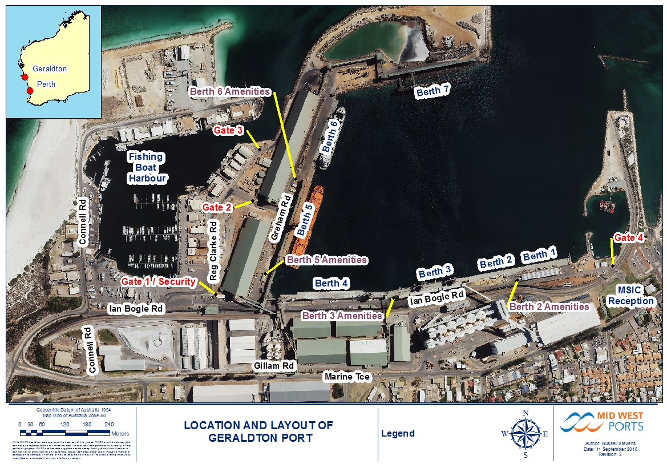

The Berth 6 Amenities is in the wrong location in the photo / plan above.

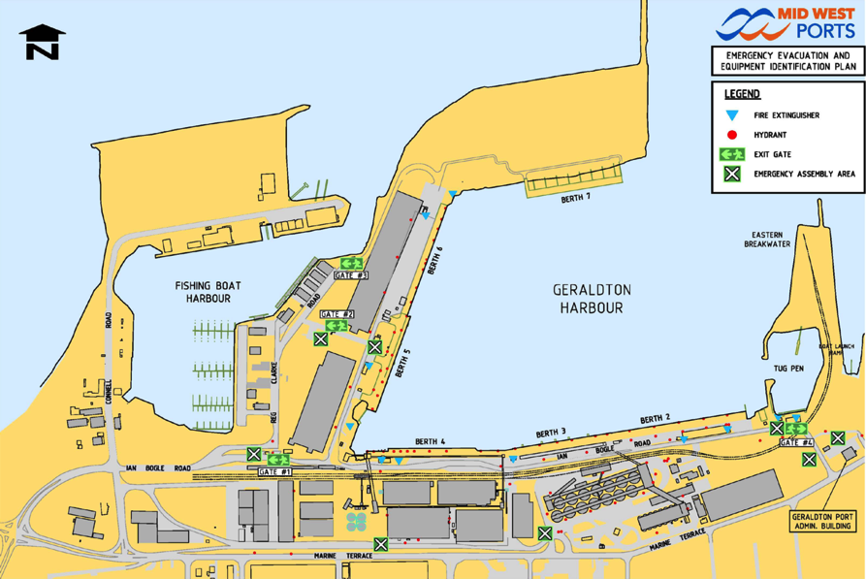
Map 03 – Emergency Evacuation and Equipment Locations

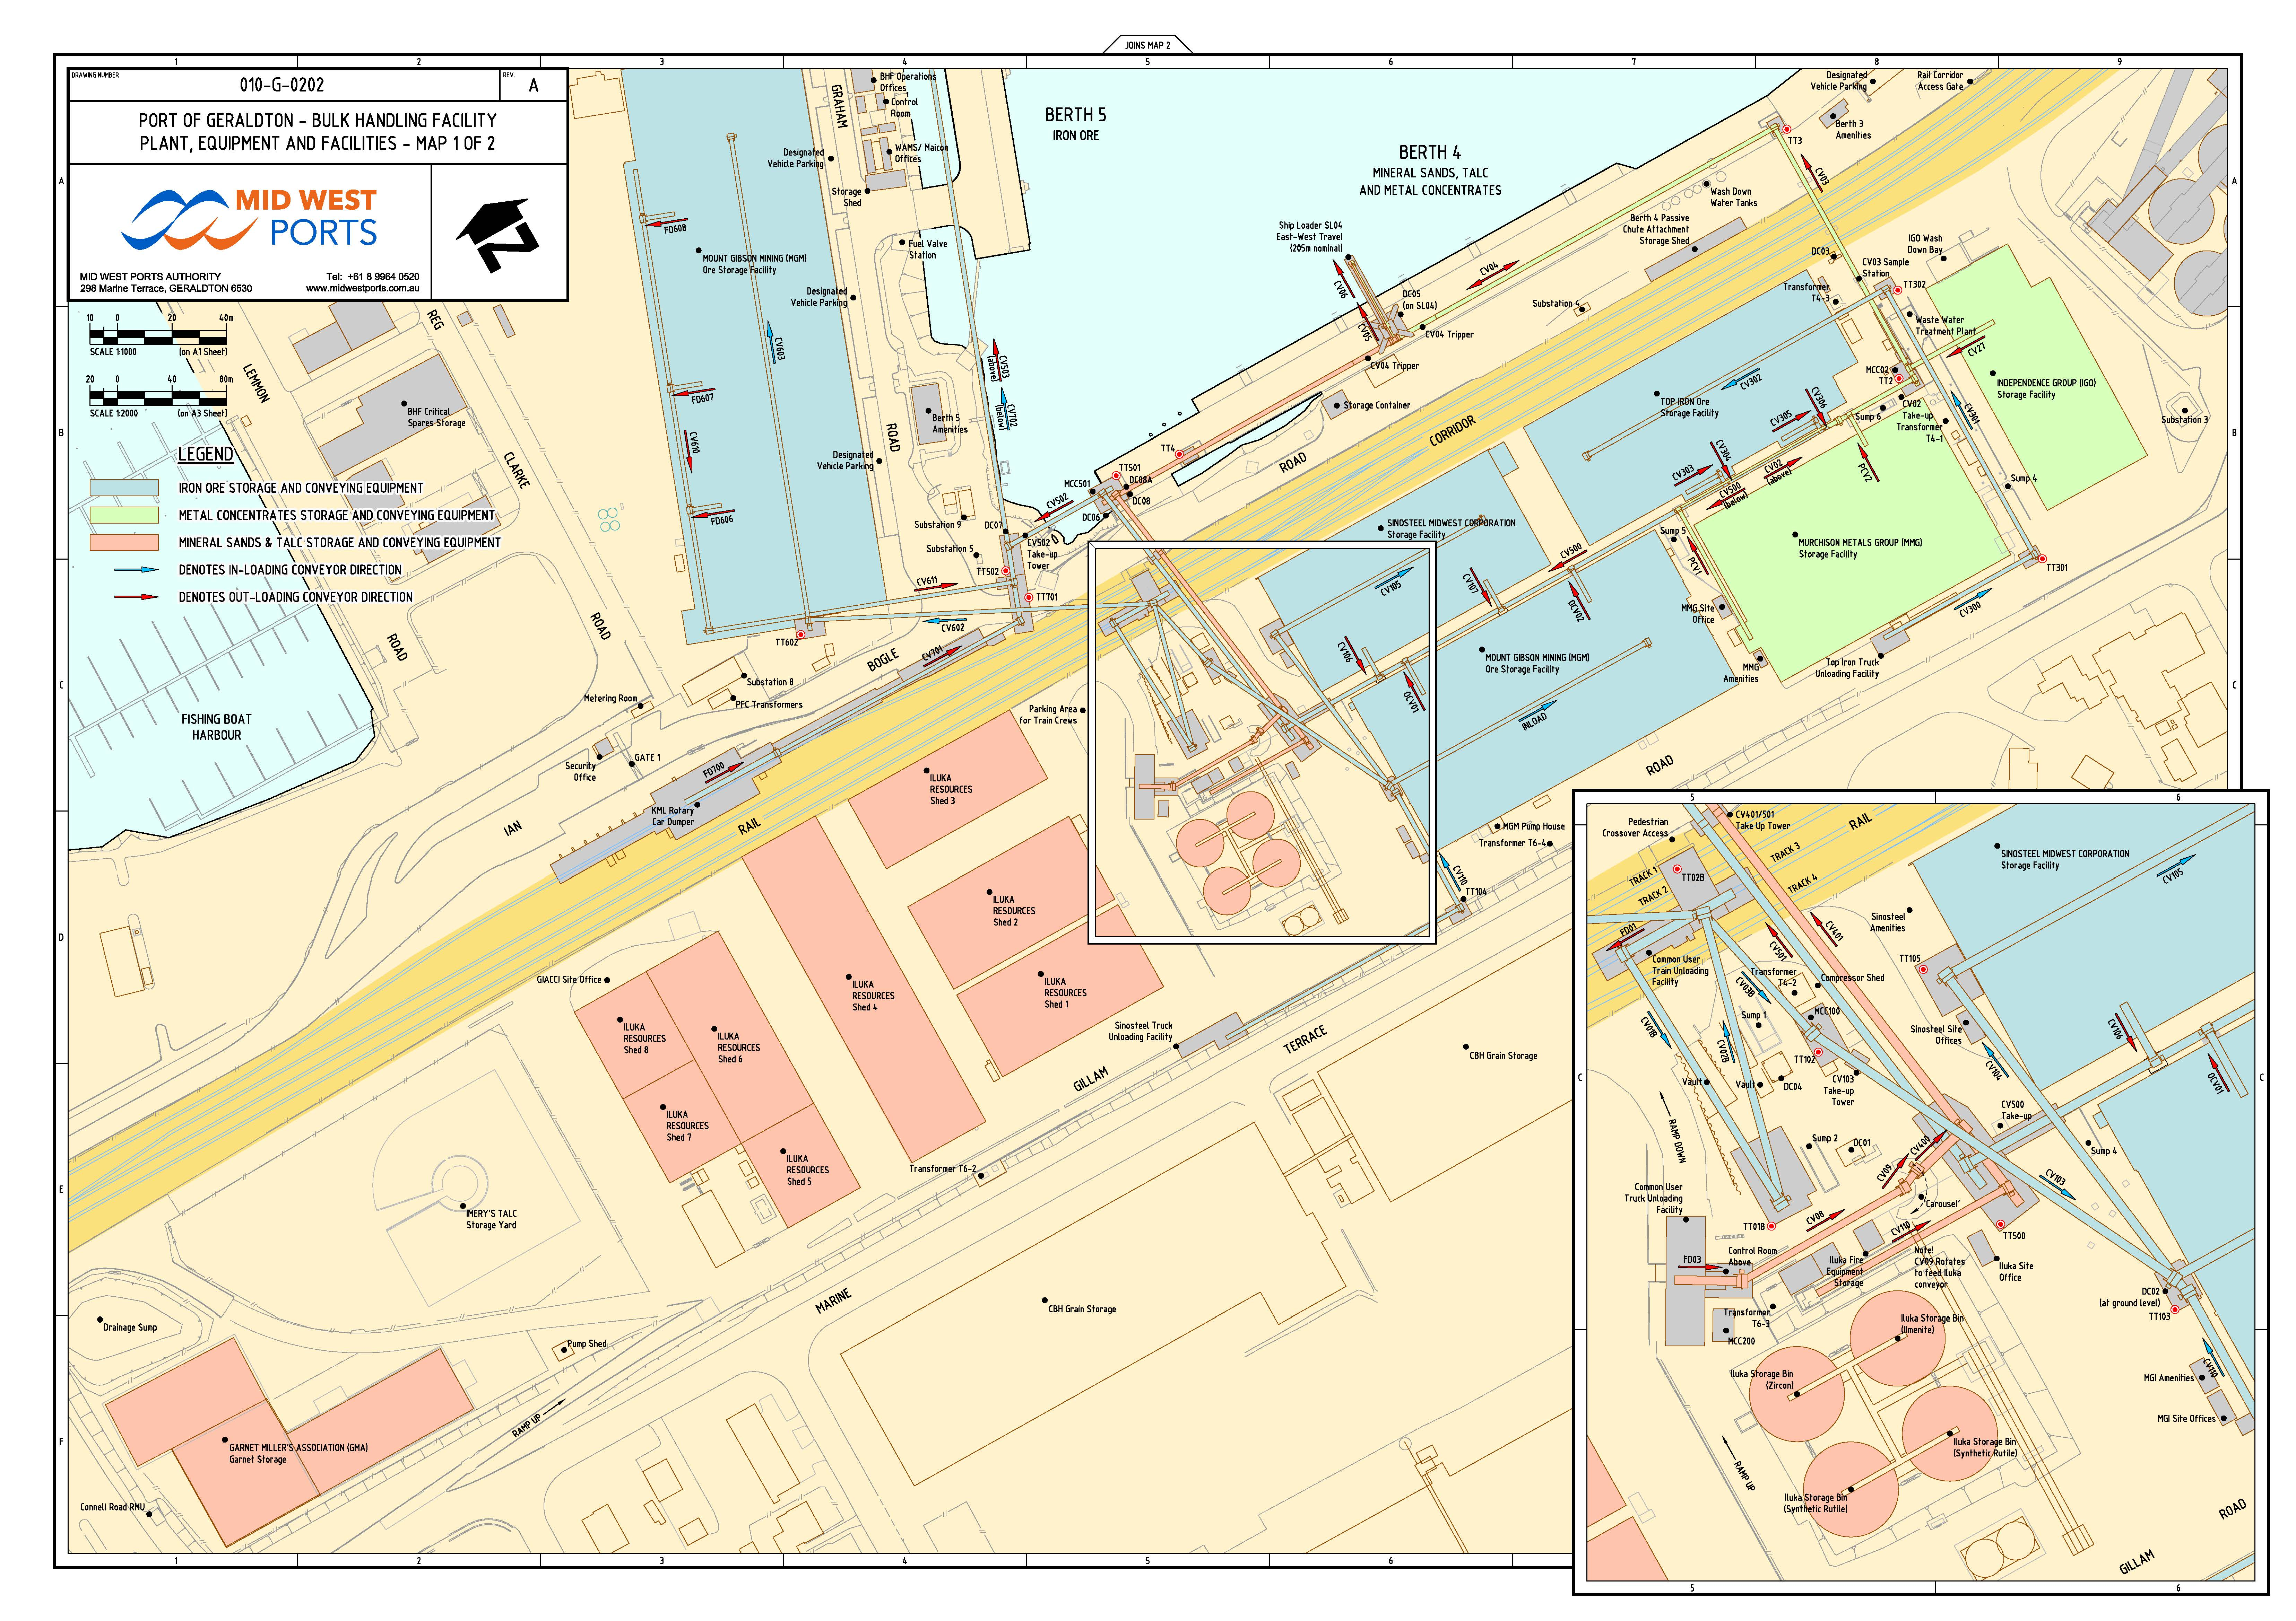
Map 04 – BHF Spill Kit Locations

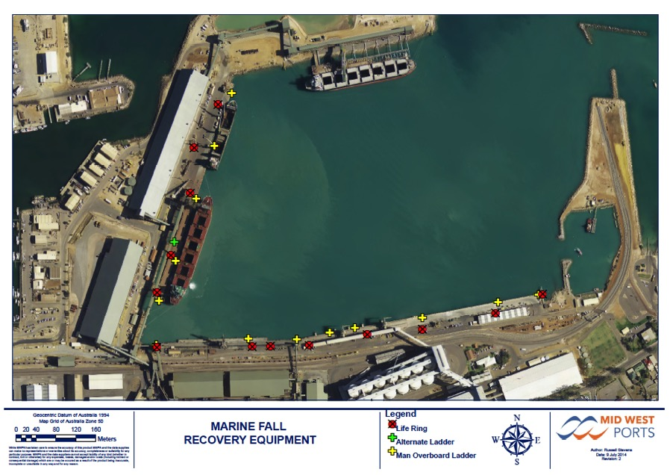
Map 05 – Marine Fall Recovery Equipment Locations

Diagram 01 – Large Scale IMT Area Layout
This floor plan depicts the locations for an expanded IMT room layout as per Table 4.

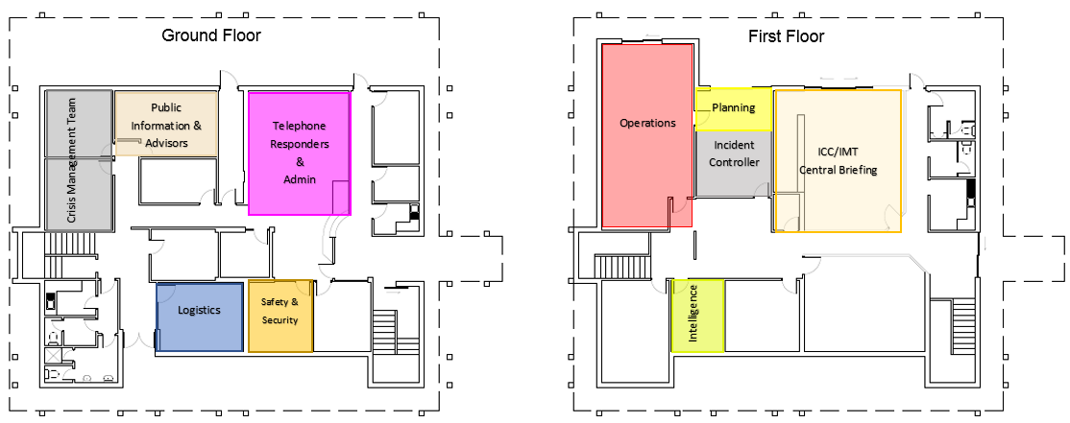

Attachment 4 – Emergency Response Procedures

The MWPA PoG has prepared a number of Emergency Response Procedures for specific incidents as follows:

ERP 01 – Immediate Response to Emergencies for all Personnel
ERP 02 - Site Evacuation
ERP 03 - Medical Emergency
ERP 04 - Office/Structural Fire
ERP 05 - Dangerous Goods/Hazardous Material Release
ERP 06 - Industrial/Transport/Rail Accident or Structural Instability
ERP 07 - Confined Space Incident (Ashore)
ERP 08 - Working at Heights Incident
ERP 09 - Incident Involving a Ship
ERP 10 - Evacuation of Personnel from a Ship
ERP 11 - Aircraft Ditching in Port Waters
ERP 12 - Oil Spill/DG Release Into the Water
ERP 13 - Severe Weather
ERP 14 - Flood/Tidal Surge/Tsunami
ERP 15 - Earthquake
ERP 16 - Bomb Threat
ERP 17 - Armed Incursion/Security Breach
ERP 18 - Civil Disturbance
ERP 19- Rail Terminal Incident
ERP20- Biosecurity Incident

ERP 01 – Immediate Response to Emergencies for all Personnel

ERP 02 - Site Evacuation and Muster
Emergency evacuation procedures for fire and bomb threats are available next to all MWPA telephones and throughout the Port buildings. For certain emergencies, a site wide evacuation may be required. A decision to evacuate will be made by the IC using the following process.

 | ERP 02 – Site Evacuation and Muster | - or N/A
1 | Incident Controller assesses the situation and determines whether a full site evacuation is warranted or if non-affected areas can continue as normal and advise accordingly.
2 | Assess risks to established muster points and egress routes for all locations to be evacuated.
3 | Quickly develop a safe evacuation plan including routes, muster locations and what to do if things go wrong during the evacuation. (NB: rely on existing muster procedures if safe to do so)
4 | Brief Fire Wardens and Assembly Area Marshalls (by radio or telephone) on the conduct of the orderly evacuation.
5 | Give specific instructions to commence the orderly evacuation.
6 | Activate the IMT and commence the IMT workflow including notifying neighbouring sites and accounting for personnel.
7 | Ensure appropriate emergency services have been notified (Including Police to assist with crowd control and/or evacuation of residents) and co-ordinate evacuation.
8 | Assign a person to the role of Security Coordinator (Duty Card 11) to secure access to the Port and direct emergency services.
9 | If full evacuation and Port closed, assign a person to advise Port users/direct all shipping, road and rail traffic as required.
10 | Pass on all relevant information regarding status of emergency and progress of evacuation to the responding emergency service.
11 | Notify external agencies (Police, DMP, DoT, AMSA, etc) if required.
12 | Make incident area safe
13 | Isolate incident area and gather information for investigation purposes.
14 | Give ‘All Clear/Stand-down’ call over emergency communication systems.

ERP 03 - Medical Emergency
 | ERP 03 - Medical Emergency | - or N/A
1 | Ascertain nature and location of the medical emergency or injury and ensure First Aid efforts are underway.
2 | Ensure appropriate emergency services have been notified.
3 | Appoint a port employee to be On Scene Commander with radio communications to the ICC.
4 | Arrange first aid assistance for person(s) injured / unwell. First aid kits located throughout the Port and in marked Port vehicles as per the table below. There are defibrillators located at the following locations  - Administration  - Berth 5 Amenities  - Truck Unloader  - Maintenance Workshop  - Lease 51  - On Wall – Outside Operations Building  - Pilot Boat (Glengarry)  - 5 Chapman Road  - Access to Defibrillators at DAFWA and Karara (if required).
5 | Consider activation of the IMT for multiple or serious injury events.
6 | Assign a person to the role of Security Coordinator (Duty Card 11) to secure access to the Port and direct emergency services.
7 | Assign a person to monitor the selected emergency channel to report / update all other MWPA PoG personnel on the status as required.
8 | Pass on all relevant information regarding status of emergency to the responding emergency service.
9 | Notify external agencies (Police, DMIRS, DoT, AMSA, etc) if required.
10 | Make incident area safe
11 | Isolate incident area and gather information for investigation purposes.
12 | Give “All Clear / Stand-down” call over emergency communication system.

Medical Equipment Locations
Location | Type
Workshop | First aid kit (toolbox)  First aid kit  Oxy Sock
Main Office Upstairs | First aid kit (small toolbox) in kitchen
Main Office Downstairs | First aid kit on top of fridge in kitchen
Operations Office | First Aid Kit in entrance
WharfOfficer’s Utes | First aid kit
Pilot Boat Jorgensen | Oxy Sock and First aid kit
Pilot Boat Glengarry | Oxy Sock and First aid kit and defibrillator
Pilot Boat Office | Oxy Sock and First aid kit
Maintenance Dept. Vehicles  (small first aid kits) | Maintenance Supervisor  Maintenance Planner  Plumber  Electrician  4.5T Hino Truck

ERP 04 - Office/Structural Fire
 | ERP 04 - Office/Structural Fire | - or N/A
1 | Contact Fire Wardens and ensure Fire Warden Duty Cards are activated as required to control the response.
2 | Consider the requirement to appoint a port employee to be On Scene Commander with radio communications to the ICC.
3 | Assess the situation and determine whether isolation and/or a full site evacuation is warranted and instigate ERP 02 (Site Evacuation & Muster) as required.
4 | Activate the IMT and commence the IMT workflow including notifying neighbouring sites and accounting for personnel.
5 | Ensure appropriate emergency services have been notified (Including Police to assist with crowd control and/or evacuation of residents) and co-ordinate evacuation.
6 | Assign a person to the role of Security Coordinator (Duty Card 11) to secure access to the Port and direct emergency services.
7 | Pass on all relevant information regarding status of emergency and progress of evacuation (if initiated) to the responding emergency service.
9 | Notify external agencies (Police, Worksafe, DMIRS, DoT, etc) if required.
10 | Follow the directions of responding emergency service and await their advice on when the incident area safe.
11 | If full evacuation and Port closed, assign a person to advise Port users/direct all shipping, road and rail traffic as required (if not being handled by responding emergency services).
12 | Make area safe or liaise with responding emergency services to ascertain when area is safe.
13 | Isolate incident area and gather information for investigation purposes.
14 | Give ‘All Clear/Stand-down’ call over emergency communication systems.

ERP 05 - Dangerous Goods/Hazardous Material Release
 | ERP 05 - Dangerous Goods/Hazardous Material Release |  | - or N/A
1 |  | Ascertain nature of the chemical/ hazardous substance spillage or toxic emission from the person reporting the emergency.
2 |  | Appoint a port employee to be On Scene Commander with radio communications to the ICC.
3 |  | Activate the IMT as required and commence the IMT workflow including notifying neighbouring sites and accounting for personnel.
4 |  | Refer to the product SDS and/or ChemAlert database on the intranet to ascertain identification, health, handling and emergency information for the product.
5 |  | Ensure appropriate emergency services have been notified and coordinate evacuation as necessary.
6 |  | Have all ignition sources extinguished or turned off (eg. Power, radios, mobile telephones, etc.).
7 |  | If necessary initiate an evacuation of the immediate vicinity of the spillage or leak in an upwind direction if possible.
8 |  | If safe, provide assistance for personnel in immediate danger.
9 |  | Assess the situation and determine whether a full site evacuation is warranted.
10 |  | Assign a person to the role of Security Coordinator (Duty Card 11) to secure access to the Port and direct emergency services.
11 |  | If full evacuation and Port closed, assign a person to advise Port users/direct all shipping, road and rail traffic as required (if not being handled by responding emergency services).
12 |  | Pass on all relevant information regarding status of emergency and progress of evacuation (if initiated) to the responding emergency service.
13 |  | Notify external agencies (Police, Worksafe, DMIRS, DoT, AMSA, etc) if required.
14 |  | Liaise with responding emergency services (if attending) and make incident area safe.
15 |  | Isolate incident area and gather information for investigation purposes.
16 |  | Give ‘All Clear/Stand-down’ call over emergency communication system.

ERP 06 - Industrial/Transport Accident or Structural Instability
 | ERP 06 - Industrial/Transport Accident or Structural Instability | - or N/A
1 | Ensure appropriate emergency services have been notified including DFES if necessary.
2 | If safe, arrange first aid assistance for person(s) injured.
3 | Appoint a port employee to be On Scene Commander with radio communications to the ICC.
4 | Contact the appropriate operator (facility/transport) if involved and coordinate a response.
6 | Assess the situation and, if necessary, initiate an evacuation of the immediate vicinity of the accident or structural instability.
7 | Arrange for the area to be isolated/barricaded.
8 | Assign a person to the role of Security Coordinator (Duty Card 11) to secure access to the Port and direct emergency services.
9 | Do not allow anything to be moved (except for life saving efforts) until General Manager - Operations or delegate (including Operator) has arrived on site.
10 | Activate the IMT as required and commence the IMT workflow including assessment for notifying neighbouring sites and accounting for personnel.
11 | If access for road traffic has been affected, assign a person to advise Port users/direct Port road traffic as required (if not being handled by responding emergency services).
12 | Pass on all relevant information regarding status of emergency and progress of evacuation (if initiated) to the responding emergency service.
13 | Notify external agencies (Police, Worksafe, DMIRS, DoT, AMSA, etc) if required.
14 | Liaise with responding emergency services (if attending) and make incident area safe.
15 | Isolate incident area and gather information for investigation purposes.
16 | Give ‘All Clear/Stand-down’ call over emergency communication system.

ERP 07 - Confined Space Incident (Ashore)
 | ERP 07 - Confined Space Incident (Ashore) | - or N/A
1 | Ensure appropriate emergency services have been notified, including DFES (for confined space rescue) if necessary.
2 | Appoint a port employee to be On Scene Commander with radio communications to the ICC.
3 | Have gas testing of confined space carried out.
4 | If personnel conducting the work are trained, equipped and approved for confined space rescue and atmosphere safe;  - Arrange first aid assistance for person(s) injured until emergency services arrive,  - Initiate appropriate rescue plan or await response from DFES.
5 | Arrange for the area to be barricaded and have non-essential personnel evacuated from the immediate area.
6 | Assign a person to the role of Security Coordinator (Duty Card 11) to secure access to the Port and direct emergency services.
7 | Excluding any injured persons, do not allow anything at the site to be moved until General Manager - Operations or delegate has arrived on site.
8 | Activate the IMT as required and commence the IMT workflow including assessment for notifying neighbouring sites and accounting for personnel.
9 | Pass on all relevant information regarding status of emergency and progress of evacuation (if initiated) to the responding emergency service.
10 | Notify external agencies (Police, Worksafe, DMIRS, DoT, AMSA, etc) if required.
11 | Make incident area safe or liaise with responding emergency services to ascertain when area is safe.
12 | Isolate incident area and gather information for investigation purposes.
13 | Give ‘All Clear/Stand-down’ call over emergency communication system.

ERP 08 - Working at Heights Incident
 | ERP 08 – Working at Heights Incident | - or N/A
1 | Ensure appropriate emergency services have been notified, including DFES (for rescue at height) if necessary.
2 | Appoint a port employee to be On Scene Commander with radio communications to the ICC.
3 | If personnel conducting the work are trained, equipped and approved for rope rescue, initiate appropriate rescue plan or await response from DFES.
4 | If safe, arrange first aid assistance for person(s) injured until emergency services arrive.
5 | Arrange for the area to be barricaded and have non-essential personnel evacuated from the immediate area.
6 | Assign a person to the role of Security Coordinator (Duty Card 11) to secure access to the Port and direct emergency services.
7 | Excluding any injured persons, do not allow anything at the site to be moved until General Manager - Operations or delegate has arrived on site.
8 | Activate the IMT as required and commence the IMT workflow including assessment for notifying neighbouring sites and accounting for personnel.
8 | Pass on all relevant information regarding status of emergency and progress of evacuation (if initiated) to the responding emergency service.
9 | Notify external agencies (Police, Worksafe, DMIRS, DoT, AMSA, etc) if required.
10 | Make incident area safe or liaise with responding emergency services to ascertain when area is safe.
11 | Isolate incident area and gather information for investigation purposes.
12 | Give ‘All Clear/Stand-down’ call over emergency communication system.

ERP 09 - Incident Involving a Ship
 | ERP 09 - Incident Involving a Ship | - or N/A
 | For Alongside Incident - The Harbour Master will assume the role of Incident Controller and determine if any ship needs to be removed from the port.
1 | Advise the Harbour Master/Marine Manager of the circumstances.
2 | Obtain an update from the ship’s crew and/or MWPA PoG Personnel at the scene.
3 | Appoint a port employee to be On Scene Commander with radio comms to the ICC.
4 | Order vessel working on adjacent berth to cease operations & move if required.
5 | Order evacuation of the ship's crew if required.
6 | Order the use of shore-based equipment to be used on the ship.
7 | Ensure tugs are prepared for use to remove a ship from a wharf.
8 | Ensure vessel removed is anchored a safe distance from the Port.
9 | Initiate an evacuation in the immediate vicinity of the incident if required.
10 | Assess the situation and determine whether a full site evacuation of the Port is warranted.
11 | In the event of a fire, coordinate with DFES to ascertain appropriate Incident Command and response strategies.
12 | Place oil spill equipment and response personnel on stand-by immediately. Consider deploying oil spill equipment to area or establishing a forward command site/post.
13 | Activate the IMT as required and commence the IMT workflow including assessment for notifying neighbouring sites and accounting for personnel.
14 | Ensure appropriate emergency services have been notified (Including Police to assist with crowd control and/or evacuation of residents) and co-ordinate evacuation.
15 | Assign a person to the role of Security Coordinator (Duty Card 11) to secure access to the Port and direct emergency services.
16 | Notify external agencies (Police, DoT, ATSB, AMSA, etc) as required (AMSA Form 18 & 19 by Master and AMSA form SV-HH by Harbour Master or Assistant Harbour Master) Advise Customs in event personnel are bought ashore.
17 | If full evacuation and Port closed, assign a person to advise Port users/direct all shipping, road and rail traffic as required (if not being handled by responding emergency services).
18 | Pass on all relevant information regarding status of emergency and progress of evacuation (if initiated) to the responding emergency service.
19 | Make vessel safe.
20 | Give ‘All Clear/Stand-down’ call over emergency communication system.
21 | Request a copy of AMSA Form 18 & 19 submitted by Master as part of Port investigations.

 | For At Anchor/Under Pilotage Incident. The Ships Master will retain control of the vessel and determine the best course of action in conjunction with the Harbour Master
2 | Ascertain and record accurate details of the incident, including:  - Time and location.  - Vessel(s) details – LOA, beam, drafts, direction of ship’s head.  - Tide gauge reading at the time of incident.  - State of the tide and times of HW and LW.  - Topography and type of the seabed in the vicinity.  - Condition of the vessel, including any underwater damage/watertight integrity/oil pollution occurring or likely/potential oil pollution/propulsion damage/steering damage.  - Are any crewmembers injured and is a medical evacuation needed.  - Type and quantity of cargo on board.
3 | If Pilot is on board, appoint them to be On Scene Commander. If no Pilot on board, liaise with Master to ascertain if suitable and safe to mobilise a Pilot to act as On Scene Commander.
4 | Call tugs for assistance if required
5 | Consider whether safe navigation within the port is affected. If so, consider stopping or curtailing all traffic in the area.
6 | Determine risk to other vessels at anchor.
7 | Establish ‘NO GO ZONE’ around vessel (using VHF).
8 | Activate the IMT and commence the IMT workflow.
9 | Ascertain any vessel damage, loss of hull integrity, any oil tanks breached.
10 | Activate MWPA PoG Oil Spill Contingency Plans as required
11 | Assess sea/ swell, weather and tidal conditions and consider weather forecasts.
12 | Place oil spill equipment and response personnel on stand-by immediately. Consider deploying oil spill equipment to area or establishing a forward command site/post.
13 | In the event of a fire, coordinate with DFES to ascertain appropriate Incident Command and response strategies.
14 | In the event of people overboard or search and rescue, coordinate with WA Police to ascertain appropriate Incident Command and response strategies.
15 | Notify external agencies (Police, DoT, ATSB, AMSA, etc) as required (AMSA Form 18 & 19 by Master and AMSA form SV-HH by Harbour Master or Assistant Harbour Master). Advise Customs in event personnel are bought ashore.
16 | Consult with involved parties (AMSA, Vessel, Agents, P&I) to determine options such as whether to attempt to re-float/beaching vessel or proceeding to an appropriate anchorage etc.
17 | Pass on all relevant information regarding status of emergency and progress of evacuation (if initiated) to the responding emergency service.
18 | Make vessel/area safe.
19 | Give ‘All Clear/Stand-down’ call over emergency communication system.
20 | Request a copy of AMSA Form 18 & 19 submitted by Master as part of Port investigations.

ERP 10 - Evacuation of Personnel from a Ship
 | ERP 10 - Evacuation of Personnel from a Ship | - or N/A
 | For Alongside Incident - The Harbour Master will assume the role of Incident Controller and determine best course of action in conjunction with the Ships Master.
1 | Appoint a port employee to be On Scene Commander with radio communications to the ICC.
2 | Restrict all access to hold space. If there is any doubt in regards to the hold space atmosphere, ensure it is tested prior to anyone else entering the space.
3 | Notify emergency services of the situation.
4 | Cease loading/discharging operations for that particular vessel.
5 | Notify the MWPA PoG Harbour Master/Marine Manager and Ship’s Agent.
6 | Send first aid qualified personnel to site to administer first aid until ambulance personnel arrive.
7 | Activate the IMT and commence the IMT workflow as required.
8 | Assign a person to the role of Security Coordinator (Duty Card 11) to secure access to the Port and direct emergency services.
9 | Liaise with ships Master to assist with personnel rescue and ensure adequate rescue and first aid equipment is available on site.
10 | Ensure suitable rescue equipment is used. DFES equipment if possible, however the shore or ship cranes may be used if considered safe.
11 | If casualty is to be lifted from the hold on a stretcher, DFES is to control and ensure there is no possibility of the casualty slipping out of the stretcher.
12 | Notify external agencies (Police, , DoT, ATSB, AMSA, etc) if required. Advise Customs in event personnel are bought ashore.
13 | Ensure a port employee escorts the casualty to hospital, preferably a witness to the accident.
14 | Notify Ship’s Master and agent when casualty reaches hospital. Agents deal with casualty once on shore.
15 | Notify external agencies (Police, , DoT, AMSA, etc) as required (AMSA Form 18 & 19 by Master).
16 | In event of serious injury/ fatality, arrange Medical opinion and ensure accident site remains unaltered for investigative purposes.
17 | Make incident area safe and give “All Clear / Stand-down” call over emergency communication system.
18 | Request a copy of AMSA Form 18 & 19 submitted by Master as part of Port investigations.
 | For At Anchor/Under Pilotage Incident. The Ships Master will retain control of the vessel and determine the best course of action in conjunction with the Harbour Master
1 | Verify nature of injury/ illness and location of casualty on board.
2 | Ask vessel Master if any assistance required - arrange boat/ambulance if requested.
3 | If Pilot is on board, appoint them to be On Scene Commander. If no Pilot on board, liaise with Master to ascertain if suitable and safe to mobilise a Pilot to act as On Scene Commander.
4 | If immediate evacuation/ treatment required, discuss options with Master:  - Establish if ship has a Neil Robertson or other suitable stretcher. If not, arrange for a suitable stretcher.  - Boat to proceed to the ship at best speed, with stretcher and a minimum of two deckhands.  - Ship’s Master and crew will transfer casualty by stretcher to the boat.  - Consider most suitable landing point for casualty recovery and inform boat and ambulance.  - Despatch an MWPA PoG employee to the landing site to ensure access and provide directions for the ambulance.  If aforementioned arrangements unworkable, consider berthing vessel then using ship alongside medical evacuation procedure.
5 | Notify Ship’s Master and Agent when casualty reaches hospital. Agents deal with casualty once on shore.
6 | In event of serious injury/ fatality, arrange Medical opinion and ensure accident site remains unaltered for investigative purposes.
7 | Notify external agencies (Police, DoT, ATSB, AMSA, etc) as required (AMSA Form 18 & 19 by Master). Advise Customs in event personnel are bought ashore.
8 | Notify vessel agent of situation. Notify Quarantine in cases of illness.
9 | Request a copy of AMSA Form 18 & 19 submitted by Master as part of Port investigations.
10 | Give ‘All Clear/Stand-down’ call over emergency communication system

ERP 11 – Aircraft Ditching in Port Waters
 | ERP 11 – Aircraft Ditching in Port Waters | - or N/A
1 | Ensure WA Police have been notified.
2 | Assess where aircraft has ditched and what draft vessel can access immediate area.
3 | Consider whether safe navigation within the port is affected and advise vessels, implement restrictions as appropriate in conjunction with WA Police.
4 | Launch pilot boat to assist recovery of survivors. Appoint a port employee to be On Scene Commander with radio communications to the ICC.
5 | Notify ATSB in consultation with WA Police
6 | If necessary, use the Pilot launch/other vessels to assist Police keeping spectator vessels clear of the area.
7 | Activate the IMT as required and commence the IMT workflow.
8 | Notify external agencies (DoT, AMSA, etc) if required.
9 | In the event of a survivor/fatality recovery, provide assistance to WA Police as required including;  - Consider most suitable landing point for casualty recovery and inform Pilot boat and ambulance.  - Despatch an MWPA PoG employee to the landing site to ensure access and provide directions for the ambulance.
10 | On advice from WA Police, give ‘All Clear/Stand-down’ call over emergency communication system.
11 | Provide support and advice to WA Police and ATSB for investigation purposes.

ERP 12 - Oil Spill/DG Release Into the Water
Implement the measures detailed in MWPA-PLN 03 Oil Spill Contingency Plan

ERP 13 - Severe Weather
This procedure is for severe weather events other than cyclones. MWPA Procedure 09 Cyclones contains detailed information on preparedness and response to cyclones.

 | ERP 13 - Severe Weather | - or N/A
 | If advanced notice is provided (media broadcasts/weather alerts/BoM information etc) – consider down manning of Port to essential staff only and make preparation for vessels to put to sea or seek refuge and pinning ship loaders in storm position etc.
Shipping
1 | - Advise all MWPA PoG operational staff.  - Advise berthed ships to secure moorings and run extra mooring lines.  - Main engines on standby.
2 | - Advise vessel at anchor to lay out extra cable.  - Have second anchor ready to let go.  - Maintain listening watch VHF 11 and 16.
3 | Harbour Master to monitor swell conditions; if heavy swell predicted advise anchored vessel to consider putting to sea.
4 | Consider closing port to shipping.
Landside
1 | Advise all personnel to remain in the buildings and keep well clear of windows.
2 | Advise all personnel in storage sheds and facilities to move to the ground level and personnel on vessels to come ashore if safe to do so.
3 | Advise all personnel in buildings to shelter close beside desks or similar structures that offer protection.
4 | If necessary, initiate an evacuation of damaged buildings and facilities only if personnel are placed at risk by the damage. In the event of an evacuation, assess the egress route to ensure that it is safe.
General
1 | If safe to do so, activate the IMT at a safe location and commence the IMT workflow.
2 | In event of the site being unsafe, carefully plan and initiate a full site evacuation. Organise a safe haven for those being evacuated and assess the egress routes to ensure the safe egress of all personnel.
3 | Assign a person to the role of Security Coordinator (Duty Card 11) to secure access to the Port.
4 | If full evacuation and Port closed, assign a person to advise Port users/direct all shipping, road and rail traffic as required (if not being handled by emergency services).
5 | Pass on all relevant information regarding status of emergency and progress of evacuation (if initiated) to the responding emergency service.
6 | Notify external agencies (Police, , DoT, AMSA, etc) if required.
7 | Prepare a safety inspection plan and brief/dispatch personnel to inspect all areas and make any impacted areas safe.
8 | Isolate affected areas and gather information for investigation purposes.
9 | Give ‘All Clear/Return to work’ call over emergency communication system.

ERP 14 - Flood/Tidal Surge/Tsunami
The Bureau of Meteorology (BoM) uses this information and data from coastal tide gauges and seismometers to determine if a tsunami has been generated. If there is a positive identification, BoM is also responsible for issuing alerts to emergency agencies, media and the public.
Upon advice from BoM, DFES activates the state arrangements (WestPlan Tsunami) so the emergency services will response to assist the Western Australian community to reduce the impact of a possible tsunami.

 | ERP 14 - Flood/Tidal Surge/Tsunami | - or N/A
 | If advanced notice is provided (media broadcasts/weather alerts/BoM information etc) – consider down manning of Port to essential staff only and make preparation for vessels to put to sea or seek refuge.
Shipping
1 | - Advise all MWPA PoG operational staff.  - Pass on all warnings and advise berthed ships to secure moorings and run extra mooring lines.  - Main engines on standby.
2 | - Pass on all warnings and advise vessel at anchor to lay out extra cable.  - Have second anchor ready to let go.  - Maintain listening watch VHF 11 and 16.
3 | Ensure warnings have been passed on to;  - Geraldton Yacht Club (08) 9964 1664  - GFC Radio Room (08) 9965 9042  - Pilot Boat Crew (08) 9964 0504
4 | Harbour Master to monitor swell conditions; if heavy swell predicted advise anchored vessel to consider putting to sea.
5 | Consider closing port to shipping and ordering all vessels out of the harbour to open sea.
Landside
1 | Advise all personnel to remain in the buildings and keep clear of access doors.
2 | If necessary, initiate an evacuation of immediate flooded areas.
3 | Ensure appropriate emergency services have been notified.
General
4 | If safe to do so, activate the IMT at a safe location and commence the IMT workflow.
5 | If the floodwaters continue to rise, assess the situation, identify suitable areas to muster on higher ground and initiate a full evacuation.
6 | Assign a person to the role of Security Coordinator (Duty Card 11) to secure access to the Port.
7 | If full evacuation and Port closed, assign a person to advise Port users/direct all shipping, road and rail traffic as required (if not being handled by emergency services).
8 | Pass on all relevant information regarding status of emergency and progress of evacuation (if initiated) to the responding emergency service.
9 | Notify external agencies (Police, Worksafe, DMIRS, DoT, AMSA, etc) if required.
10 | Prepare a safety inspection plan and brief/dispatch personnel to inspect all areas and make any impacted areas safe.
11 | Isolate affected areas and gather information for investigation purposes.
12 | Give ‘All Clear/Return to work’ call over emergency communication system.

ERP 15 - Earthquake
 | ERP 15 - Earthquake | - or N/A
1 | Advise all personnel to remain in the buildings and keep well clear of windows and, where possible, shelter close beside desks or similar structures that offer protection.
2 | Advise all personnel in storage sheds and facilities to move to the ground level.
3 | Ensure appropriate emergency services have been notified.
4 | If safe to do so, activate the IMT at a safe location and commence the IMT workflow.
5 | If necessary initiate an evacuation of damaged buildings and facilities. In the event of an evacuation, assess the egress route to ensure that it is safe.
6 | Arrange first aid assistance for injured persons.
7 | Assign a person to the role of Security Coordinator (Duty Card 11) to secure access to the Port and direct the emergency services.
8 | If full evacuation and Port closed, assign a person to advise Port users/direct all shipping, road and rail traffic as required (if not being handled by responding emergency services).
9 | Pass on all relevant information regarding status of emergency and progress of evacuation (if initiated) to the responding emergency service.
10 | Notify external agencies (Police, DMIRS, DoT, AMSA, etc) if required.
11 | Prepare a safety inspection plan and brief/dispatch personnel to inspect all areas and make any impacted areas safe.
12 | Isolate affected areas and gather information for investigation purposes.
13 | Give ‘All Clear/Return to work’ call over emergency communication system.

ERP 16 - Bomb Threat
 | ERP 16 - Bomb Threat | - or N/A
1 | Ensure the call/threat receiver has recorded call details using the AFP Phone Threat Checklist.  www.afp.gov.au/what-we-do/operational-support/~/media/afp/pdf/a/afp-abdc-phone-threat-checklist.ashx
2 | Notify the emergency services (000).
3 | Notify the Port Security Officer.
4 | Seek advice from WA Police (000) before initiating an evacuation. Check that the egress routes and Assembly Areas are clear of suspicious items or vehicles. (Choose alternate Assembly Areas to avoid secondary targeting)
5 | Initiate an evacuation of buildings and facilities nominated by the person making the threat. If threat is not specific, initiate a full evacuation of the Port and Offices. Use alternative Assembly Areas and do not congregate in large crowds near publicly accessible areas.
6 | Advise all persons NOT to:  - Turn on or off any lighting or appliance;  - Turn off main electrical supply;  - Make any telephone calls (land line or mobile); or  - Use radios.
7 | Advise all personnel to leave windows and doors open.
8 | If safe to do so, activate the IMT at a safe location and commence the IMT workflow.
9 | Harbour Master and Port Security Officer to implement arrangements outlined in the PoG Maritime Security Plan.
10 | Port Service Providers and MIP’s to be notified of incident.
11 | If safe to do so, assign a person as Security Coordinator (Duty Card 11) to secure access to the Port and direct emergency services.
12 | If full evacuation and Port closed, assign a person to advise Port users/direct all shipping, road and rail traffic as required (if not being handled by responding emergency services).
13 | Pass on all relevant information regarding status of emergency and progress of evacuation to the responding emergency service.
14 | Notify external agencies (Police, DMIRS, DoT, Office of Transport Security, etc) if required.
15 | On advice from WA Police, isolate incident area and support/instigate investigation purposes.
16 | On advice from WA Police, give ‘All Clear/Stand-down’ call over emergency communication system.

ERP 17 - Armed Incursion/Security Breach
 | ERP 17 - Armed Incursion/Security Breach | - or N/A
1 | Communicate with the person reporting the emergency and endeavour to ascertain:  - The number and location of the intruders;  - Whether the intruders are still on site; and  - If the there is any perceived danger to on site personnel.
2 | Evaluate the status of the security breach and determine if the alarm needs to be raised.
3 | Notify Harbour Master and Port Security Officer of any incident.  Notify Police (000) unless it has been proven a false alert.
4 | Harbour Master to assume the role of Incident Controller when on site and implement any precautions required under PoG Maritime Security Plan.
5 | Saving and protecting life  - Use the built environment to restrict or deny access.  - Commence CCTV surveillance and track the offender(s).  - Communicate appropriate escape or shelter in place options to those present.  - Identify and establish a safe medical triage/first aid location.  - Restrict further vehicle access to the site (bollards, gates, road closures, etc).  - Restrict physical access to the site or general vicinity.  - If safe to do so, activate the IMT at a safe location and commence the IMT workflow.
6 | If the intruders are still on site, attempt to monitor their position from a safe distance and report their movements to the Incident Controller.
7 | Facilitating the evacuation of those at risk  - Notify key staff of the incident.  - Provide guidance on safe routes (considering cover & concealment) for those that are self-evacuating.  - Assess the suitability and potential safety of normal evacuation routes.  - Evaluate the safety of standing evacuation Assembly Areas and change if necessary.  - Identify potential safe places or strong holds for those unable to evacuate.
8 | Containing the incident or threat  - Consider electronic/ mechanical isolation systems to constrain the movement of the offender or restrict access to potential victims.  - Identify and establish a suitable perimeter for securing the location.  - Use the existing built environment to best advantage for safety and containment action.  - Consider restricting escape options for the offender if these may endanger others.
9 | If full evacuation and Port closed, assign a person to advise Port users/direct all shipping, road and rail traffic as required (if not being handled by responding emergency services).

10 | Supporting emergency response and investigation activities  - Identify and communicate safe access routes/form up points for emergency services.  - Consider using CCTV and other remote methods where possible to enable situational awareness.  - Commence incident and decision-making logs.  - Port Security Officer or IC to meet/brief the police.  - Ensure access to site plans and CCTV footage (where possible).  - Clearly identify when Incident Control has transitioned to the WA Police.  - Provide ongoing support to the emergency response action as requested.
11 | Notify external agencies ( DMIRS, Worksafe, DoT, Office of Transport Security, etc) if required.
12 | On advice from WA Police, isolate incident area and support/instigate investigation purposes.
13 | On advice from WA Police, give ‘All Clear/Stand-down’ call over emergency communication system.

ERP 18 - Civil Disturbance
 | ERP 18 - Civil Disturbance | - or N/A
1 | Ascertain nature and location of the civil disturbance and determine the threat level posed.
2 | Ensure appropriate emergency services have been notified (Police).
3 | If safe to do so, activate the IMT at a safe location and commence the IMT workflow.
4 | If safe, have personnel remain in area of responsibility and advise them not to confront protestors.
5 | If a threat is posed to those working in the immediate vicinity of the protest, initiate an evacuation of that area via safe egress routes to muster points.
6 | If safe, assign a person to the role of Security Coordinator (Duty Card 11) to secure access to the Port and direct emergency services.
7 | Assess the situation and determine whether a full evacuation is warranted.
8 | If full evacuation and Port closed, assign a person to advise Port users/direct all shipping, road and rail traffic as required (if not being handled by responding emergency services).
9 | Pass on all relevant information regarding status of emergency and progress of evacuation (if initiated) to the responding emergency service.
10 | Notify external agencies (DMIRS, Worksafe, DoT, Office of Transport Security, etc) if required.
11 | On advice from WA Police, isolate incident area and support/instigate investigation purposes.
12 | On advice from WA Police, give ‘All Clear/Stand-down’ call over emergency communication system.

ERP 19 - Rail Terminal Incident
 | ERP 19 – Rail Terminal Incident | - or N/A
1 | Ensure appropriate emergency services have been notified including DFES if necessary.
2 | If safe, arrange first aid assistance for person(s) injured.
3 | Contact the MWPA Rail Terminal Coordinator to stop/control all train movements.
4 | MWPA Rail Terminal Coordinator shall;  - Contact all train crews within or on immediate approach to the MWPA Rail Terminal to control train movements.  - Contact Arc Infrastructure duty train controller to control train movements from Narngulu.  - Contact KML to ensure cessation/coordinated control of car dumper activities.  - Contact CBH to ensure cessation/coordinated control of grain loading activities.  - Cancel all live work permits within the Rail Terminal and contact permit holders to advise/ensure work stops and they follow the direction of the On Scene Commander.  - Coordinate with the On Scene Commander to control/shunt trains inside the Rail Terminal in support of emergency response efforts.  - Ensure access to all locked gates to support emergency response efforts.  - Maintain communications with the On Scene Commander for the duration of the incident.
6 | Appoint a port employee to be On Scene Commander with radio communications to the ICC.
7 | Assess the situation and, if necessary, initiate an evacuation of the immediate vicinity of the incident.
8 | Arrange for the area to be isolated/barricaded.
9 | Assign a person to the role of Security Coordinator (Duty Card 11) to secure access to the Port and direct emergency services.
10 | Do not allow anything to be moved (except for life saving/emergency response efforts) until GM - Operations or delegate (including Operator) has arrived on site.
11 | Activate the IMT as required and commence the IMT workflow including assessment for notifying stakeholders and accounting for personnel.
12 | If access for road has been affected, assign a person to advise Port users/direct all road traffic as required (if not being handled by responding emergency services).
13 | Pass on all relevant information regarding status of emergency and progress of evacuation (if initiated) to the responding emergency services.
14 | Notify external agencies (Police, Office of the National Rail Safety Regulator, DMIRS, etc) if required.
15 | Liaise with responding emergency services (if attending) and make incident area safe.
16 | Isolate incident area and gather information for investigation purposes.
17 | Give ‘All Clear/Stand-down’ call over emergency communication system.

ERP 20 – Biosecurity Incident
The scope of this ERP is limited to the initial response actions by the Port in the event of a biosecurity incident. Information on the monitoring, management and training for biosecurity risks is contained in the following Port procedures:
- MAR-SWP-003 Vessel Quarantine Rubbish Disposal
- HSE-PRO-013 Waste Management Procedure
- HSE-PRO-005 Incident Reporting and Investigation
- HSE-PRO-009 Wildlife Procedure
- Induction Package

A first response skill kit is located within the Quarantine area to the eastern end of Berth 3. This is a red bin labelled ‘BIOSECURITY RESPONSE’ (image below)

INSERT IMAGE

Information on incident management arrangement by government agencies is summarised below.

Emergency Animal Disease Response Agreement (EARDA) - For all diseases listed in EADRA, there is a preferred approach to how an outbreak is managed. These preferred approaches have been developed and agreed upon by governments and relevant industries, and are captured in the Australian Veterinary Emergency Plan (AUSVETPLAN) disease strategies and response policy briefs. The Department of Agriculture and Water Resources (DAWR) are the lead agency for the EARDA and all four subsidiary plans. The plans pertinent to the Port are as follows;
- AUSVETPLAN is a comprehensive series of manuals that sets out the various roles, responsibilities and policy guidelines for agencies and organisations involved in the response to the disease outbreak. The AUSVETPLAN documents are available on the Animal Health Australia website
- AQUAVETPLAN. Similar to AUSVETPLAN, AQUAVETPLAN sets out the preferred to approach to diseases that affect aquatic animals, including finfish, crustaceans and molluscs. AQUAVETPLAN is aquaculture focused, making it distinct from the Emergency Marine Pest plan. The Aquatic Animal Health Program in the DAWR develops and maintains the AQUAVETPLAN manuals. AQUAVETPLAN is available on the department’s website
- Emergency Mari​ne Pest Plan. The Emergency Marine Pest Plan (EMPPLAN) has been developed to respond to pest emergencies in Australia’s marine environment. This plan sets out the roles, responsibilities and actions that must be undertaken when a new pest is detected. The EMPPLAN is consistent with the emergency response model in place for animal and plant emergencies in Australia. The decision to activate the EMPPLAN is based upon an assessment that the pest concerned is likely to have a significant impact on Australia's marine environment, economy, amenity or human health. See the Keeping marine pests out of Australian waters website for more information on EMPPLAN.
- PLANT Plan is the agreed technical response plan used for emergency plant pest incidents. It provides nationally consistent guidelines for response procedures under the Australian Emergency Plant Pest Response Deed (EPPRD), outlining the phases of an incursion, as well as the key roles and responsibilities of industry and government during each phase. PLANTPLAN is an appendix to the EPPRD and is endorsed by all signatories. PLANTPLAN is available on the Plant Health Australia website.

Human Infectious Diseases - For all diseases listed in the Biosecurity (Listed Human Diseases) Determination 2016, the Commonwealth Health Department (DoH) is the lead agency. If an ill individual is identified at Australia’s borders, biosecurity officers will be able to ask questions to determine if the individual has a sign or symptom of a Listed Human Disease, or has been exposed to a Listed Human Disease. If the officer believes that an individual may be infected, they will be placed under a Human Biosecurity Control Order and biosecurity measures applied, which must be undertaken by the ill individual. There is a broad range of measures that may be used to respond to the threat of serious communicable diseases, which are called Listed Human Diseases. The Minister of Health has powers to prevent, manage, and respond to outbreaks of a Listed Human Disease.

 | ERP 20 – Biosecurity Incident | - or N/A
For incidents involving a vessel where prior notification has been received
(vessel arrival declaration etc.).
1 | Vessel notifies the Agent as part of pre-arrival procedures.
2 | Agent informs the DAWR and/or DoH who will provide appropriate direction on quarantine arrangements.
3 | Agent informs Geraldton Port (Shipping) on vessel management arrangements.
4 | Geraldton Port Shipping informs Port Environment Dept.
5 | Consider the requirement to activate the IMT and commence the IMT workflow.
6 | Port provides support/responds to advice from the DAWR and/or DoH and or Agent as appropriate.
For incidents where no prior notification has been received.
The following section describes Incident Response action by the Port.
1 | On discovery of an incident or potential incident, inform the DAWR and/or DoH and the Port Environment Dept.
2 | Assess the situation and, if necessary, initiate an evacuation of the immediate vicinity of the incident to ensure health and safety of Port personnel.
3 | If safe to do so, appoint a port employee to be the On Scene Commander (Pilot or Duty Operations Supervisor).
4 | Consider the requirement to activate the IMT and commence the IMT workflow.
5 | Implement immediate containment arrangements to limit escalation / spread of the incident.  This includes isolating ill travellers or confining them to the vessel until they can be assessed by a biosecurity official.
6 | Activate support/advice from the DAWR and/or DoH.
7 | In consultation with DAWR and/or DoH, implement appropriate measures to eradicate the outbreak including  - Activation of Port resources (Quarantine Waste Area Store’s).  - Activation of approved treatment providers to manage incident.  - Implement collection and treatment of biosecurity waste goods as per D15/1876 Collection and Transportation of Quarantine Waste.
8 | For incidents outside Geraldton Port’s capability (above Level 1), support external agencies in the operational response. Typically, the aim of the operational phase is to contain and/or eradicate the pest or disease. During the Operational Phase:  - operations centres will be established at the appropriate levels (i.e. national, state and/or local), to manage strategic and operational aspects of the response.  - a national consultative committee may be established  - a national management group may be established
9 | Implement stand down actions when appropriate. Stand-down phase commences when:  - the response strategy has been effective, or  - eradication of a pest or disease is not considered feasible, cost effective or beneficial, or  - the relevant national management group formally declares that the pest or disease outbreak is over.  During the stand-down phase operations centres will:  - develop and implement an on-going management program, if required  - recover, decommission and dispose of stores and equipment  - arrange appropriate archiving of all records  - finalise accounts  - conduct debriefings and record all learnings  - develop an action plan to address learnings.

